Configuration confusion
Education in Chemistry
September 2021
https://rsc.li/2WHSi4F
The Bohr model, or solar system model, is used for drawing electron configuration diagrams that depict the position of electrons as they orbit the nucleus of an atom.
This model is a suitable representation of the first 20 elements, but if you go on to study chemistry post-16, it will be expanded with the addition of sub-shells and electron clouds or orbitals.
To draw an accurate Bohr model of an atom, follow these easy steps for any of the first 20 elements:
- Find the element on the periodic table. The atomic number tells you how many electrons to draw in total.
- Electrons must occupy the lowest available energy level first. This is the shell closest to the nucleus.
- The maximum number of electrons that can fill each shell is:
  - two in the first shell,
  - eight in the second shell,
  - eight in the third shell.
- Potassium and calcium have further electrons that go in the fourth shell.

Task
You’ve been asked to peer-assess a classmate’s homework.
The homework task was to draw eight electron configuration diagrams for any of the first 20 elements on the periodic table. For each electron configuration diagram that your classmate has drawn you need to draw the corrected diagram and write a brief explanation of what they have done wrong.
Refer to the bullet points above to help you check the accuracy of the diagrams and to give advice for improving their work.

Electron configuration diagram | Peer assessment (draw the correct diagram and briefly explain)
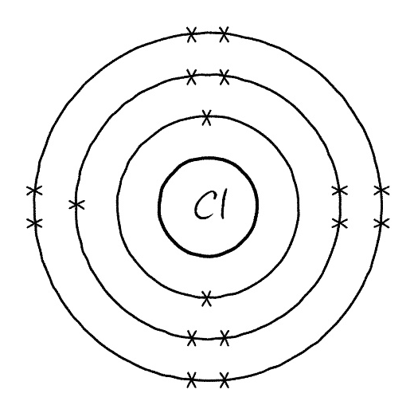
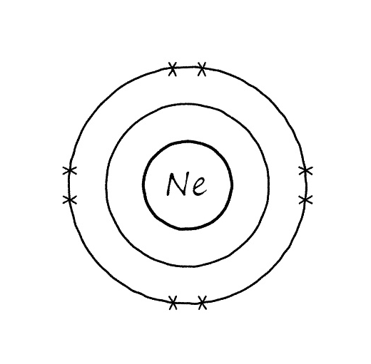
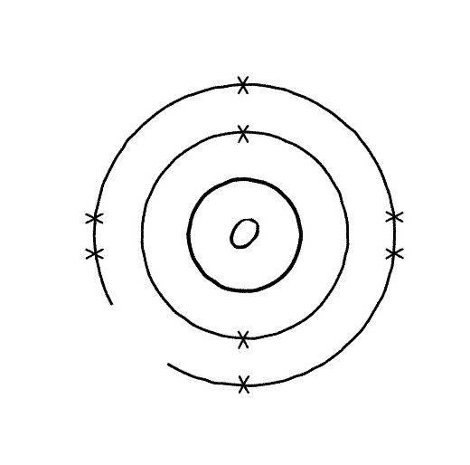
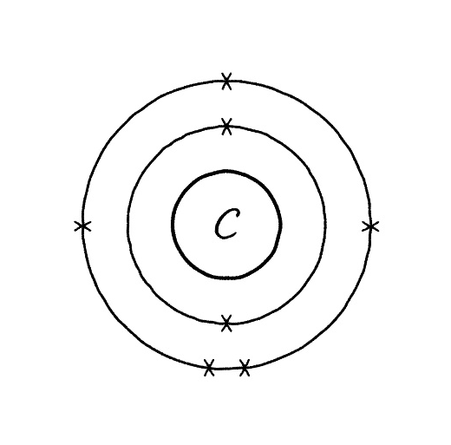
Electron configuration diagram | Peer assessment (draw a correct diagram and briefly explain)
