Complete teaching ideas
Education in Chemistry
January 2018
rsc.li/EiC118-preciouswater
These teaching ideas accompany the above article ‘Precious Water’.

In your class
Download the text of this article, and all the related teaching resources, worksheets and experiments from the Education in Chemistry website: rsc.li/EiC118-preciouswater

Antibacterial halogens
Experiment, ages 11–14 (science club) and 14–16 (class) and extension questions, ages 14–16
The halogens are important elements. They are used in a huge number of chemicals that are useful to our everyday lives. Dissolved in water, and even in their elemental forms as Cl₂, Br₂ and I₂, they can act as antibacterial agents.
This standard microbiology practical lies at the interface of chemistry and biology. Place discs soaked in the halogen waters on bacterial lawns grown on agar plates. Compare the zones of inhibition at a suitable point (which depends on the bacteria used) to determine which halogen has the best antibacterial action. Encourage pupils to think about exactly what they need to record in order to give the best account of their experiment.
Extension questions are also provided that prompt learners to consider why particular halogens are chosen as anti-bacterials in different situations.
Download the experiment worksheet, extension questions and teacher guide from the Education in Chemistry website: rsc.li/EiC118-preciouswater

Electrolysis of brine in an improvised cell
Class experiment, ages 14–16
In this experiment pupils work in pairs to construct a cell to carry out electrolysis as discussed in the article ‘Precious water’.
This improvised cell is easy to construct and very effective.
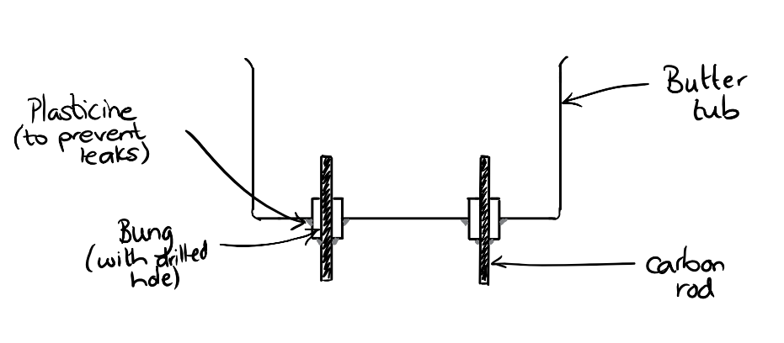
Materials needed:

- Butter/margarine tub
- 2 corks with pre-drilled holes
- 2 carbon rods
- Plasticine or a glue gun
- Circuit apparatus: power pack or battery (6V is usually sufficient); wires; crocodile clips
- Brine

Pupils should run the electrolysis of brine solution for a few minutes and make their observations. Take care to make sure pupils turn off their power packs or disconnect their circuits to prevent large amounts of chlorine being released.
A further guide to the electrolysis of brine can be found on Learn Chemistry: rsc.li/Electrolysis-brine
Debate cards
Once they have had chance to make their own observations, provide lab partners with debate cards containing statements that represent ideas about what is happening in the cell. These ideas may be present in a class but perhaps not articulated. Then, discussing the ideas as a whole class. This could be followed up with homework where pupils annotate the debate cards with their own ideas.
Theory
- Ions are attracted to the opposite electrode. After the initial electrostatic attraction, the ion movement is actually due to diffusion.
- As water is present in the solution, this is also electrolysed giving H⁺ and OH⁻ ions.
- Both Na⁺ and H⁺ ions are attracted to the negative electrode. However, the element with the lower position in the reactivity series is the one discharged. So, hydrogen gas is produced.
- At the negative electrode, 2H⁺ + 2e⁻ H₂. The presence of H₂ can be confirmed with a lit splint in the ignition tube of gas.
- At the positive electrode, 2Cl⁻ Cl₂ + 2e⁻. The presence of Cl₂ can be confirmed by a characteristic smell. It is not advised to collect the gas.
The theory of electrolysis can be difficult for pupils. This activity might highlight many misconceptions from earlier work on atomic structure, reactivity and bonding.
Further details on chemicals from salt can be found on Learn Chemistry.
Historical context about salt mining in the UK can be found on the site of the Winsford salt mine.

Debate cards
There are bubbles forming on top of the carbon rods. That must be a physical change like evaporation. | There is a smell like swimming pools so chlorine must be being produced.
The sodium ions are making sodium which is reacting with the water and producing hydrogen. | The ions in the brine are attracted to the electrode with the opposite charge – a bit like magnets.
The bubbles coming from each electrode are different sizes. Different gases must be being produced. | The brine is mostly water so the gases produced could be hydrogen and oxygen from splitting up water.
Sodium can’t be being produced at one of the electrodes as sodium sets on fire when it reacts with water. | When universal indicator is added the water turns purple which means there is an alkali. Alkalis have OH⁻ ions so something must be happening to the water.

How big is the nanoscale?
Maths in science, ages 14–16
Pupils really struggle to imagine just how small measurements in nanometres actually are. These exercises immerse pupils in the mathematics of this measurement using familiar objects and a variety of pupil learning activities. They include a matching exercise, a reading exercise, a calculator conversion exercise and construction of a scale using toilet paper. The exercises are differentiated to give greater to support to pupils with lower prior achievement. These activities can be used as a single lesson focusing on maths in science.
Download the exercises and teacher guide from the Education in Chemistry website: rsc.li/EiC118-preciouswater
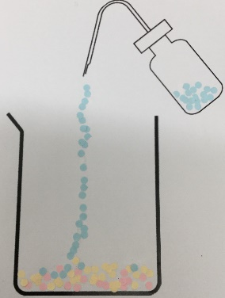

Separating salt from sand
Class experiment and particle pictures pair work, ages 11–14
Separating salt from rock salt is a common practical for younger secondary school pupils. Learn Chemistry has a guide to the practical: rsc.li/separating-salt-sand
Running it as a competition adds a nice challenge element. The winner has the cleanest salt sample.
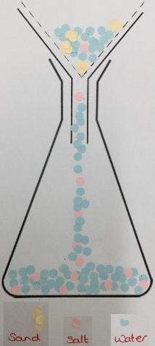
Even when pupils are very careful, ‘dirty’ samples with visible sand or silt particles are common. An interesting discussion for the pupils is ‘are all filter papers created equal?’. Many pupils won’t have considered how a physical filter works (chip pan basket, sieve and other analogies are helpful here). School filter papers are basic and may not filter out very fine particles. Particles the size of ‘silt’ particles may come through.
The particle model underpins much of chemistry, especially for 11–14 students. A solid foundation in the particle model helps pupils with simple concepts like state changes and separations, but also provides the basic building blocks for more advanced study in areas such as bonding.
Challenge students to model the separation of salt from rock salt in a series of images.
Share out templates of the experimental sequence. Two diagrams per pair works well with the expectation each diagram is constructed between the pair.
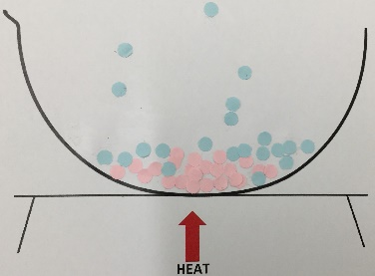
Particles can be drawn onto the templates provided. Or better, they can be collaged onto the template using hole-punched coloured paper or dot stickers as drawing the particles can cause issues with particle diameter consistency. I found the hole-punched paper best as the arrangement of particles can be discussed with pupils before they’re stuck in place.
Download templates of the experimental sequence for making particle pictures from the Education in Chemistry website: rsc.li/EiC118-preciouswater

