Explaining observations in energetics quiz
Education in Chemistry
May 2021
rsc.li/3rWG5TH
Read the questions and consider your answers carefully. Use the thinking time to guide you on how long to spend on each question. When you finish, review your answers before submitting them.
Thinking time:
3 mins
- When zinc powder is added to sulfuric acid the temperature increases quickly and then slowly decreases.
Which of the following provides the best explanation for what is taking place?
- The reaction between zinc and sulfuric acid is exothermic.
- The temperature rises as zinc and sulfuric acid react, and then decreases back to room temperature as the heat energy is lost to the surroundings.
- The reaction between zinc and sulfuric acid is exothermic so the temperature in the test tube rises.
- The temperature rises quickly as zinc and sulfuric acid react exothermically but decreases as heat energy is slowly transferred to the mixture of air particles.
Thinking time:
2 mins
- When copper is added to hydrochloric acid, the temperature of the acid does not change.
Which of the following explanations for this observation is least helpful?
- Copper is a metal.
- Copper is less reactive than hydrogen so it does not react with the acid.
- No energy transfer is taking place.
- There is no exothermic or endothermic change taking place.

For questions 3–5, use the following table to choose whether the answer is A, B, C, or D:
A | B | C | D
I and III | II and IV | I, II, and III | IV only
Thinking time:
3–4 mins
- When 0.3 g of magnesium ribbon is added to 20 cm³ of hydrochloric acid (which is in excess), the temperature increases by 22℃.
Which (combination) of the following would decrease the maximum temperature reached?
- Using 0.3 g of magnesium powder.
- Using 50 cm³ of hydrochloric acid.
- Using more concentrated hydrochloric acid.
- Using 0.1 g of magnesium ribbon.
Thinking time:
2 mins
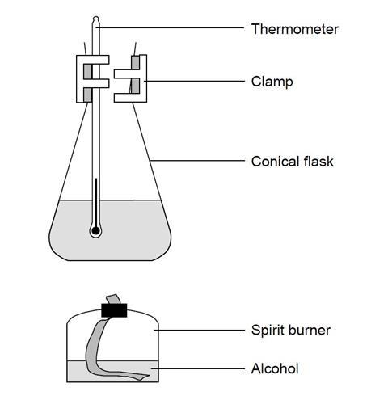
- Which (combination) of the following would increase the temperature rise of the water in the conical flask?
- Use half the volume of water in the conical flask.
- Moving the conical flask down so the flame turns yellow-orange and leaves soot on the base of the flask.
- Using a longer chain alcohol.
- Moving the conical flask to the top of the clamp stand.
Thinking time:
4 mins
- When the white solids barium hydroxide and ammonium hydroxide are mixed in a beaker a chemical reaction takes place. If the beaker is placed on a heat proof mat with a few drops of water on it, the mat will stick to the bottom of the beaker.
Which (combination of) statement(s) explains why the mat sticks to the bottom of the beaker?
- The water molecules have less energy so the water freezes.
- The barium hydroxide and ammonium chloride undergo an endothermic reaction in the beaker.
- Heat energy is transferred from the surroundings into the beaker.
- Water is formed in the reaction.

