- A teacher shows a class an experiment in which liquid paraffin is cracked.
Watch the video at https://youtu.be/ZYyKUePdC2Y

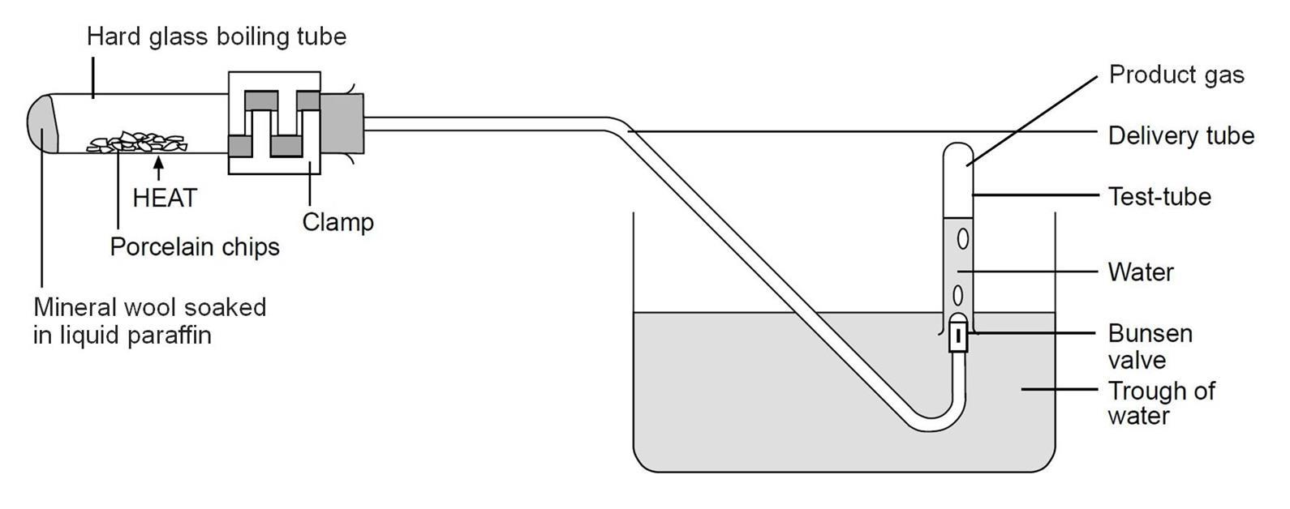
Here is a diagram of the equipment used.
Source: Royal Society of Chemistry

- Porcelain chips are used because they catalyse the reaction.
Define ‘catalyse’?
Answer: To make the reaction take place at a faster rate.
- Using the diagram, what evidence is there that smaller molecules are made in the experiment?
Explain your answer.
Answer: A product gas is formed from the liquid paraffin.
The gas has a lower boiling point than the liquid paraffin.
This is because the gas contains smaller molecules.

- Using the diagram, describe how you think the experiment works.
Answer: Liquid paraffin and porcelain chips are heated with a Bunsen flame.
The liquid paraffin boils and turns into a vapour.
The paraffin molecules break down due to heat and the catalyst.
The smaller molecules are then collected in the test tube as a gas.
- What evidence is there from the diagram that the product gas is insoluble in water?
Answer: The product gas is collected over water, and if it were soluble, it would dissolve.
- Suggest why a special valve called a Bunsen valve is used in the experiment.
Answer: It is a safety feature – if suck-back of water back into the glass equipment occurs, water on very hot glass could cause an accident. The Bunsen valve is supposed to decrease the likelihood of this happening.

Paraffin is a mixture of large hydrocarbon molecules.
The structure of one of these molecules, called dodecane, is shown below.
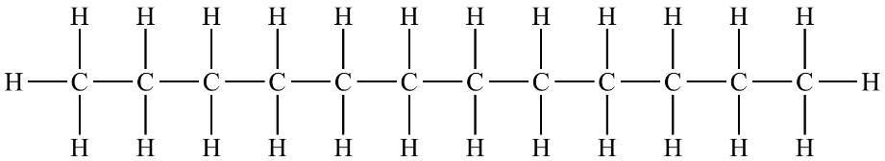

- State the molecular formula of dodecane.
Answer: C₁₂H₂₆

Dodecane is a member of a homologous series.
- Give two characteristics of molecules in a homologous series.
Answer: They have the same functional group.
One member differs from the next by a CH₂ unit.
When arranged in order, they have a graduation in physical properties.

- To which homologous series does dodecane below?
Answer: The alkanes.
- What is the general formula of the homologous series in part h)?
Answer: C_{n}H_{(2n+2)}
- Which of these molecules do not belong to the same homologous series as dodecane?
Write ‘Yes’ or ‘No’ into the right-hand column in the table.
Molecular formula of substance | The same homologous series as dodecane (‘Yes’ or ‘No’)
C₈H₁₆ | Answer: No.
C₁₃H₂₈ | Answer: Yes.
C₅H₁₂ | Answer: Yes.
C₂₃H₄₆ | Answer: No.
C₅₀H₁₀₂ | Answer: Yes.

- Dodecane may be cracked to form smaller alkanes and alkenes.
Write a symbol equation to show dodecane being cracked to form ethene as one of the products, together with a different product.
Answer: C₁₂H₂₆ C₁₀H₂₂ + C₂H₄
- Complete the symbol equations for the following cracking processes.

- C₈H₁₈ C₆H₁₄ + C₂H₄

- C₁₆H₃₄ C₁₂H₂₆ + 2C₂H₄

- C₂₀H₄₂ C₁₃H₂₈ + 2C₂H₄ + C₃H₆
- State a use for the products formed from a cracking reaction.
Smaller alkanes | Answer: Petrol
Alkenes | Answer: Polymers and solvents.

The molecule shown below can form from a cracking reaction.

- What is the name of this molecule?
Answer: Butene or but-1-ene.
- State whether this molecule is saturated or unsaturated.
Give a reason for your answer.
Answer: Unsaturated.
A carbon double bond is present.

