Thermodynamics

Definitions

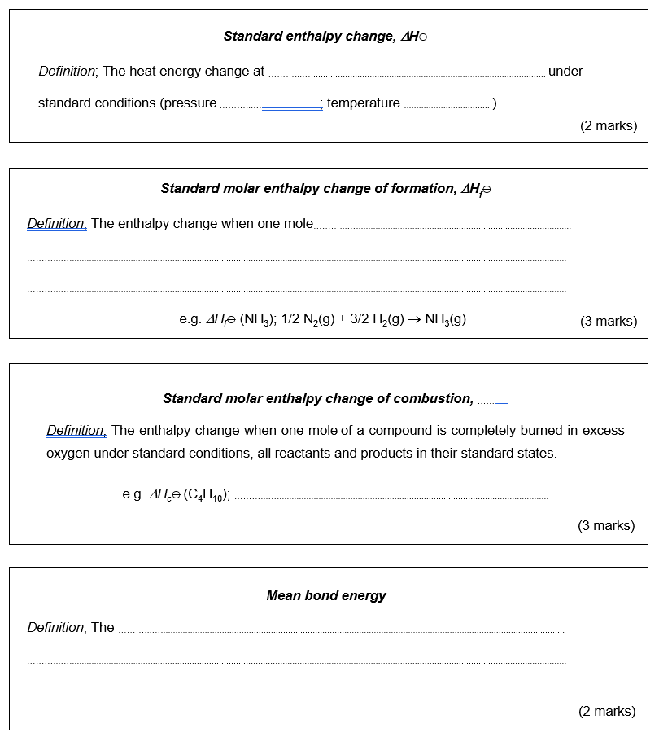
Complete the gaps in the boxes below;

Calorimetry

Below is a student’s write up of the calorimetry practical he recently completed in class. There are 10 ways in which the teacher thinks he could have improved his experimental technique and analysis. Can you spot them?

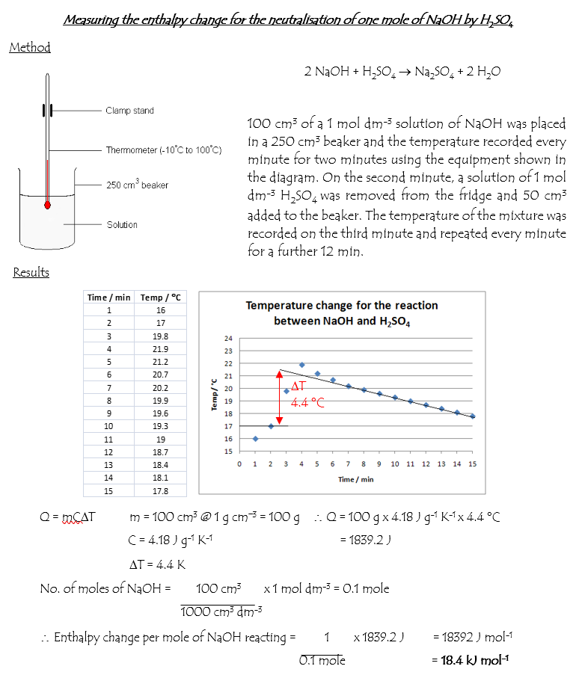

Hess’s law

This question is all about the possible fuels you might come across when going camping. Use your knowledge of Hess’s law to investigate the energetics of the processes involved.

1. One form of camping stove runs on the fuel butane. Along with other isomers this contains the gas iso-butane or 2-methylpropane.
(a) The enthalpy change of formation of iso-butane is –134.5 kJ mol⁻¹. Write an equation, including state symbols, for the reaction to which this enthalpy change applies.
(2 marks)

(b) In a camping stove, the iso-butane undergoes combustion. Write an equation to represent the enthalpy change of combustion of iso-butane in excess oxygen.
(2 marks)

(c) Using the answers to part (i) and part (ii) together with the information in the table below, calculate ΔH_{c}⦵ for iso-butane.
(2 marks)

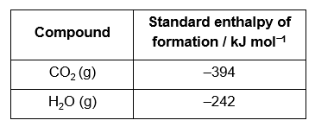
2. An alternative to a gas camping stove is a Trangia™. This burns methylated spirits which is predominantly ethanol with additives to make it more poisonous or unpalatable.

(a) Write an equation to represent the enthalpy change of formation of ethanol (CH₃CH₂OH)
(2 marks)

(b) Use the information in the table together with Hess’s law to calculate ΔH_{f}⦵ for ethanol.
(2 marks)

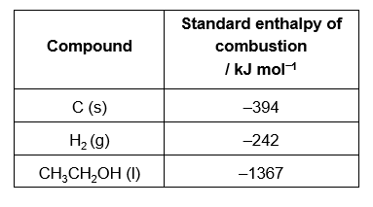

Using bond enthalpies

1. A student is carrying out a project to compare the theoretical and experimental value for the enthalpy change of combustion of ethanol. Using the data in the table, calculate a theoretical value for ΔH_{c}⦵ [CH₃CH₂OH(l)].

(HINT Remember to fully balance any equations before starting your calculations)
- marks)
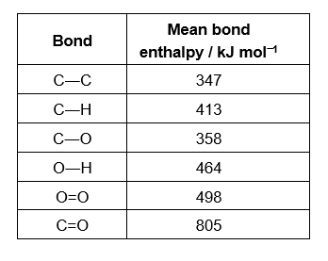
1. When the student shows his calculation to his teacher, she points out that mean bond enthalpies are only applicable for molecules in the gas state. Therefore the student must take into account the enthalpy change of vaporisation of ethanol
[CH₃CH₂OH(l) → CH₃CH₂OH(g), ΔH_{vap} +39 kJ mol⁻¹)
Use this value to correct your answer to Q1 (You may assume that the water formed from the combustion is in the gas state).
- mark)

2. The student now wishes to determine an experimental value for the enthalpy of combustion of ethanol. He intends to burn approximately 1 g of fuel and measure the heat energy produced by heating up a known volume of water in a copper calorimeter (using the equipment shown).

Using your answer to question 2, suggest a suitable volume of water for the copper calorimeter if he is aiming for a temperature rise of no more than 40 °C?
(Specific heat capacity of water = 4.2 J K⁻¹ g⁻¹)
(4 marks)

3. The experimental value obtained by the student is considerably lower than the theoretical value calculated. Suggest one reason for this (other than experimental error).
(1 mark)

Thermodynamics – Answers

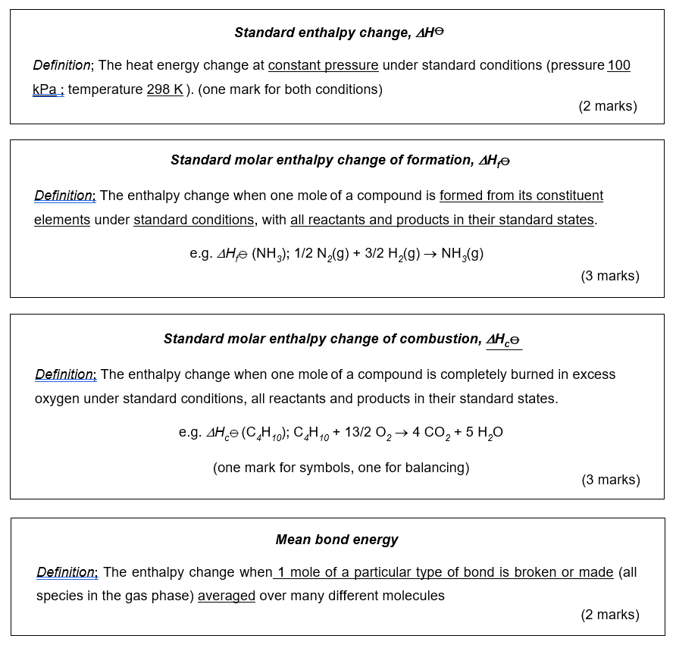
Definitions

Calorimetry
Possible improvements / corrections include (any 10 from);

1. The beaker needs some form of insulation (or a polystyrene beaker should be used)
2. An accurate thermometer is needed (not one that records −10 to 100 °C)
3. The thermometer is placed too near the surface of the mixture. It must be in the centre
4. The liquids are not allowed to equilibrate to similar temperatures before use; the H₂SO₄ is removed from the fridge!
5. Only two readings were taken before the addition of the H₂SO₄. It is therefore impossible to draw a line to indicate the average temperature of the NaOH before addition.
6. It is more usual to mix the reagents on the 3rd minute say and take no measurement at this point then measure the temperature again on the 4th, 5th minutes etc.
7. There is no mention of the mixture being stirred.
8. Not all temperatures are recorded to 1 decimal point in the student’s results table
9. A straight line is drawn for the temperature of the solution after addition of the H₂SO₄ despite the fact that the temperature clearly drops more steeply initially – better extrapolation needed.
10. A volume of 100 cm³ is indicated in the student’s calculation for the energy transferred. The volume is in fact 150 cm³ (100 cm³ of NaOH and 50 cm³ of H₂SO₄).
11. The calculation requested is per mole of NaOH reacting. This reaction involves two equivalents of NaOH so the final enthalpy change must be divided by 2.

NOTE The experimental data is made up and in no way represents the real enthalpy of neutralisation of NaOH.

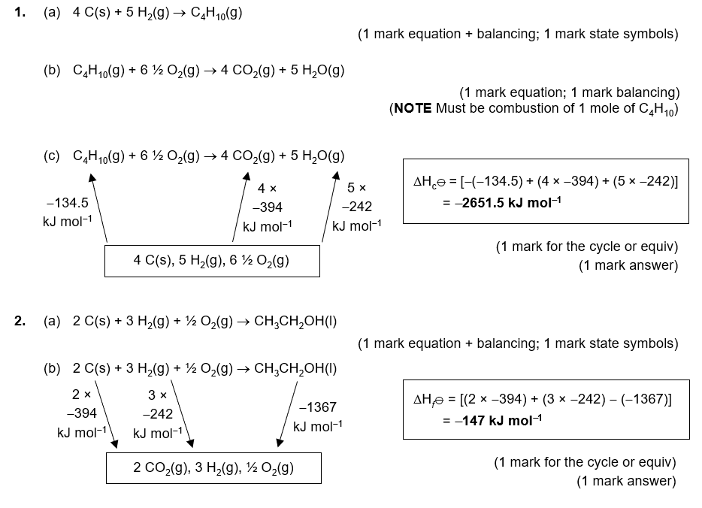
Hess’s law

Using bond enthalpies
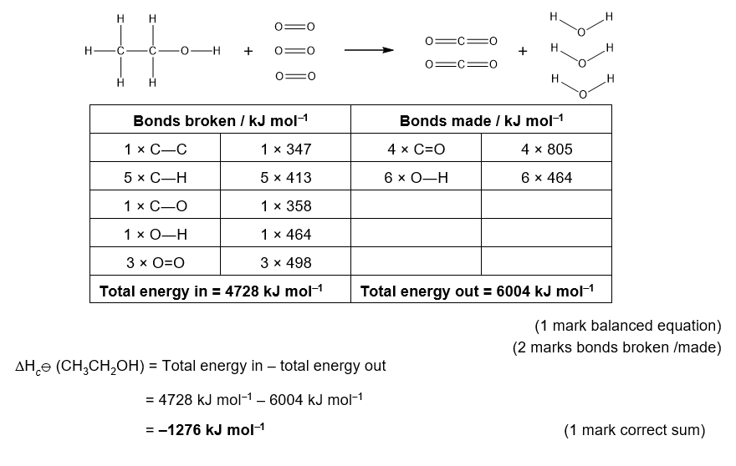
2. 39 kJ mol⁻¹ of energy must be put in to the reaction to initially convert the liquid ethanol into gaseous ethanol. Hence, the total energy in becomes 4728 kJ mol⁻¹ + 39 kJ mol⁻¹ = 4767 kJ mol⁻¹.

Therefore the more correct;
ΔH_{c}⦵ [CH₃CH₂OH(l)] = 4767 kJ mol⁻¹ – 6004 kJ mol⁻¹ = –1237 kJ mol⁻¹
(1 mark)

3. Number of moles in 1 g = 1 g ÷ M_{r} (CH₃CH₂OH) = 1 g ÷ 46 g mol⁻¹ = 0.022 moles
(1 mark)
Theoretical heat transferred by 1 g = 0.022 moles × 1237 kJ mol⁻¹ = 26.9 kJ
(1 mark)
26891 J = mass of water × 4.2 J K⁻¹ mol⁻¹ × 40 K
∴ mass of water = 26891 J / (4.2 J K⁻¹ g⁻¹ × 40 K)
= 160 g
(1 mark)
Density of water = 1 g cm⁻³, therefore 160 g has a volume of 160 cm³
(1 mark)

4. either
Mean bond enthalpies are averages of the bond enthalpies in many different compounds. Therefore they are not exact for the specific bonds in ethanol
or
There is considerably loss of heat to the environment / copper calorimeter that is not included in the calculations for the experimental enthalpy of combustion of ethanol. This loss of heat would result in an experimental value that is lower than the actual value.
or
The heat capacity of the copper calorimeter has not been taken into account meaning that the heat transferred into the copper is not included in the calculation.

