Investigating rates of reaction with on-screen simulations
Education in Chemistry
June 2020
rsc.li/2BR86rt

Introduction
The rate, or speed, or a reaction is a measure of how quickly a reaction happens.
- Some reactions, like explosions, are very quick – they finish within seconds.
- Some reactions, like rusting, are very slow – they finish in months or years.
- Some reactions, like baking a cake, are somewhere in between – they finish in minutes or hours.
More information here: https://www.bbc.co.uk/bitesize/guides/z3nbqhv/revision/1

By studying the rate of a reaction, we can understand the reaction in more detail.
We can make predictions about when the reaction will finish.
We can make predictions about how the reaction actually works.

In the lab we can carry out simple experiments to study rates of reaction. For example:
- Add magnesium to acid: https://www.youtube.com/watch?v=TUcBpWXwkMM
- Add sodium thiosulfate to acid: https://www.youtube.com/watch?v=J8zyMnMzbLA
- Add marble chips to acid: https://www.youtube.com/watch?v=WF8j0EIbJNo
- Add manganese dioxide to hydrogen peroxide: https://www.youtube.com/watch?v=DJ5f9mQLEcw

With these experiments we find that we can speed up and slow down reactions by changing some properties.
For example – in general:
- when reactants have higher concentration, reactions are faster;
- when reactions are heated up, reactions are faster;
- when solid reactants are smaller, reactions are faster;
- when catalysts are added to reaction, reactions are faster.
More information here: https://www.bbc.co.uk/bitesize/guides/z3nbqhv/revision/1

Activity
In this activity, you will simulate changing two properties: concentration and temperature.
You will use an online simulation to collect data.
You will use a spreadsheet to analyse and present the data.

Part 1: Learning to use the simulation
- Open the simulation: https://lab.concord.org/embeddable.html#interactives/sam/chemical-reactions/2-concentration-and-reaction-rate.json
- Spend some time experimenting with the controls: add atoms – click on the play ( ) – watch the atoms move around and react (join together) – monitor the percentage ‘reaction complete’ – restart the simulation () – try more atoms.
- Once you are happy with how the simulation works, set up your spreadsheet.

Part 2: Setting up the spreadsheet – use Excel, or Google Sheets or any other spreadsheet program.
- Set up a table such as the one below:
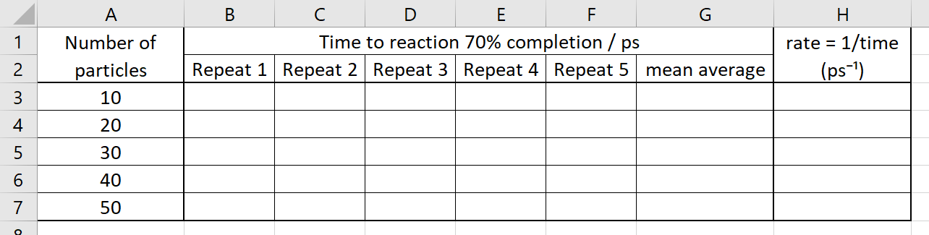
- Reset the simulation ().
- Add 10 atoms.
- Start the simulation ().
- Stop the simulation when ‘reaction complete’ reaches 70% – don’t worry if you don’t hit the pause button () at exactly the right time.
- Add your time (measured in ps = picoseconds = 10⁻¹² seconds!) into your spreadsheet.
- Repeat steps 2–6 for each repeat of each number of atoms – a total of 25 simulations in total. This will take about 10 minutes.

Part 3: Processing your data
- Here is some sample data:
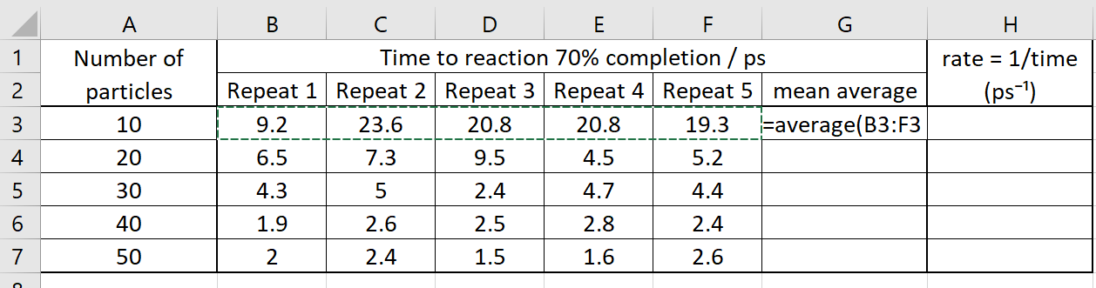
- Calculate the mean average for all the repeats of the ‘10 particle’ simulations:
  - Click in cell G3
  - Type =average(
  - Click, hold, drag and release from cell B3 to F3
  - Press enter
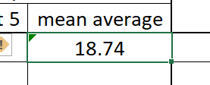
  - Copy the formula into the rest of the ‘mean average’ cells – click on cell G3, double-click on the small square in the bottom right of the cell:
- Calculate the rate of the reaction:
  - Here, we are using (1/mean average) as a measure of the rate
  - Click in cell H3
  - Type =1/G3
  - Press enter
  - Copy the formula into the rest of the ‘rate’ cells

- Change the number of decimal places on the rate number to 3:
  - Select all the rate cells (click, hold, drag and release cells H3–H7)
  - Right click and select ‘Format cells’
  - Select the ‘Number’ tab
  - Select ‘Number’ in the Category list
  - Change ‘Decimal places’ to 3
  - Click ‘Ok’
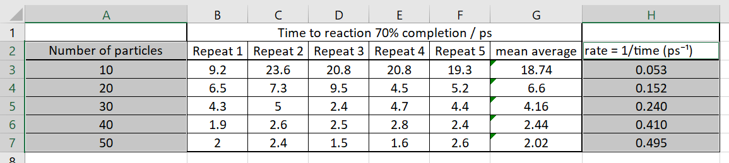
- Look at your data – how does the rate of reaction change as the number of particles increases?

Part 4: Presenting your data – making patterns easier to see
- You will now plot a scatter graph with line of best fit. This will help you see patterns in your data clearly.
- Select the ‘Number of particles’ column (including the header) – click, hold, drag and release cells A2–A7.
- Select the ‘Rate’ cells (including the header) – press the Ctrl key while you click, hold, drag, release cells H2–H7. Both columns should now be selected.
- Insert a scatter graph – click Insert > Charts > Scatter – select the chart without any lines.
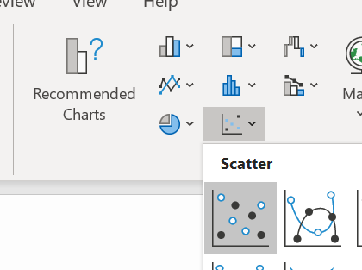

- Add an x-axis label and y-axis label – select the Chart, click Chart Design > Add Chart Element > Axis Titles > Primary Horizontal … and Primary Vertical
- Label your axis titles and graph appropriately.
- Add a trend line to your data: Click on one of your data points, right-click, click on ‘Add trendline…’
- You may need to change the ‘Trendline options’ to make the line curved (use the ‘Exponential’ option).

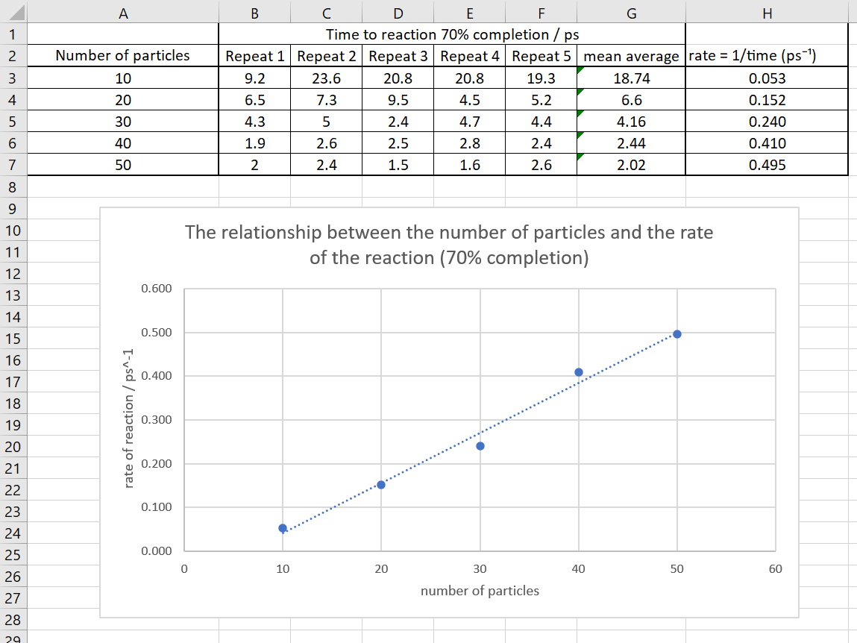

Part 5: Interpreting your data
- You can now write a statement linking together the number of particles (concentration of the reactants) and the rate of reaction.
- Make sure your sentence uses comparative words (greater, higher etc) and you state both variables.
- If you used a curved line of best fit, extend your statement by saying how rate changes at higher/lower number of particles.

Part 6: Taking it further
- 70% completion was chosen in the first instance as this produced good data in a reasonable time. Investigate whether 50% or 100% completion gives you similar patterns.
- Investigate how far you can take this simulation – 60, 70, 80…. Atoms – and fewer – 2, 4, 6… particles.
- A second simulation is available to investigate how temperature affects rate of reaction – use this to carry out a similar investigation to the one you have on concentration: https://lab.concord.org/embeddable.html#interactives/sam/chemical-reactions/3-temperature-and-reaction-rate.json

Part 7: Reporting
- Write up and return a report on what you have done and what you have found out. Minimum expectations (Parts 1–5):
  - Aim – why you have carried out this investigation
  - Background theory – why reactions happen, what rate means, how we can affect rate
  - Method – how you used the simulation, and how you analysed your data
  - Data and analysis – screenshots of your spreadsheet and graphs
  - Discussion – explanation of what you have learned from the data and analysis; any problems in the investigation; how you could overcome these problems and improve the investigation
  - Conclusion – a short summary of what you did and what you learned
- You can carry out Part 6 as well and include this in your report if you wish.
- Return your assignment as a pdf or Word document.

