- These six molecules include alkanes, alkenes and alcohols.

- State which molecules belong to which group.
Write your answer underneath each molecular structure.

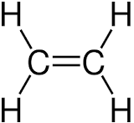 | 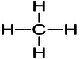 | 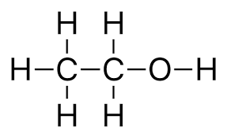
Answer: Alkene: ethene. | Answer: Alkane: methane. | Answer: Alcohol: ethanol.

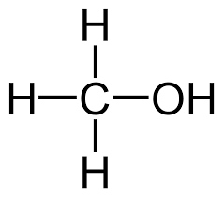 | 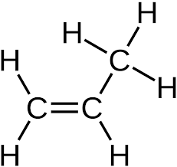 | 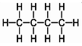
Answer: Alcohol: methanol. | Answer: Alkene: propene. | Answer: Alkane: butane.
- Name each of the substances in part a).
Answer: See answers above.
- Using one of the molecules shown, circle the alcohol functional group.
Answer: See diagram of ethanol in which the O-H (hydroxyl) group is circled.
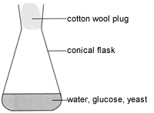
- Janice and Matt set up this equipment then waited for one week.
A chemical reaction takes place in which new substances are made.
- Complete the word equation for this reaction:

Glucose ethanol + carbon dioxide
- Complete the symbol equation for the reaction.

C₆H₁₂O₆(aq) 2C₂H₅OH(aq) + 2CO₂(g)
- What is the name given to the type of reaction taking place?
Answer: Fermentation.
- Explain why yeast is used in the experiment.
Answer: Yeast contains an enzyme that makes the fermentation happen at a faster rate.

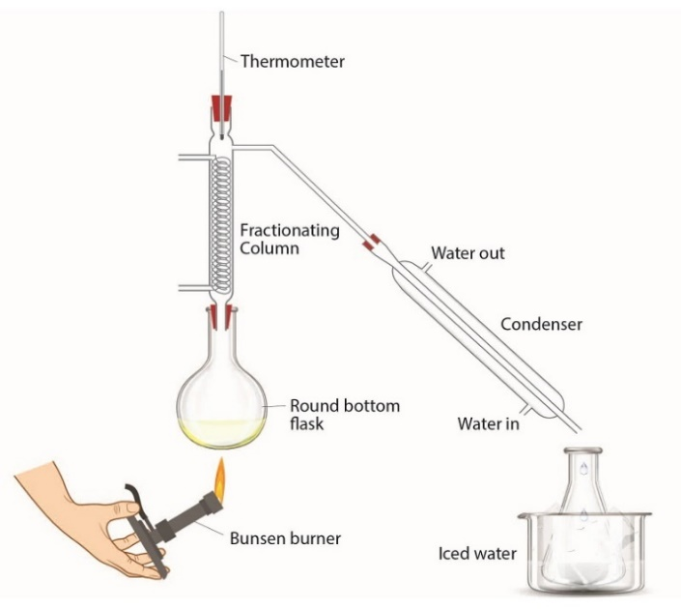
Janice and Matt then add the mixture from the conical flask to the round-bottom flask in a different experiment.
- Why is this new experiment needed?
Answer: To separate the ethanol from the aqueous
solution.
- Explain how this experiment works.
Answer: Ethanol has a lower boiling point than water, so is able to form a vapour that can be removed and condensed.
Source: Royal Society of Chemistry
Source: Royal Society of Chemistry

- What is the name of this technique or experiment?
Answer: Fractional distillation.
- Give two uses of alcohols.
Answer: Solvent, fuel.

- Ravi carries out an experiment with a mixture of ethanol dissolved in water.
He leaves the ethanol open to the air for two weeks.
He notices that a very slow chemical reaction takes place.
He removes a few drops of his new mixture and adds some universal indicator solution.
He notices that the indicator turns orange.
- What type of substance has formed?
Answer: A weak acid.
- What is the name of the new organic product formed?
Answer: Ethanoic acid.
- State the name of the chemical substance that reacts with ethanol in this reaction.
Answer: Oxygen, from the air (in the presence of certain bacteria).
- What type of reaction has taken place?
Answer: Oxidation.
- Ravi knows that a different chemical substance could be added to ethanol to make the same product, but a lot faster.
State the name of this substance.
Answer: Acidified potassium manganate(VII) [OCR] or acidified potassium or sodium dichromate(VI) [AQA].

- Complete the chemical equation that shows the reaction taking place:

C₂H₅OH + 2[O] CH₃COOH + H₂O

- Complete the diagram to show the structure of the new organic product made.
