From toilet to tap
Education in Chemistry
May 2019
rsc.li/2G1LCCy
Have you ever wondered what happens when you flush the toilet? Read through the article, What happens when I flush the loo? and find out how the contents of the flush is treated and how this treatment is different in the UK and in Singapore.
1. Mark the UK and Singapore on the map of the world below.
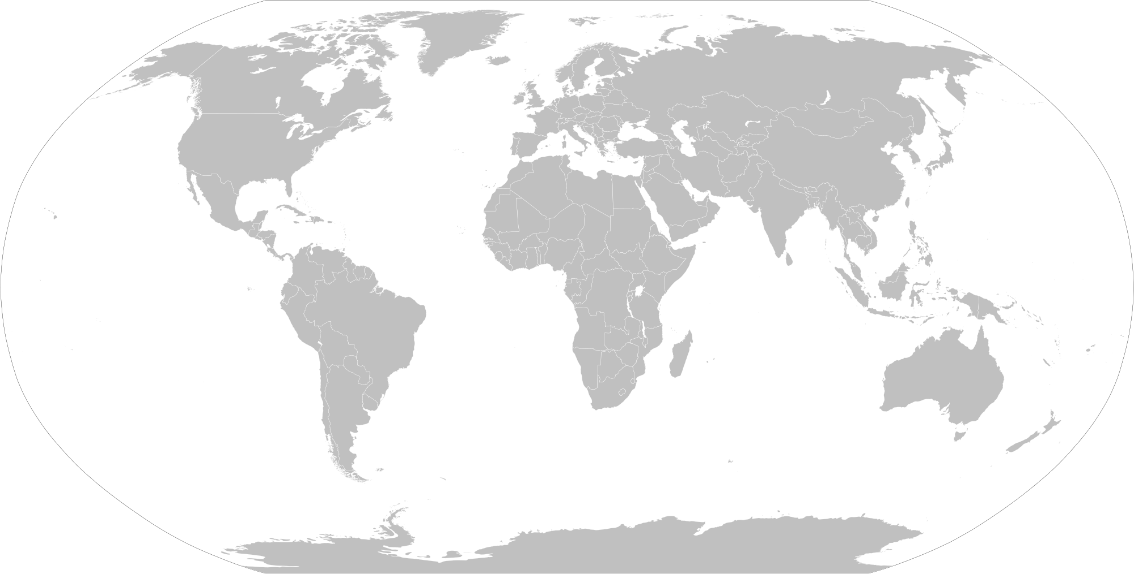
2. a. Draw a flow diagram to represent the different stages involved in the treatment of waste water.
Add brief details (either in written form or as diagrams) to describe each stage.
b. Which stage is currently used in the Singaporean system but not in the UK system?
c. Which other countries have adopted a similar approach to Singapore and why?

3. Nowadays water treatment is not just about removing contamination but can also be about recovery and recycling.
a. Explain how the Stoke Bardolph waste water treatment works near Nottingham is;
i. generating methane gas from waste water.
ii. recovering the nutrient phosphorus from waste water.
b. Which other products is current research looking at being able to recover from waste water?

4. Would you be happy to drink water that has been recycled from the contents of a toilet flush?
Justify your opinion.

Answers

1.
Preliminary screening
- Fishes out large pieces of waste.

Singapore
United Kingdom (England, Northern Ireland, Scotland and Wales)
2. a.

Primary treatment
- Solid particles settle out of the liquid portion by gravity.
- Forms a sludge that can be used to fertilise fields.
- Reduces the organic components in the water.
- Lowers the BOD (biological oxygen demand).

Secondary treatment
- Microbes break down all the unsavoury stuff.
- Lowers the BOD (biological oxygen demand)

Tertiary treatment
- Uses ultra-fine filters
- Requires additional chemical treatments

b. The Singaporean system involves the tertiary treatment phase. This currently isn’t involved in water treatment in the UK.
c. Similar approaches to that in Singapore have been adopted in Australia and parts of the US where drought is leaving reservoirs and rivers running low.

3. a. i. A biological process is used to take the phosphorus out the water and store it in the sludge. The sludge is then anaerobically digested to generate methane.
ii. After the sludge has been anaerobically digested, the phosphorus is then recovered from the sludge as a chemical called struvite.
b. Severn Trent water is now testing methods for the recovery of nitrogen and cellulose from waste water, and is involved in research on recovering plastics. High-value metals such as copper and possibly even medicines could in the future also be recovered from waste water.

4. Student personal opinion with suitable justification.

