Using multiple models

Learning objectives
- Use a variety of models to develop scientific understanding of a molecule of hydrogen.
- Discuss limitations of models in science.

The problem

Many models are used in science to represent the same idea.

Your challenge is to use multiple models and representations to build a more concrete understanding of an abstract idea.

By answering a set of questions, you will evaluate each representation and gain a deeper understanding of the overall concept.

The task

Below are five representations of the hydrogen molecule, labelled A–E. Answer the questions in the table to evaluate. Refer to each model specifically for questions three and four.
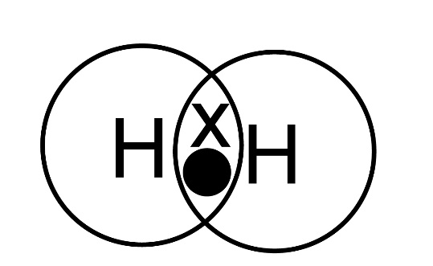
H₂

B
C
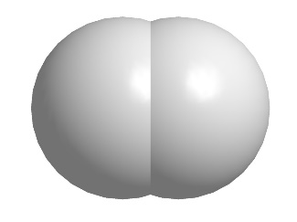
A
D
E

Question | Your response
1. What is the purpose of these models?
2. What scientific concepts are these models showing?
3. How are these models similar to real life?
4. How are these models different to real life?
5. What questions do you have after being shown this model?
6. Could you create a different model? If yes, what would you do?

Self-Assess
- All models show the hydrogen molecule is made of two atoms.
- Models B and E don’t show any information about the type of bonding.
- Models C and E don’t specify what particular atoms are in the molecule.
- Models A, C and D show a single bond between the two atoms, so give more information than B and E.
- Model A gives further information about the type of bonding (covalent) by showing the overlapping electrons.
- Models C and E show the structure in 3D giving information about the shape of the molecule.
- Model C shows the bond as if it is a fixed structure, but E shows the atoms overlapping as they bond.

