Basic practical competencies answer sheet

Basic practical competencies
Laboratory equipment

1. For each part (a)–(e) give ½ mark for the correct name and ½ mark for one or more correct possible volumes depending on what is available in your laboratory.
- conical flask
100 cm³ / 250 cm³
- beaker
100 cm³ / 250 cm³
- volumetric flask
100 cm³ / 200 cm³ / 250 cm³
- test tube or boiling tube
10 cm³ or 25 cm³
- burette
50 cm³
- pipette
various sizes although 20 cm³ or 25 cm³ are the most common at school level

2.
- (gas) syringe (1 mark)
- evaporating basin(1 mark)
- crucible (1 mark)
- pestle and mortar (the mortar is the bowl) (1 mark)

Recording results
- Improvements: (1 mark for each improvement identified)

- Units for temperature should be included in the table headings.
- All results should be recorded to the same number of decimal places (the resolution of the thermometer used), in this case 1 d.p.
- The temperature changes are negative and so should be recorded as such, eg –22.1, or the heading should be changed to ‘Temperature decrease’ or similar.
- The temperature change for Run 3 is anomalous and so should be circled, or similar, to show this. It is correctly not included in the calculation of the mean.
- The mean temperature change should be stated to the same number of significant figures as the values from which it is calculated.

- Experiment 1: (2 marks)
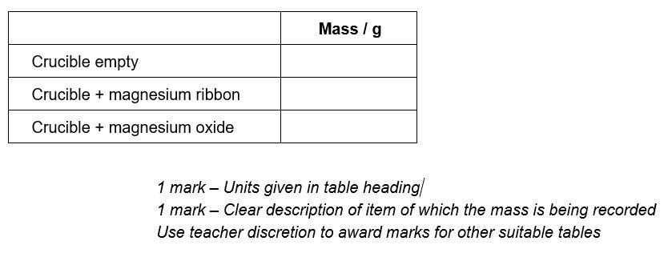
Experiment 2: (3 marks)

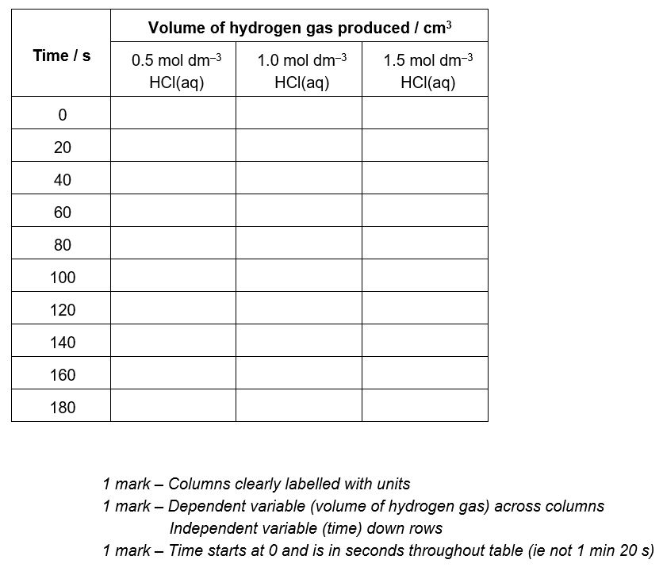

Drawing scatter graphs
- Graph plotted with marks allocated as follows:

- Temperature on the x-axis, volume on the y-axis. (1 mark)
- Suitable scales are chosen so that the plotted points cover more than half the graph paper (ie axes do not start at 0). (1 mark)
- Axes labelled with value and unit. (1 mark)
- Points are plotted accurately with a neat pencil cross and within ±1 square.
All points plotted accurately 3 marks
4 points plotted accurately 2 marks
3 points plotted accurately 1 mark

- Error bars are added to each plotted point (except 80 °C, 51.0 cm³) (1 mark)
Anomalous values circled in table not included in error bars (1 mark)

- Suitable line of best fit drawn (1 mark)

- As the temperature increases the volume of the gas increases (or suitable similar comparative statement) (1 mark)

