Temperature changes in exothermic and endothermic reactions
Education in Chemistry
August 2020
rsc.li/2EijKwA
Follow the experiment instructions and safety advice from your teacher. Note your temperature measurements in the table below.

1. Results

Reaction 1
Reactant 1 | Reactant 2 | Starting temperature /°C |  | Maximum temperature /°C |  | Final temperature /°C
 |  | Reactant solution | Surrounding air | Product solution | Surrounding air | Product solution | Surrounding air

Reaction 2
Reactant 1 | Reactant 2 | Starting temperature /°C |  | Minimum temperature /°C |  | Final temperature /°C
 |  | Reactant solution | Surrounding air | Product solution | Surrounding air | Product solution | Surrounding air

2. Exothermic reaction
a. Based on your results, decide which reaction was exothermic. Use the results to fill in the gaps in the chemical story.
Chemical story
Starting temperature  At the start, the cup contains ______________.  This reactant is dissolved in water,  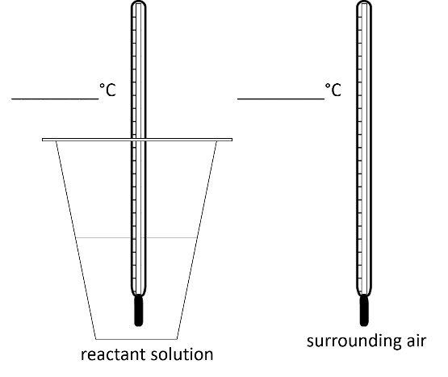  _______________________ is added. | Maximum temperature  The products of the reaction are ________________ and ________________.  The product _____________ is dissolved in water.  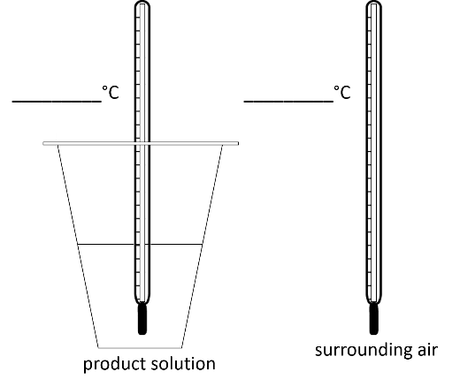 | Final temperature  The products are left in the cup for 15 minutes.
b. Circle the correct word(s) in the energy story.
Energy story
The reactant solution and surrounding air are at the same temperature. Energy is/ is not being transferred to or from the surroundings. | During the chemical reaction energy is transferred to/from the water. The product solution is at a higher temperature than the surrounding air. Energy will start to transfer to/from the surrounding air. | The product solution and surrounding air are at the same temperature. The energy has transferred to/from the surrounding air where it has dissipated.

3. Endothermic reaction
a. Based on your results, decide which reaction was endothermic. Use the results to fill in the gaps in the chemical story.
Chemical story
Starting temperature  At the start, the cup contains ______________.  This reactant is dissolved in water.  _______________________ is added. | Maximum temperature  The products of the reaction are ________________ and ________________.  The product _____________ is dissolved in water. | Final temperature  The products are left in the cup for 15 minutes.
b. Circle the correct word(s) in the energy story.
Energy story
The reactant solution and surrounding air are at the same temperature. Energy is/ is not being transferred to or from the surroundings | During the chemical reaction energy is transferred to/from the water. The product solution is at a higher temperature than the surrounding air. Energy will start to transfer to/from the surrounding air. | The product solution and surrounding air are at the same temperature. The energy has transferred to/from the surrounding air.

