Bonding: knowledge check
- Complete the sentences.
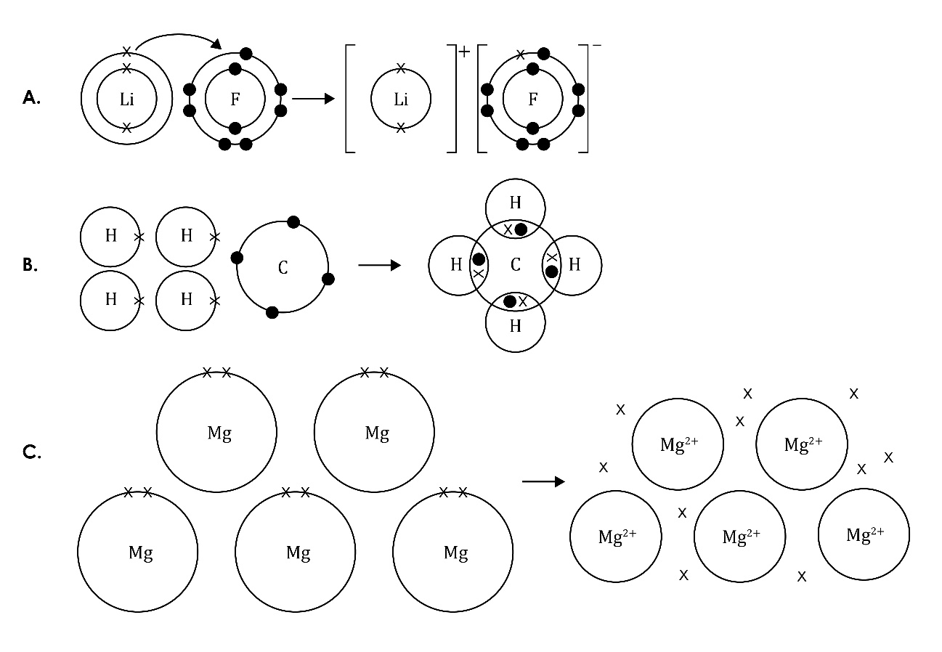
  - The type of bonding in figure A is ______________________________________.
  - The type of bonding in figure B is ______________________________________.
  - The type of bonding in figure C is ______________________________________.

- Complete the sentences.

________________________________ bonding – this bond is formed when electrons are _____________________________ from a metal atom to a _____________________ atom, forming positively charged ions and _______________________________ charged ions. Strong _______________________________________ _________________________ attract the oppositely charged ions to each other.
- Complete the sentences.

________________________________________ bonding – this bonding occurs between ______________________________________ atoms. In a single covalent bond, a pair of ___________________________ is shared between two atoms. These shared electrons are found in the _________________________________ shells of the atoms. Each atom contributes one _________________________________ to the shared pair of electrons.
- Complete the sentences using suitable words.

______________________________ bonding – the electrons leave the outer shells of metal atoms, forming positive metal ions and a ‘sea’ of delocalised __________________________ that are free to move. This bond is the result of the strong _______________________________________ _____________________________ of attraction between the positive metal _________________________and the negative delocalised ______________________________.

Bonding: test myself

Complete the sentences using suitable words.
- What types of elements are involved in:
  - ionic bonding? _____________________________________________________
  - covalent bonding? _____________________________________________________
  - metallic bonding? ____________________________________________________

- In which type of bonding are electrons shared?

Electrons are shared in ______________________________________ bonding.
- What does the curved arrow represent in the diagram?

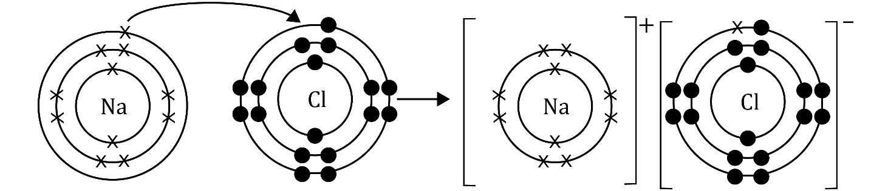

The arrow represents an _____________________ being _____________________from one atom to another.
- What type of forces hold the particles together in an ionic bond?

______________________________________ forces of attraction hold the particles together in an ionic bond.
- What does ‘delocalised’ mean?

Delocalised means that the electrons are ______________________ to move around.

- What are the charged particles called in an ionic compound?

The charged particles in an ionic compound are called _________________________.
- What type of bonds do you find in a compound?

The bonds in a compound can be either ________________________________ or _________________________________.
- Why are metals good conductors of electricity?

Metals are good conductors of electricity because they contain ________________________________________________ ______________________________ that are free to _________________ and carry the charge.
- How do ionic compounds conduct electricity when solid, liquid and in solution? Explain your answer.

Ionic compounds cannot conduct electricity when they are in the ________________________ state because the ions are not free to move.
They can conduct electricity when they are in a _____________________________________ or when they are _________________________ because the __________________________ can _____________________ and carry the charge.
- Why are most covalent substances non-conductors of electricity?

Most covalent compounds do not conduct electricity because they do not have __________________________ particles (_____________________ or _____________________) that can move and carry the _______________________ .

Bonding: feeling confident?

Complete the bonding diagrams.
- The reaction between magnesium and fluorine.
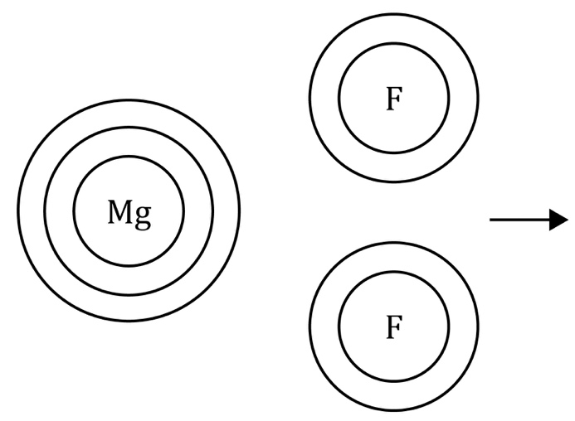
- The reaction between hydrogen and chlorine.
- The metallic bonding in zinc.

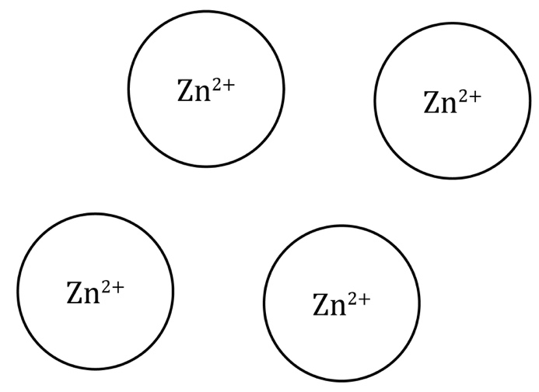

Bonding: what do I understand?

Think about your answers and confidence level for each mini-topic. Decide whether you understand it well, are unsure or need more help. Tick the appropriate column.
Mini-topic | I understand  this well | I think I understand this | I need more  help
I can identify ionic, covalent and metallic bonds from diagrams.
I know that there are ions in ionic bonds.
I know about electrostatic forces in ionic bonds.
I know that electrons are shared in covalent bonds.
I know that there are positive metal ions and negative delocalised electrons in metallic bonds.
I know the types of elements involved in:
- ionic bonds
- covalent bonds
- metallic bonds.
I can explain why metals conduct electricity.
I can explain the conditions required for ionic compounds to conduct electricity.
I can explain why covalent substances do not conduct electricity.
Feeling confident? topics | I understand  this well | I think I understand this | I need more  help
I can draw diagrams to represent ionic and covalent bonds.

