Inorganics in aqueous solutions

Acid-base chemistry

For each of the test tube reactions described below;

(a) Write a balanced symbol equation (including state symbols) for the reactions occurring,
(b) Describe what you would expect to observe.

1. Sodium hydroxide solution is added dropwise to an aqueous solution of copper(II) sulfate until present in excess.
Equation
(1 mark)
Observations
(1 mark)

2. Sodium hydroxide solution is added dropwise to an aqueous solution of iron(II) sulfate until present in excess.
Equation
(1 mark)
Observations
(1 mark)

3. Sodium carbonate solution is added dropwise to an aqueous solution of manganese(II) sulfate until present in excess.
Equation
(1 mark)
Observations
(1 mark)

4. Sodium carbonate solution is added dropwise to an aqueous solution of iron(IIl) chloride until present in excess.
Equation
(1 mark)
Observations
(1 mark)

5. Sodium hydroxide solution is added dropwise to an aqueous solution of chromium(III) sulfate until present in excess.
Equation(s)
(1 mark)
Observations
(1 mark)

Brønsted-Lowry or Lewis base?

A Brønsted-Lowry base is a proton acceptor. A Lewis base donates a pair of electrons.
In each of the test tube reactions described below, ammonia acts either as a Brønsted-Lowry base or a Lewis base. Complete the descriptions by filling in the blanks labelled 1-10.
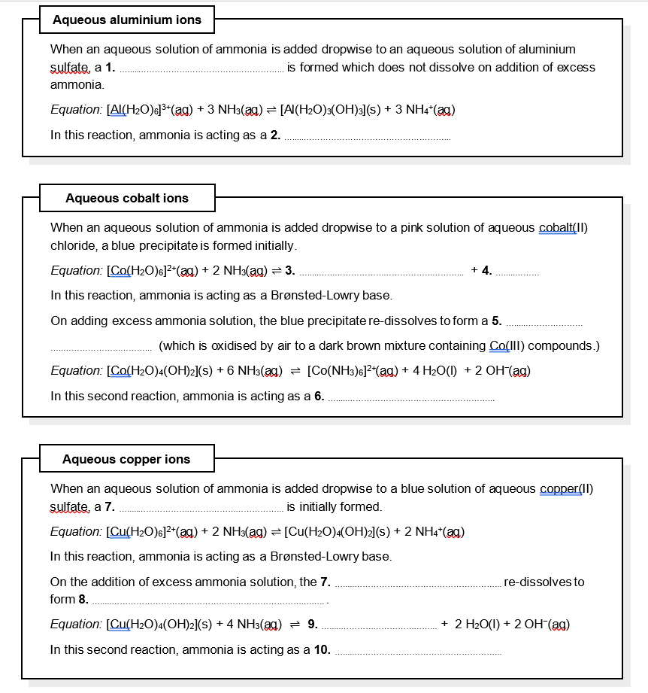
(10 marks)

Ligand substitution reactions

For each of the criteria 1-5 below, identify a ligand substitution reaction starting from [Cu(H₂O)₆]²⁺ and selecting ligands from NH₃, Cl⁻, en (H₂NCH₂CH₂NH₂), C₂O₄²⁻ and EDTA⁴⁻ which meet the criteria required.

Choose a different reaction for each set of criteria, and in each case, draw a 3-dimensional representation of the final product.

- No change in either the coordination number or the overall charge on the complex

- No change in the coordination number of the complex but a change in the overall charge on the complex.

- A change in both the coordination number and overall charge on the complex

- The largest positive change in entropy

- Produces a chiral product

(2 marks each)

Inference from aqueous tests
Use the results of the simple test tube reactions shown below to identify the anion and the cation in each of the unknown salts A-E. Each of the tests were carried out on a small sample of the salt dissolved in water.
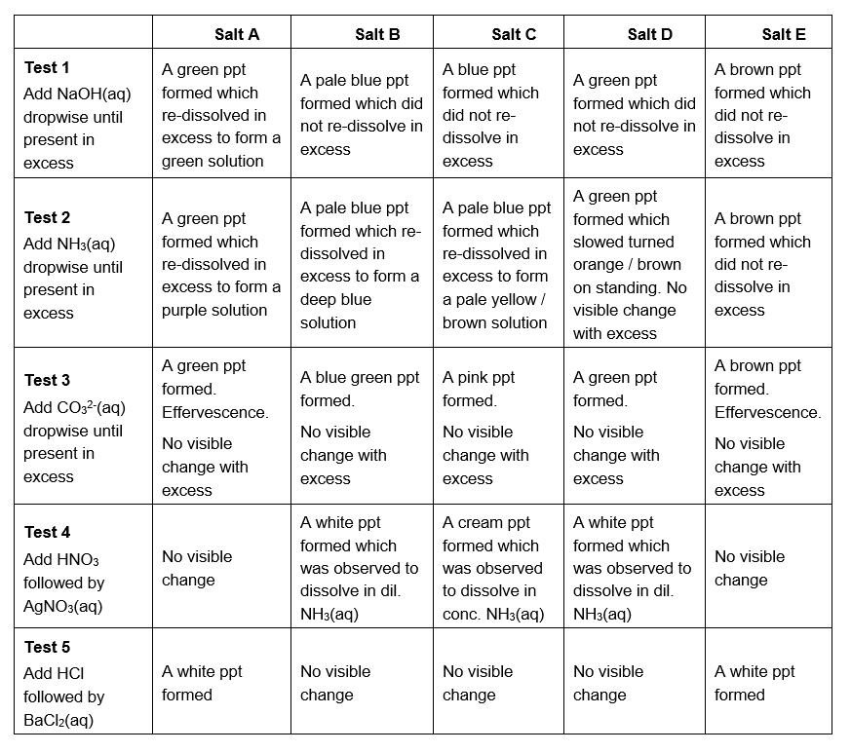
Salt A is (2 marks)
Salt B is (2 marks)
Salt C is (2 marks)
Salt D is (2 marks)
Salt E is (2 marks)

Inorganics in aqueous solution – Answers

Acid-base chemistry

(1 mark for each correct equation with state symbols; 1 mark for each correct full observation)

1. Equation: [Cu(H₂O)₆]²⁺(aq) + 2 OH⁻(aq) ⇌ [Cu(H₂O)₄(OH)₂](s) + 2 H₂O(l)
Observations: Blue solution to a blue precipitate which doesn’t re-dissolve in excess NaOH.

2. Equation: [Fe(H₂O)₆]²⁺(aq) + 2 OH⁻(aq) ⇌ [Fe(H₂O)₄(OH)₂](s) + 2 H₂O(l)
Observations: Pale green solution to a murky green precipitate which is oxidised in the air to orange/brown [Fe(H₂O)₃(OH)₃](s).

3. Equation: [Mn(H₂O)₆]²⁺(aq) + CO₃²⁻(aq) ⇌ MnCO₃(s) + 6 H₂O(l)
Observations: Very pale pink solution to a very pale pink precipitate.

4. Equation: 2 [Fe(H₂O)₆]³⁺(aq) + 3 CO₃²⁻(aq) ⇌ 2 [Fe(H₂O)₃(OH)₃](s) + 3 H₂O(l) + 3 CO₂(g)
Observations: Yellow/brown solution to an orange/brown precipitate and effervescence.

5. Equations: [Cr(H₂O)₆]³⁺(aq) + 3 OH⁻(aq) ⇌ [Cr(H₂O)₃(OH)₃](s) + 3 H₂O(l)
[Cr(H₂O)₃(OH)₃](s) + 3 OH⁻(aq) ⇌ [Cr(OH)₆] ³⁻(aq) + 3 H₂O(l)
Observations: Ruby or green solution to a green precipitate which dissolves in excess NaOH to form a green solution.

Brønsted-Lowry or Lewis base?
1. white precipitate
2. Brønsted-Lowry base
3. [Co(H₂O)₄(OH)₂](s)
4. 2 NH₄⁺(aq)
5. pale yellow/brown solution
6. Lewis base
7. blue precipitate
8. deep blue solution
9. [Cu(NH₃)₄(H₂O)₂]²⁺
10. Lewis base
(10 marks)

Ligand substitution reactions
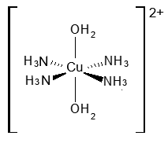
1. [Cu(H₂O)₆]²⁺(aq) + 4 NH₃(aq) ⇌ [Cu(H₂O)₂(NH₃)₄]²⁺(aq) + 4H₂O(l)

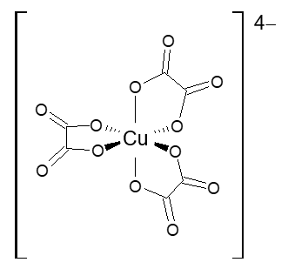
2. [Cu(H₂O)₆]²⁺(aq) + 3 C₂O₄²⁻(aq) ⇌ [Cu(C₂O₄)₃]⁴⁻(aq) + 6 H₂O(l)

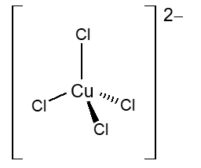
3. [Cu(H₂O)₆]²⁺(aq) + 4 Cl⁻(aq) ⇌ [CuCl₄]²⁻(aq) + 6 H₂O(l)

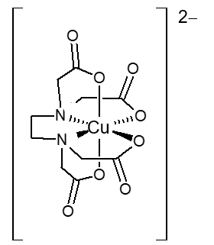
4. [Cu(H₂O)₆]²⁺(aq) + EDTA⁴⁻(aq) ⇌ [CuEDTA]²⁻(aq) + 6 H₂O(l)

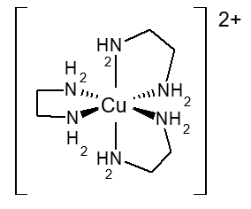
5. [Cu(H₂O)₆]²⁺(aq) + 3 ‘en’(aq) ⇌ [Cu‘en’₃]²⁺(aq) + 6 H₂O(l)

(1 mark for each correct equation, 1 mark for each correct drawing)

Inference from aqueous tests
Salt A is chromium(III) sulfate (2 marks)
Salt B is copper(II) chloride (2 marks)
Salt C is cobalt(II) bromide (2 marks)
Salt D is iron(II) chloride (2 marks)
Salt E is iron(III) sulfate (2 marks)

