Basic practical competencies question sheet

Laboratory equipment

Practical work is a key aspect in the work of a chemist.
To help you plan effective practical work it is important that you are familiar with the common laboratory equipment available to you.

For each of the pieces of glassware shown in the images below, state their name and give a possible volume(s).

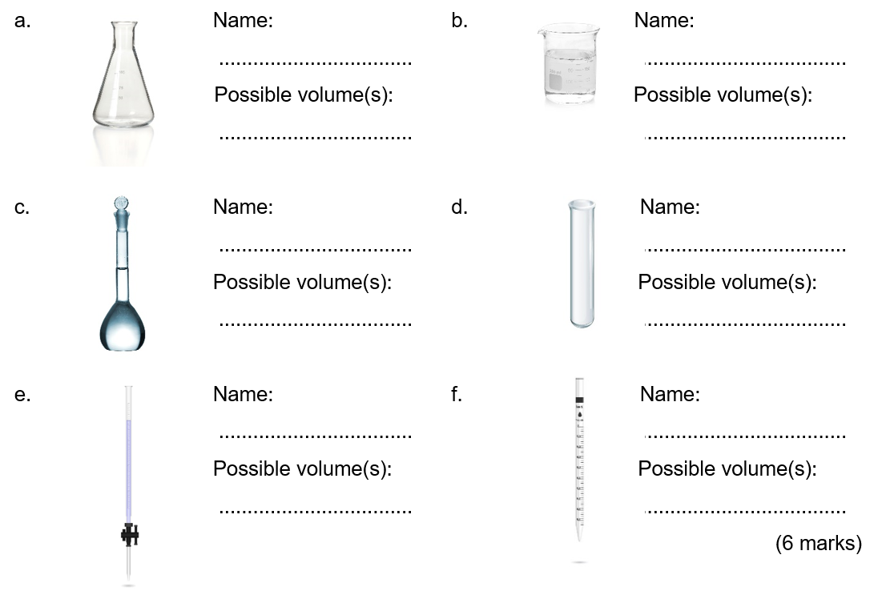

Name the common laboratory equipment in the images below. (4 marks)

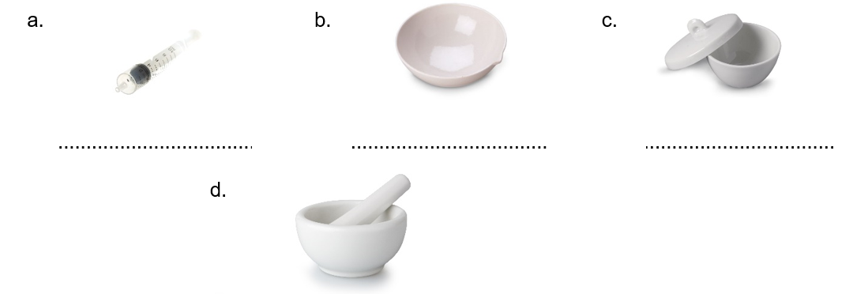

Recording results

- A student is looking at endothermic processes. He adds 2.0 g of ammonium nitrate to 50 cm³ of water and measures the temperature change. He repeats the experiment three times.

His results are shown in the table below.

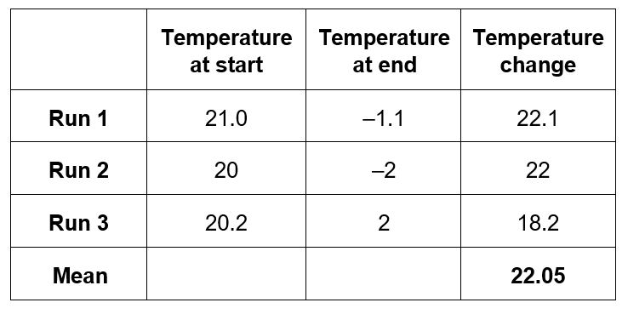
Annotate the table to suggest five ways in which the table layout and the recording and analysis of his results could be improved.
(5 marks)

- For each of the experiments described below, design a table to record the results.

Experiment 1: Simon is investigating mass changes during chemical reactions. He investigates the change in mass when magnesium ribbon is oxidised to form magnesium oxide:

magnesium + oxygen → magnesium oxide

He records the mass of an empty crucible. He places a 10 cm strip of magnesium ribbon in the crucible and records the new mass of the crucible. He heats the crucible strongly until all the magnesium ribbon has reacted to form magnesium oxide. He allows the crucible to cool before recording the mass of the crucible and magnesium oxide.

Experiment 2: Nadiya is investigating how the rate of a reaction is affected by concentration. She investigates the reaction between magnesium ribbon and hydrochloric acid.

magnesium + hydrochloric acid → magnesium chloride + hydrogen

She places 25 cm³ of hydrochloric acid with a concentration of 0.5 mol dm^{–3} into a conical flask and fits a gas syringe. She adds a 3.0 cm strip of magnesium ribbon and measures the volume of hydrogen gas produced every 20 s for 3 minutes.

She repeats the experiment with hydrochloric acid with concentrations of 1.0 mol dm^{–3} and then 1.5 mol dm^{–3}.
(5 marks)

Drawing scatter graphs

When you want to find a correlation between two variables it is helpful to draw a scatter graph.

Key points to remember when drawing scatter graphs include:
- The independent variable (the variable that is changed) goes on the x-axis and the dependent variable (the variable you measured) goes on the y-axis.
- The plotted points must cover more than half the graph paper.
- The axes scales don’t need to start at zero.
- A straight line or smooth curve of best fit is drawn through the points to show any correlation.

Karina is investigating the relationship between the volume of a gas and its temperature.

She injects 0.2 cm³ of liquid pentane (b.p. 36.1 °C) into a gas syringe submerged in a water bath at 40 °C. After 5 minutes she measures the volume of gas in the syringe. She repeats the experiment three times with the water bath at 40 °C.
She then repeats the experiment for temperatures of 50, 60, 70 and 80 °C.

Her results are shown in the table below:
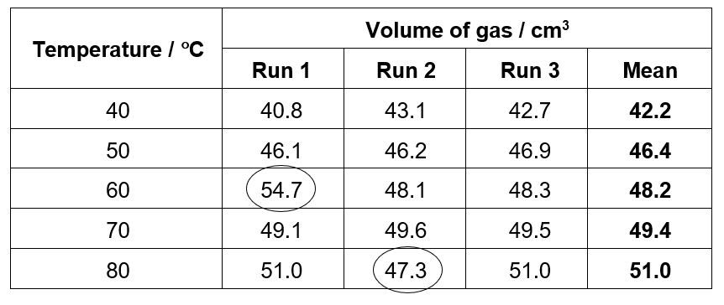
- Plot a scatter graph of the volume of the gas against the temperature. (6 marks)
- Add error bars to show the range of readings used to calculate the mean volume of the gas at each temperature. (2 marks)
- Draw in a line of best fit. (1 mark)
- Describe the correlation observed. (1 mark)

