Choosing lithium – the future of battery power
Education in Chemistry
January 2021
rsc.li/3kypRfO
Lithium-ion batteries are in increasingly high demand. They are used in phones, laptops and tablets. New electric car technologies also rely on lithium-ion batteries. However, lithium has a relatively low abundance in the earth’s crust so demand for lithium compounds may soon outstrip supply.

A salty solution
These questions are about separating mixtures.
- Lithium is an element found on the periodic table.
What is an element?
Answer: An element is a substance made up of only one type of atom.
- Lithium ions are extracted from deep underground in the form of lithium salts.
Circle the word that describes a salt:
element mixture compound
- A source of lithium salts in the UK are hot springs in Cornwall. Proposed Cornish lithium mines will use a process that involves extracting salty water from underground, separating the salts, and then pumping the water back underground again. Salty water is called ‘brine’.
Circle the word that describes brine:
element mixture compound
- What is the name of the process that occurs when a solid salt forms a solution with liquid water?
Answer: Dissolving
- Lithium mining already occurs in parts of South America. They use a method to separate the lithium salts from water where the brine sits in large shallow lakes, called pans, and is allowed to dry out. What is the name of this separation technique?
Answer: Evaporation
- Suggest one reason why drying pans are not suitable for lithium extraction in Cornwall, UK?
Answer: The climate is too cold in the UK for evaporation to occur quickly enough.
The large salt pans would be an eyesore/damage the landscape.

The best metal for the job
These questions are about trends in the periodic table.

Diagram 1
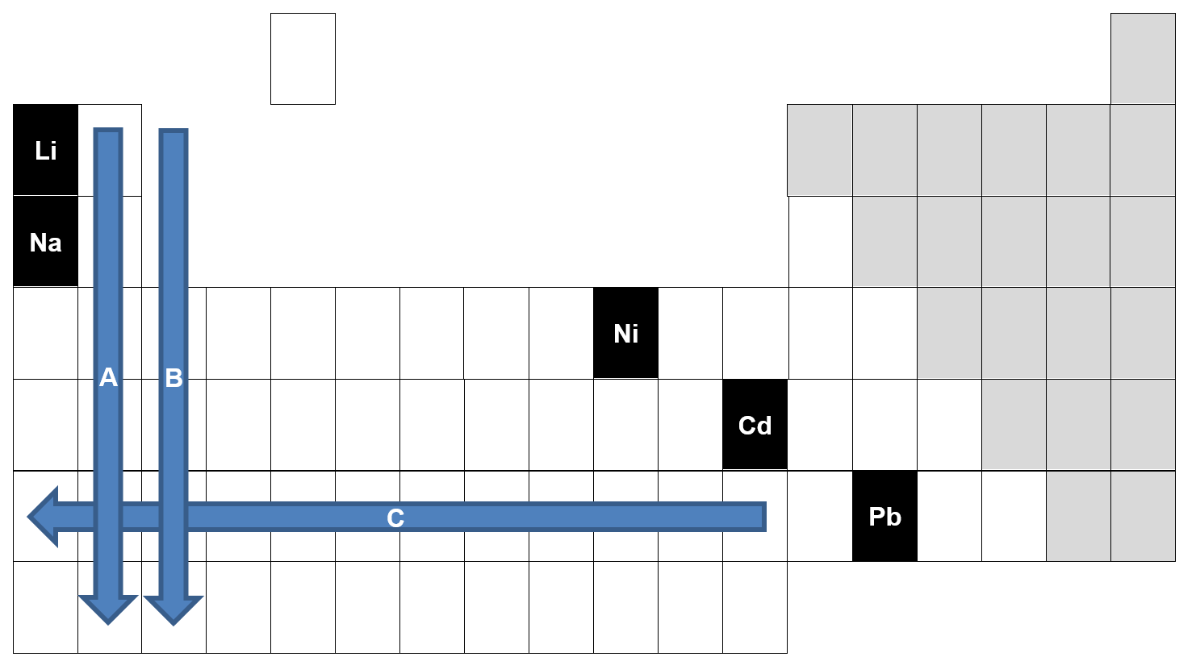
- Diagram 1 shows the position of lithium on the periodic table. What group is lithium in?
Group 1
- Is lithium a metal or a non-metal? How do you know from Diagram 1?
Answer: A metal.
Reason (any one from):
Lithium is on the left-hand side of the periodic table.
The metals and non-metals are separated by the stepped line.
The non-metals are shaded in grey.
Group I is called the alkali metal.
- Arrow A shows the trend in density in group I of the periodic table. What is the trend?
Answer: Density increases down the group.
- Arrows B and C show the trend in reactivity of the metals in the periodic table. What are the trends?
Answer: Reactivity of the metals increases down the group. Reactivity of the metals increases towards the left of the periodic table.

- Nickel-cadmium and lead-ion batteries are alternatives to lithium-ion batteries. 12V lead-ion batteries are used in vehicles with combustion engines. Using the trends from the periodic table make a prediction about the properties of lithium compared to nickel, cadmium and lead.

- Lithium is ( more / less ) dense than nickel because it is further ( up / down ) and further
( left / right ) on the periodic table.
- Lithium is ( more / less ) dense than lead because it is further ( up / down ) and further
( left / right ) on the periodic table.
- Lithium is ( more / less ) reactive than cadmium because it is further ( up / down ) and further
( left / right ) on the periodic table.
- Lithium is ( more / less ) reactive than lead because it is further ( up / down ) and further
( left / right ) on the periodic table.

- Using the properties above decide if the following statements are true or false. Put a tick in the correct box.
Statement | True | False
Lithium is a good choice for phone batteries because it is less dense than nickel-cadmium. This means handheld devices can be made much lighter. | Y
Lithium is a cheaper option than nickel-cadmium because it is less reactive. This means it can be easily extracted from its compounds. |  | Y
Nickel-cadmium is highly reactive, making it easier to get a current flowing through a battery. |  | Y
Lithium is highly reactive which makes it difficult to recycle at the end of the life of the battery. | Y
Lead has a higher density than lithium which makes it unsuitable for fully electric vehicles. | Y

The future of lithium mining
This question is about future developments in science.
Lithium is a comparatively rare metal and demand for lithium-ion batteries is increasing. Car manufacturer, Tesla, has warned of a global lithium shortage in the near future. This means that new lithium mining initiatives like the Cornish proposal are much needed.
However, some scientists believe that sodium may be a better battery material in the future. Sodium is another group I metal and forms a salt, sodium chloride, which is found in seawater.
- Suggest two reasons why scientists believe sodium will be a better source of metal ions than lithium for batteries in the future?
Answer: Seawater is easier to collect.
Seawater is more plentiful.
Sodium is a more common element.
Seawater is free/inexpensive.
Sodium is more reactive than lithium.

