Recycling the undesired enantiomer of naproxen
A context/problem-based learning (C/PBL) resource

Laboratory manual

Nimesh Mistry, Sarah Naramore and George Burslem
University of Leeds

Table of contents
Health and safety 3
General procedures 3
Preparation of naproxen ester 3
Soft enolisation 3
Enzymatic resolution 4
Calculating enantiomeric excess (ee) and enantiomeric ratio by optical rotation 5
Preparing samples for HPLC 5
Spectra 6
¹H NMR – Naproxen 6
¹³C NMR – Naproxen 7
FTIR – Naproxen 8
¹H NMR – Naproxen methyl ester 9
¹³C NMR – Naproxen methyl ester 10
FTIR – Naproxen methyl ester 11

Health and safety
You will be expected to perform your laboratory work in a safe fashion and obey COSHH regulations.
You must read this health and safety guide before starting any experimental work - http://rsc.li/1PWZOwt.

General procedures

Preparation of naproxen ester

Figure 1: Reaction scheme for the preparation of naproxen ester

Dissolve (R)-Naproxen (2 g) in methanol (50 mL) and add H⁺ resin (500 mg) heat to 40 °C for 2 days or until no starting material visible by TLC. Filter the reaction mixture to remove the resin and evaporate the methanol using a rotary evaporator. Dissolve the residue in ethyl acetate (50 mL) and wash with sodium bicarbonate solution (3 x 20 mL), dry over MgSO₄ and evaporate solvent using a rotary evaporator to give (R)-naproxen methyl ester.

Soft enolisation

Figure 2: Reaction scheme for soft enolisation

Dissolve (R)-naproxen methyl ester (0.1 g) in your solvent (2 mL) and add your base and additive. Stir at the temperature of your choice overnight. Dilute the reaction with 1M HCl (5 mL) and extract with ethyl acetate (3 x 10 mL), evaporate the ethyl acetate with a rotary evaporator and measure the enantiomeric ratio of your product using optical rotation or chiral HPLC.
Some example reagents and solvents that you may want to try are given below, however you should not restrict yourself to only using these reagents. You can choose how many equivalents of base and additive to add.

Table 1: Reagents and solvents for enolisation optimisation
Solvent | Base | Additive
THF | Diisopropylethylamine(DIPEA) | MgBr.Et₂O
Dichloromethane (DCM) | Triethylamine | LiCl
MeOH | 1,8-diazabicyclo[5.4.0]undec-7-ene (DBU)

Once you have found your optimised conditions scale up the reaction to a 10 g scale. Check the purity by NMR and purify by recrystallisation from methanol if necessary. Full analysis is needed: NMR, IR, mp, optical rotation and chiral HPLC.

Enzymatic resolution

Figure 3: Reaction scheme for enzymatic resolution

Suspend racemic naproxen methyl ester (0.1 g) in 4 mL of your solvent, add 100 mg of enzyme and stir at the temperature of your choice for 2 days. Dilute the reaction with 1 M HCl (10 mL) and extract with ethyl acetate (3 x 10 mL). Wash the ethyl acetate layers with sodium bicarbonate solution (3 x 10 mL) remove the ethyl acetate using a rotary evaporator and analyse the enantiomeric ratio of the residue by optical rotation or chiral HPLC. Combine the sodium bicarbonate solutions used for washing and acidify them by addition of concentrated HCl (add a few drops at a time until the solution is acidic to pH paper). Extract the aqueous layers with ethyl acetate (3 x 10 mL), evaporate the ethyl acetate on a rotary evaporator and analyse the enantiomeric ratio of the residue by optical rotation or chiral HPLC.
- Solvent choice – phosphate buffer or water
- Available enzymes – Burkholderia Cepacia, Candida Rugosa, Candida Cylindracea, Psudemonas Fluorescens, Porcine Pancreas
- Optional additive – water miscible solvents
Once you have found your optimised conditions scale up your reaction using the material from your scaled up enolisation. Check the purity of your (S)-naproxen by NMR and purify by recrystallisation from toluene if necessary. Full analysis is needed: NMR, IR, mp, optical rotation and chiral HPLC.

Calculating enantiomeric excess (ee) and enantiomeric ratio by optical rotation
Read the instructions for the polarimeter carefully.
Make up a 1 g/mL solution of your sample in chloroform. Weigh your sample carefully
Record the rotation in degrees and use the following formula to calculate the specific rotation:
$$∝_{D}^{T}=\frac{∝}{l×c}=\frac{measured rotation}{path length×concentration}$$
T is the temperature and D means a wavelength of 589 nm was used. The rotation is given in degrees, the path length in dm and the concentration in g/mL.
Calculate the ee of your sample using the following equation:
$$ee=\frac{100× ∝_{D}of your sample}{∝_{D} of pure sample}$$
For (R)-naproxen methyl ester [α]_{D}²⁵ 74.0 (c 1.00, CHCl₃)
For pure (S)-naproxen [α]_{D}²⁵ + 66.0 (c 1.00, CHCl₃)
J. Med. Chem., 1970, 13, 203

Note: Using the enantiomeric excess value obtained, the enantiomeric ratio can be calculated.

Preparing samples for HPLC
Take 5 mg of your pure product and dissolved it in 1 mL of the relevant HPLC eluent in a vial with a septum cap.
Eluent for naproxen analysis – 10:90 isopropanol/hexane
Eluent for naproxen methyl ester analysis – 2:98 isopropanol/hexane

Spectra

¹H NMR – Naproxen
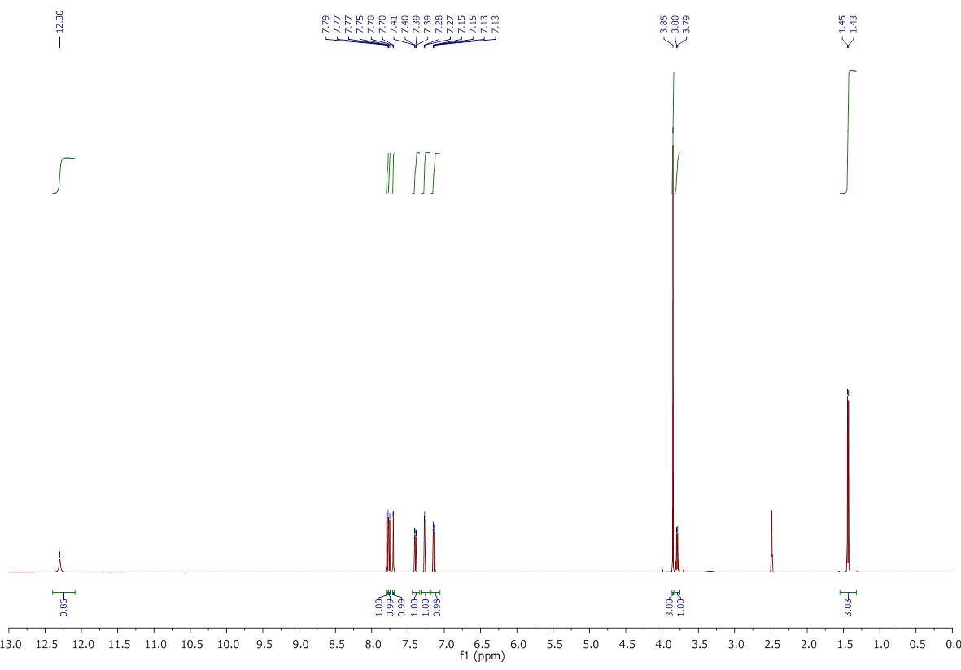

¹³C NMR – Naproxen
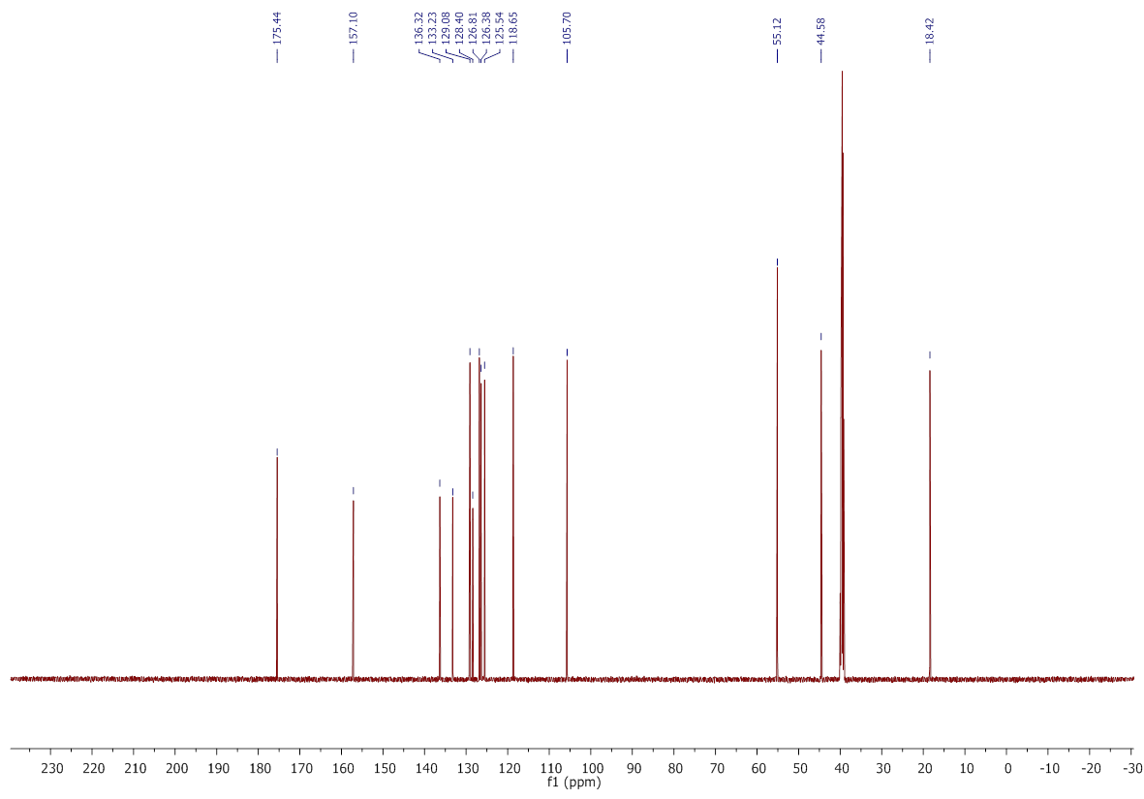

FTIR – Naproxen
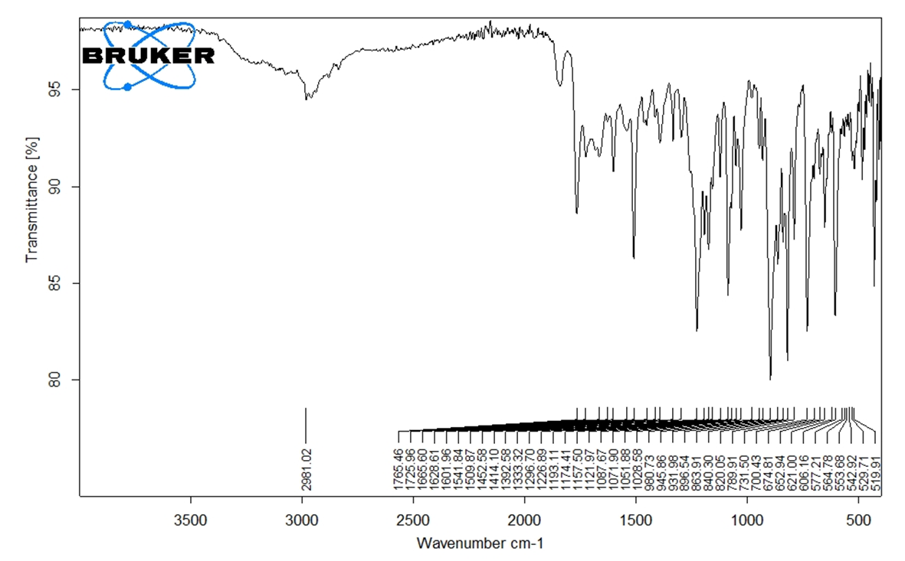

¹H NMR – Naproxen methyl ester
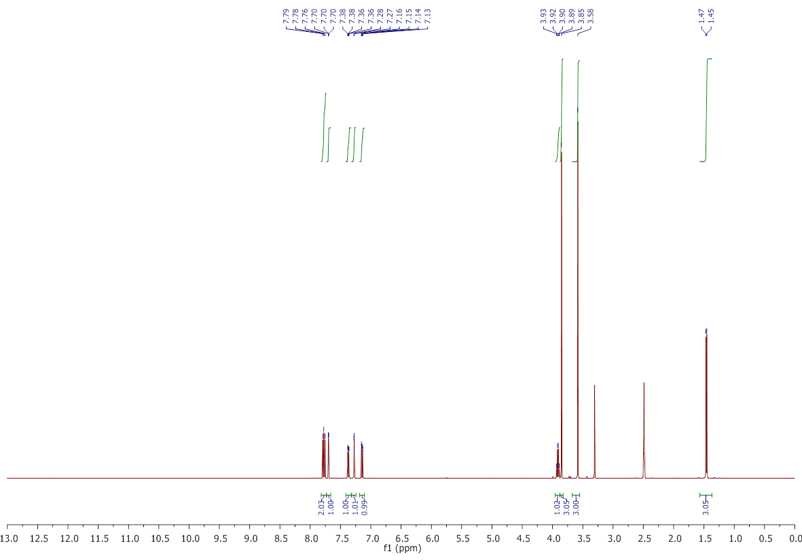

¹³C NMR – Naproxen methyl ester
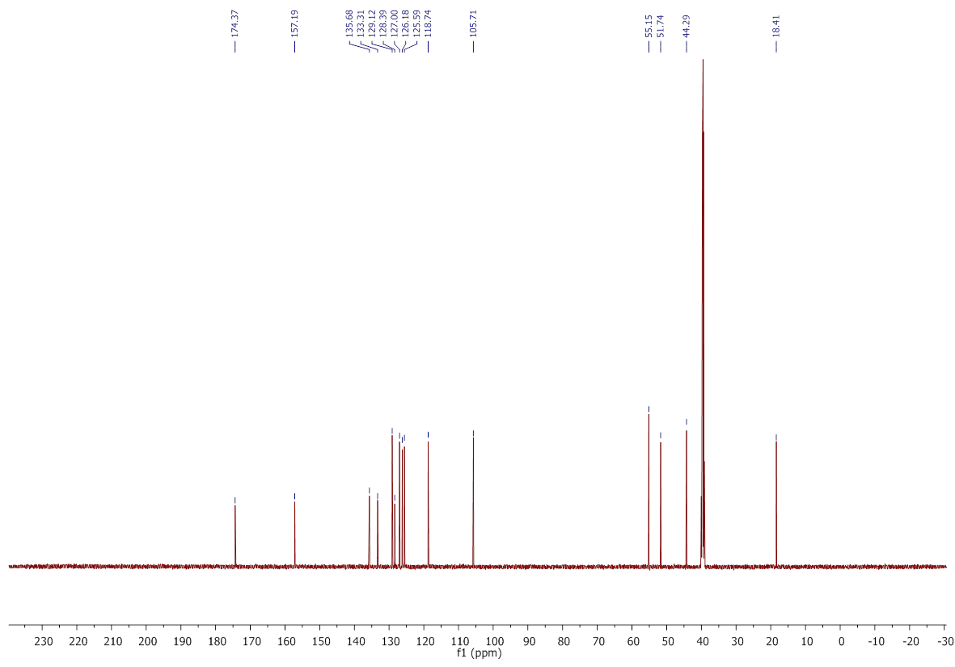

FTIR – Naproxen methyl ester
