Microscale synthesis of aspirin – teacher notes

In this experiment students prepare 2-ethanoyloxybenzenecarboxylic acid (aspirin) from the reaction between 2-hydroxybenzoic acid (salicylic acid) and ethanoic anhydride, using phosphoric acid as a catalyst.

The use of chemical splash goggles is recommended.

The reaction is:

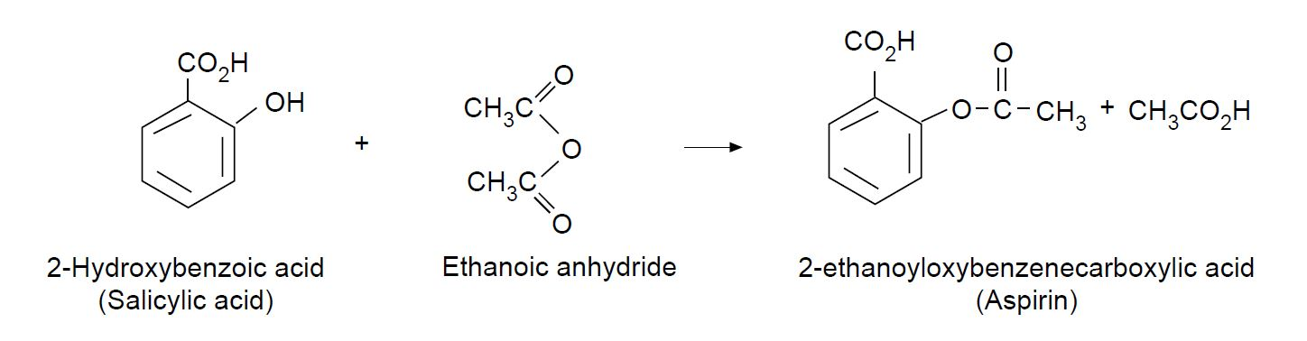

Topic

Medicines and organic synthesis

Timing

20 minutes

Equipment

Apparatus

- Eye protection
- Beaker, 10 cm³
- Hot plate
- Measuring cylinder, 5 cm³
- Beaker, 50 cm³
- Test tube
- Small filter funnel

Chemicals

- 2-hydroxybenzoic acid (salicylic acid)
- Ethanoic anhydride
- Phosphoric acid (85%)

Observations

This esterification reaction, which uses reactive ethanoic anhydride and phosphoric acid catalyst, is quite fast at microscale. A good yield of white crystals should be formed.

Reference

J.Chem.Ed., 1987, 64, 440.

Health, safety and technical notes

- Read our standard health and safety guidance (https://rsc.li/33PrOhX).
- Wear eye protection throughout (splash-resistant goggles to BS EN166 3).
- This experiment should be done in a fume cupboard.
- 2-hydroxybenzoic acid – see CLEAPSS Hazcard HC052. 2-hydroxybenzoic acid (salicylic acid) is HARMFUL if swallowed or in contact with the skin and can cause eye damage.
- Ethanoic anhydride – see CLEAPSS Hazcard HC039. Ethanoic anhydride is CORROSIVE, HARMFUL if swallowed or inhaled and FLAMMABLE.
- Phosphoric acid – see CLEAPSS Hazcard HC072. Phosphoric acid (85%) is CORROSIVE.

