Fermentation of glucose using yeast

Learning objectives
- Carry out and observe a fermentation reaction.
- Test the products of a fermentation reaction.
- Explain the conditions needed for a fermentation reaction.

Introduction

Beer and wine are produced by fermenting glucose with yeast. Yeast contains enzymes that catalyse the breakdown of glucose to ethanol and carbon dioxide.

The equation for the reaction is:

glucose $→$ ethanol $+$ carbon dioxide

$${ C}_{6}H_{12}O_{6}\left(aq\right) → 2C_{2}H_{5}OH\left(aq\right) + 2CO_{2}(g)$$

In this experiment, you will leave a glucose solution to ferment. You will then test the fermentation products. Your teacher may also demonstrate distilling the fermentation mixture to separate the ethanol formed.

Equipment (per group)
- 100 cm³ conical flask
- 50 cm³ measuring cylinder
- Boiling tube
- Boiling tube rack
- Access to a mass balance, correct to 1 decimal place
- Cotton wool
- Safety glasses

Chemicals (per group)
- Glucose, 5 g
- Yeast, 1 g
- Limewater, 5 cm³
- Warm water 30–40°C

Safety and hazards
- Wear eye protection.
- Limewater is an irritant – avoid skin and eye contact.

Procedure

Part 1
- Put 5 g of glucose in the conical flask and add 50 cm³ of warm water. Swirl the flask to dissolve the glucose.
- Add 1 g of yeast to the solution and loosely plug the top of the flask with cotton wool.
- Wait while fermentation takes place. The time it takes will depend on the temperature, how well you mixed the reactants and the yeast’s freshness.
- Add 5 cm³ of limewater to the boiling tube. Avoid contact with your skin as limewater is an irritant.
- Remove the cotton wool and pour the invisible gas into the boiling tube containing limewater. Take care not to pour in any liquid as well.
- Gently swirl the limewater in the boiling tube and note what happens.
- Replace the cotton wool in the top of the flask.

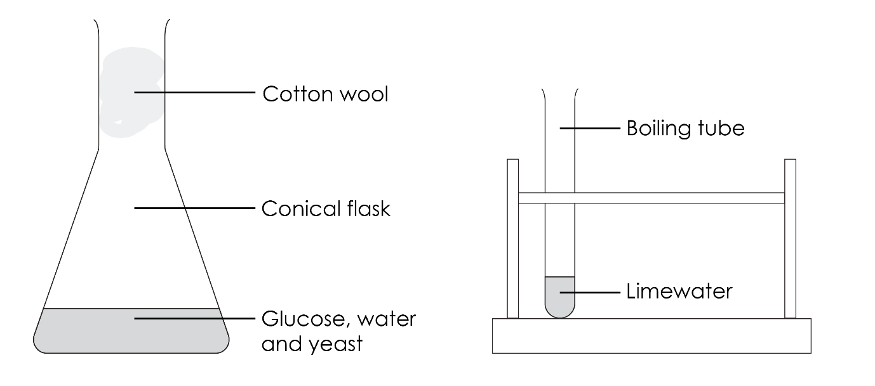

Part 2
- Remove the cotton wool and note the smell of the solution.

If you are going to observe the distillation then you, or your teacher, will:

- Filter all the groups’ solutions into a distillation flask.
- Distil the mixture and collect the distillation fraction between 77–82°C.

The distillation fraction should easily burn.

Questions
- Describe the appearance and smell of the reaction mixture after fermentation has occurred.

__________________________________________________________________________________

__________________________________________________________________________________

__________________________________________________________________________________

- Describe the change in the appearance of the limewater when mixed with the gas produced by fermentation.

__________________________________________________________________________________

__________________________________________________________________________________

- Name the gas produced by the fermentation reaction.

__________________________________________________________________________________

- Explain why the water in the reaction mixture should not be colder than 30°C.

__________________________________________________________________________________

__________________________________________________________________________________

__________________________________________________________________________________

- Explain why the water in the reaction mixture should not be hotter than 40°C.

__________________________________________________________________________________

__________________________________________________________________________________

__________________________________________________________________________________

- Ethanol ($C_{2}H_{5}OH$) burns in oxygen.

Write a balanced equation for the complete combustion of ethanol in oxygen.

__________________________________________________________________________________

- Suggest a method for measuring the rate of reaction for this fermentation.

__________________________________________________________________________________

__________________________________________________________________________________

__________________________________________________________________________________

__________________________________________________________________________________

