- A teacher shows a class an experiment in which liquid paraffin is cracked.
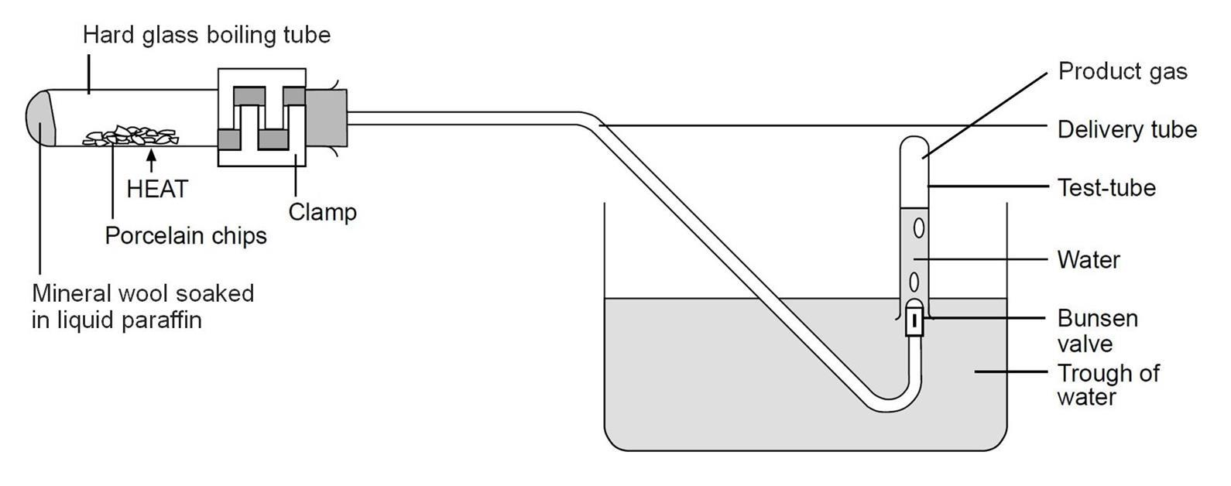
Here is a diagram of the equipment used.
Source: Royal Society of Chemistry

- Suggest what happens to liquid paraffin when it is ‘cracked’.
Answer: The molecules in paraffin are broken down to form smaller molecules.
- Porcelain chips are used because they catalyse the reaction.
What is the meaning of the word ‘catalyse’?
Answer: To make the reaction take place at a faster rate.
- Using the diagram, what evidence is there that smaller molecules are made in the experiment?
Explain your answer.
Answer: A product gas is formed from the liquid paraffin.
The gas has a lower boiling point than the liquid paraffin.
This is because the gas contains smaller molecules.

- Using the diagram, describe how you think the experiment works.
Answer: Liquid paraffin and porcelain chips are heated with a Bunsen flame.
The liquid paraffin boils and turns into a vapour.
The paraffin molecules break down due to heat and the catalyst.
The smaller molecules are then collected in the test tube as a gas.
- What evidence is there from the diagram that the product gas is insoluble in water?
Answer: The product gas is collected over water, and if it were soluble, it would dissolve.

Paraffin is a mixture of large molecules.
The structure of one of these molecules is shown below.
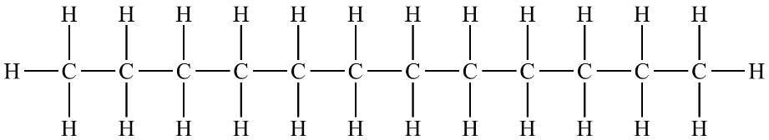

- Which elements are present in the molecule?
Answer: Hydrogen and carbon.
- What is the name of substances containing the elements in part f)?
Answer: Hydrocarbons.
- This molecule is also a member of a homologous series.
What is a homologous series?
Answer: One in which molecules differ by a CH₂ unit.
They also contain the same functional group.
- What is the name of this homologous series?
Answer: The alkanes.
- What is the general formula of the homologous series in part i)?
Answer: C_{n}H_{(2n+2)}
- The molecule above is called dodecane.
What is the molecular formula of dodecane?
Answer: C₁₂H₂₆
- Which of these molecules do not belong to the same homologous series as dodecane?
Write ‘Yes’ or ‘No’ into the right-hand column in the table.

Molecular formula of substance | The same homologous series as dodecane (‘Yes’ or ‘No’)
C₈H₁₆ | Answer: No.
C₁₃H₂₈ | Answer: Yes.
C₅H₁₂ | Answer: Yes.
C₂₃H₄₆ | Answer: No.
C₅₀H₁₀₂ | Answer: Yes.
- The molecules made from cracking long chain molecules can be very useful.
Give a use for these molecules.
Smaller alkanes | Answer: Petrol.
Alkenes | Answer: Polymers / solvents.
- When a long chain molecule is cracked, a substance called ethene is normally made.

- Draw the structure of an ethene molecule.
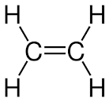

- To which homologous series does ethene belong?
Answer: The alkenes.

Another molecule that has a similar name to ethene is ethane.

One of these molecules is described as ‘saturated’ and the other as ‘unsaturated’.
- What is the meaning of each of these terms?
Answer: Saturated – contains carbon single bonds only.
Unsaturated – contains one or more carbon double bonds.
- Write ‘unsaturated’ or ‘saturated’ in the correct spaces next to the names below:

Ethene | Answer: Unsaturated.
Ethane | Answer: Saturated.
- Complete the word equation that shows octane being cracked to make ethene.
Write the name of the other product into the space.
Octane hexane + ethene

