What is the difference between accuracy and precision?
Education in Chemistry
June 2018
rsc.li/2JaSamI

A result or measurement is accurate if it is close to the true value. A precise result is one where the data points are close together (but there can be a random error). It is therefore possible to have a precise measurement that is not accurate.

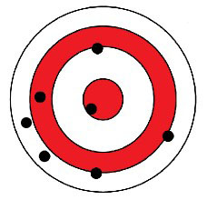 | LOW accuracy  LOW precision

LOW accuracy

HIGH precision
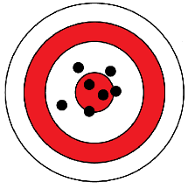 | HIGH accuracy  LOW precision
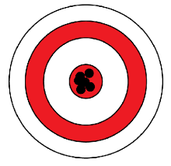 | HIGH accuracy  HIGH precision

