An electrifying lesson
Education in Chemistry
May 2017
rsc.li/EiC317ec

While much of chemistry can be explained to students using classical experiments, there’s no way to authentically visualise electrons transitioning between energy levels. Flame tests provide evidence through line spectra but this demonstration using LEDs offers an even simpler way to demonstrate this complex idea. The experiment is adapted from a classic physics A-level experiment.

Technicians notes

Kit

3 V battery pack or power supply

Potentiometer or rheostat

Different coloured LEDs (use LEDs with clear housing so the colour obviously comes from the component)

Voltmeter

Ammeter or multimeter capable of reading in mA

Wires and crocodile clips

The LED requires a protecting resistor to keep the current below 20mA. You may already have a Planck’s constant kit in school, or LEDs pre-mounted with resistors. If not, use another c.50 Ω resistor

Preparation
Setup the circuit with a red LED; connecting the longer leg to the positive terminal. The potentiometer or rheostat controls the voltage through the LED, set this so the voltmeter reads 0 V. Then set the ammeter or multimeter to record current up to 20 mA, this is the typical maximum safe current for LEDs but it’s recommended to stay below 5 mA.
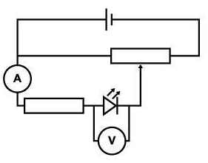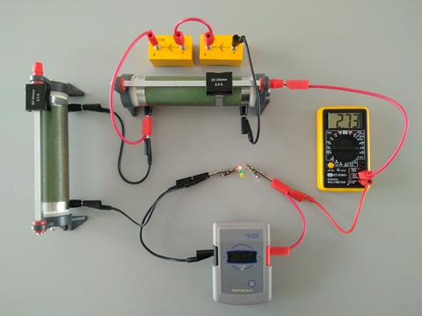

In front of the class
Remind students that electricity is the movement of charge, usually electrons in wires. The rate the electrons are flowing through the circuit is shown by the ammeter or multimeter. The voltmeter reading shows the energy per coulomb transferred by the electrons between the two points where it’s connected.
Adjust the potentiometer or rheostat until the LED becomes visible to the students and note the voltage (probably around 1.6–1.7 V depending on lighting conditions in the room). Note too that the ammeter or multimeter will have just started to show current flowing (probably under 1 mA). Ask your students to suggest what will happen when the red LED is replaced for a green or blue one. The LEDs look identical but the green or blue LED won’t illuminate and the multimeter will probably show no current flowing.
With the same voltage passing through the green or blue LED as that used to light the red one, the electrons can’t cross the barrier, meaning no current flows and no light is released. If you use the potentiometer or rheostat to increase the voltage, each electron will receive more energy allowing them to cross the barrier. This means the current can flow and the higher frequency LED will illuminate. This demonstrates that lower frequencies are associated with less energy, and that if the minimum energy criteria for the transition isn’t met, electrons can’t jump the energy barrier.
For more spectacular demonstrations, take a look at the Exhibition Chemistry archive on the Education in Chemistry website: https://eic.rsc.org/exhibition-chemistry

