Preparation of an organic liquid: supporting resources

This resource supports the practical video Preparation of an organic liquid, available here: https://rsc.li/38LiKx6

Contents

Teacher notes
How to use this video . . . . . . . . . . . . . . . . . . . . . . . . . . . . . . . . . . . . . . . . . . . . . . . . . . . . . . 2
Notes on running the practical experiments . . . . . . . . . . . . . . . . . . . . . . . . . . . . . . . . . . . . . . . . 2
Prior knowledge . . . . . . . . . . . . . . . . . . . . . . . . . . . . . . . . . . . . . . . . . . . . . . . . . . . . . . . . . 3
Common misconceptions . . . . . . . . . . . . . . . . . . . . . . . . . . . . . . . . . . . . . . . . . . . . . . . . . . . 3
Intended outcomes . . . . . . . . . . . . . . . . . . . . . . . . . . . . . . . . . . . . . . . . . . . . . . . . . . . . . . 4
How to use the additional resources . . . . . . . . . . . . . . . . . . . . . . . . . . . . . . . . . . . . . . . . . . . . . 5

Additional resources
Pause-and-think questions: teacher version . . . . . . . . . . . . . . . . . . . . . . . . . . . . . . . . . . . . . . . . 6
Pause-and-think questions: student version . . . . . . . . . . . . . . . . . . . . . . . . . . . . . . . . . . . . . . . . 8
Follow-up worksheet . . . . . . . . . . . . . . . . . . . . . . . . . . . . . . . . . . . . . . . . . . . . . . . . . . . . . . 9
Follow-up worksheets: answers . . . . . . . . . . . . . . . . . . . . . . . . . . . . . . . . . . . . . . . . . . . . . . . . 10

Teacher notes

This resource supports the practical video Preparation of an organic liquid, available here: rsc.li/38LiKx6

The value of experiencing live practical work cannot be overstated. Numerous studies provide evidence of its value in terms of learner engagement, understanding, results and the likelihood of continuing to study chemistry or work in a related field. This video can be used to complement live practical work, as well as helping learners to understand the methods, equipment and skills when they cannot access the lab.

How to use this video
The video and additional resources are designed to be used flexibly, but some suggestions follow.

Flipped learning
Learners view the video ahead of the live practical lesson to help it run more smoothly and keep objectives in focus. This may also help build confidence for some learners and improve their outcomes in the lesson. Use questions from the pause-and-think set provided as part of the preparation task.

Consolidation and revision
Learners view the video after the practical – this may be directly after the lesson or learners can return to it as part of revision for examinations.

Revisiting a practical with a different focus
A practical experiment can support many learning outcomes. Focusing on just one or two of those in a lesson will help ensure that the aims are achieved. The video could be used to revisit the experiment with a different focus.

Home learning
Whether it is remote teaching, homework, or individual learner absence, the video provides an opportunity to engage with a practical experiment and the associated skills when learners are not in the lab.

Other tips
- Provide your own commentary
Mute the voice over and provide your own commentary. This will allow you to better engage with learners and adapt to the needs and objectives of your lesson.
- Use questions
A set of pause-and-think questions are provided in two formats, one for teacher-led questions and discussion and a student worksheet which can be used independently by learners. Select from these or create your own questions to help engage learners and target specific aims.

Notes on running the practical experiment
Technician notes including the equipment list and safety notes are available as a separate document here: rsc.li/38LiKx6. If you are planning to carry out the practical, you will need to carry out your own risk assessment.

All UK specifications aimed at learners 16–18 years include some form of synthesis of a pure organic liquid or solid. Learners will need to appreciate that organic synthesis can involve multiple reactions, followed by separation and purification steps. This purification process is generally more complex than the initial preparation and learners should understand why purification is so important when creating chemical compounds – connect to real-world examples, such as the preparation of medicines.

There are multiple steps involved in this practical providing a good opportunity for learners to practice a number of experimental techniques and procedures. Help them to make links to different situations and processes where the same techniques are used, eg a separating funnel is used whenever we have two immiscible liquids we want to separate.

With multi-step experiments, it’s easy for students to follow instructions unthinkingly without pausing to appreciate the underlying chemistry behind each step. Using the video as support will help learners feel more confident with the procedures and gain a better understanding of the reason for each task before they carry out the live practical – allowing them to develop the skills along with this understanding in the laboratory.

Instructions for learners
A student sheet with instructions for carrying out the experiment is available here: rsc.li/38LiKx6 .

Further practical activities
Complete the process by testing the organic sample for purity using Thin layer chromatography.

A related experiment based on preparation of an organic solid is shown in our Aspirin screen experiment. This is an interactive experiment to walk students through the experimental process of preparing an organic solid.

Prior knowledge
The video and resources assume the following prior knowledge:
- Nucleophilic substitution reaction of alcohols.
- Separation techniques:
  - Separating funnel used for immiscible liquids – polar/non-polar solute and solvents – organic haloalkane will not bond with aqueous solvent, which is why separating funnel can be used.
- Often reagents used are either acidic or alkaline and that neutralisation is an important step after the product is made to neutralise any unreacted reagent.
- Distillation as a separation technique when the product we are interested in has a different boiling temperature to the other compounds in the mixture.
- How to complete a TLC chromatography test (if learners have only done paper chromatography use this as the base with some additional teaching at the time).

Common misconceptions
Be aware of misconceptions learners may have around this practical, for example:
- Purity in chemistry is not the same as purity in other contexts. A pure element or compound contains only one substance. So pure water in chemical terms is H₂O molecules with nothing mixed in. This is unlike the ‘real-world’ view of pure water, often meaning water from a tap or mountain spring – these water samples will contain dissolved minerals, so are not chemically pure.
- Not understanding the need for purification. With a liquid the visible different layers help to introduce the need to separate the product, but impurities remain even when layers are no longer visible – as demonstrated in the later steps of this practical. This misconception can be more of a problem with an organic solid as the crude product formed appears to be a pure substance although it contains impurities that need to be removed. It is worth going into what and why impurities can occur in the first place to avoid rote learning of the phrase ‘to remove impurities’ without understanding what these actually are.
- Learners can struggle to realise that each technique has a purpose and can therefore be used in various synthesis routes – these techniques are not limited to this practical only. To combat this, focus on the rationale behind why each technique is used and discourage learners from copying mechanical processes without understanding why they are doing each step.

Intended outcomes
It is important that the purpose of each practical is clear from the outset, defining the intended learning outcomes helps to consolidate this. Outcomes can be categorised as hands on, what learners are going to do with objects, and minds on, what learners are going to do with ideas to show their understanding. We have offered some differentiated suggestions for this practical. You may wish to focus on just one or two, or make amendments based on your learners’ own needs. (Read more at rsc.li/2JMvKa5.)
Consider how you can share outcomes and evaluations with learners, empowering them to direct their own learning.

Hands on Minds on

Effective at a lower level Learners correctly:
- follow instructions to carry out the experimental techniques or procedures safely
- successfully complete each stage of the process and synthesise a pure organic liquid

Effective at a higher level Learners correctly:
- set up the distillation equipment, making appropriate checks and successfully collect the product in the correct temperature range
- carry out appropriate testing of the sample prepared, to test for purity

Learners can:
- understand that a large part of the process is not the making of the products but the separation and purification, followed by testing
- understand the chemistry behind key steps in synthesis of organic substances
- know which substances are removed to purify the product: water, unreacted reactants, by-products

Learners can:
- use their knowledge of organic chemistry and testing processes to plan appropriate tests for the prepared sample
- measure mass of organic product and calculate percentage yield from experimental data

How to use the additional resources

Using the pause-and-think questions
Pause-and-think questions are supplied in two formats: a teacher version for ‘live’ questioning and a student version which can be used during independent study. The time stamps allow you to pause the video when presenting to a class, or learners to use for active revision.

Teacher version
The questions are presented in a table and you can choose to use as many as appropriate for your class and the learning objectives.

Some questions have two timestamps to allow you to adapt the questions for different classes or scenarios. Pause the videos at the earlier timestamp to ask a question before the answer is given, useful for revision or to challenge learners. Pause at the later timestamp to ask a question reflectively and assess whether learners have understood what they have just heard or seen. This would be useful when introducing a topic, in a flipped learning scenario or when additional support and encouragement is needed.

Think about how you will ask for responses. Variation may help to increase engagement – learners could write and hold up short answers; more complex questions could be discussed in groups.

Not all answers to questions are included in the video. Some of the questions will draw on prior learning or extend learners’ thinking beyond the video content.

Student version
The same questions are offered as a printable worksheet for learners. Use in situations where there is not a teacher present to guide discussion during the video, for example homework, revision or remote learning.

Using the follow-up worksheet
A follow-up worksheet has been included as part of this resource. This worksheet could be used to follow up the practical activity, for example as homework or a revision exercise.

Pause-and-think questions

Teacher version

Timestamp(s) | Question | Answer/discussion points
00:20/00:24 | What is the structural formula for the organic product being prepared:  2-chloro-2-methylpropane?  (CH₃)₃CCl | 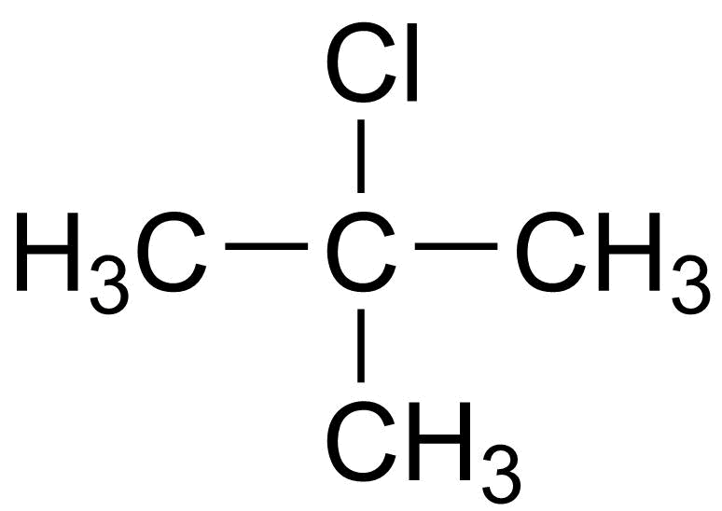
00:24 | What type of functional group does the target molecule contain? | Haloalkane.
01:16 | What is the structural formula of the starting organic reactant:  2-methylpropan-2-ol?
01:16 | What is the classification of this alcohol? | Tertiary.
01:17/01:22 | What are the risks associated with each of the starting reactants? | 2-methylpropan-2-ol (C₄H₁₀O)  DANGER  Flammable  Corrosive (eyes)  Irritant (skin, respiratory)  May cause drowsiness or dizziness  Concentrated hydrochloric acid (HCl (aq))  DANGER  Corrosive (skin, eyes)  Irritant (respiratory)
01:17/01:22 | What actions can we take to control these risks? | Wear eye protection (goggles); avoid inhaling fumes – work in a fume cupboard; keep away from naked flames; take particular care to avoid skin contact.
01:39 | Why is the presenter wearing gloves for this task? | The gloves are to protect skin from the mineral wool – note that note that CLEAPSS does not recommend wearing gloves to dispense concentrated hydrochloric acid (unless wounds or skin conditions exist) as it can be difficult to find the correct gloves and there might be a loss of dexterity.
01:41/01:43 | What is the purpose of the mineral wool bung? | The reaction between the acid and alcohol is exothermic and generates significant fumes at room temperature.
02:03 | This reaction takes place between the starting reactant 2-methylpropan-2-ol and a Cl⁻ nucleophile. Define a nucleophile. | A species which has a free lone pair of electrons to donate and create a bond.

02:03 | What type of reaction is taking place? | Nucleophilic substitution.
02:40/02:44 | Why do we have two layers in this mixture? | The cloudy layer is the aqueous layer. The clear layer is the organic layer containing the organic substance. They separate because the haloalkane compound is not soluble in water. This is because it cannot form hydrogen bonds with the water molecules to replace the strong hydrogen bonds between the water molecules themselves.
03:04 | What do you think could be in the organic layer requiring further purification? | Traces of water.  Unreacted excess hydrochloric acid.
03:16/03:22 | What step can be taken to remove unreacted hydrochloric acid from the sample? What is the name of this reaction? | React with an alkali and separate using a separating funnel.  A neutralisation reaction.
04:03/04:07 | How do we know all excess acid has been removed? | Effervescence stops – carbon dioxide gas is no longer produced.
05:12 | How will we know when all the final traces of water have been removed by the sodium sulphate? | When we add the sodium sulphate and it does not clump indicating all traces of water have been removed.
05:56 | How does the specific collection of product in a set temperature range increase the accuracy of the purification process? | As we know the boiling point of the product we want to collect, we only collect liquid from the distillation within the appropriate temperature range and can remove substances which do not have this boiling point and are therefore impurities. This process also indicates purity of the sample with a sharp (specific) boiling point indicating pure product and a range of boiling points indicating an impure product.
06:08 | What checks should you perform on the distillation apparatus before beginning the process? | Check water in and out on condenser: water inlet is at the bottom of the condenser and the outlet is at the top.  Check joints are secure and safe.  Check height of the thermometer in the apparatus – should be directly in line with the side arm.

Pause-and-think questions

Student version
Pause the video at the time stated to test or revise your knowledge of these practical experiments.
Time Question
00:20 What is the structural formula for the organic product being prepared: 2-chloro-2-methylpropane (CH₃)₃CCl?
00:24 What type of functional group does the target molecule contain?
01:16 What is the structural formula of the starting organic reactant 2-methylpropan-2-ol?
01:16 What is the classification of this alcohol?
01:17 What are the risks associated with each of the starting reactants?
01:17 What actions can we take to control those risks?
01:39 Why is the presenter wearing gloves for this task?
01:41 What is the purpose of the mineral wool bung?
02:03 This reaction takes place between the starting reactant 2-methylpropan-2-ol and a Cl- nucleophile, what is a nucleophile?
02:03 What is the name of the mechanism for the reaction?
02:40 Why do we have two layers in this mixture?
03:04 What do you think could be in the organic layer requiring further purification?
03:16 What step can be taken to remove unreacted hydrochloric acid from the sample? What is the name of this reaction?
04:03 How do we know all excess acid has been removed?
05:12 How will we know when all the final traces of water have been removed by the sodium sulphate?
05:56 How does the specific collection of product in a set temperature range increase the accuracy of the purification process?
06:08 What checks should you perform on the distillation apparatus before beginning the process?

Follow-up worksheet

The video Preparation of an organic liquid, available at: rsc.li/38LiKx6 shows the synthesis of 2-chloro-2-methylpropane from 2-methylpropan-2-ol and concentrated hydrochloric acid.

- Show the reaction, including the structural formulas for the organic products.
- Why is Na₂CO₃(aq) added to the product of the reaction?
- What type of reaction takes place between 2-methylpropan-2-ol and concentrated hydrochloric acid?
- Draw out the mechanism for the reaction (show fully with correct curly arrows).
- 2-chloro-2-methylpropane contains the haloalkane functional group. What test could be used for this functional group in the product we make?
- Draw a simple hydrogen bond between two water molecules.
- Draw a simple hydrogen bond formed between water and an alcohol.
- Is 2-chloro-2-methylpropane soluble in water? Explain your answer.
- 2-methylpropan-2-ol has a density of 0.775 g/cm³. Calculate the mass of the compound used in this preparation (6.5 cm³)?
- Calculate the moles used in the reaction.
- If we produced 1.49 g of 2-chloro-2-methylpropane what was the % yield?
- State possible reasons for not achieving 100% yield in this reaction.

Follow-up worksheet: answers

The video Preparation of an organic liquid, available at: rsc.li/38LiKx6 shows the synthesis of 2-chloro-2-methylpropane from 2-methylpropan-2-ol and concentrated hydrochloric acid.

- Show the reaction, including the structural formulas for the organic products.
+ HCl + H₂O

- Why is Na₂CO₃(aq) added to the product of the reaction?
To react with the excess Acid added in the reaction stage.

- What type of reaction takes place between 2-methylpropan-2-ol and concentrated hydrochloric acid?
Nucleophilic substitution.

- Draw out the mechanism for the reaction (show fully with correct curly arrows).
- 2-chloro-2-methylpropane contains the haloalkane functional group. What test could be used for this functional group in the product we make? What would we expect to see?
Add sodium hydroxide solution and ethanol to the sample and warm. Then add a few drops of nitric acid before testing with silver nitrate solution. A white precipitate will form AgCl(s) indicating the presence of chloride ions.

- Draw a simple hydrogen bond between two water molecules.
- Draw a simple hydrogen bond that could form between water and an alcohol.
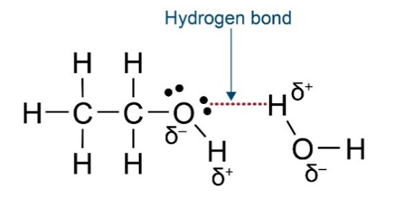

- Is 2-chloro-2-methylpropane soluble in water? Explain your answer.
No. It cannot form hydrogen bonds with the water molecules to replace the strong hydrogen bonds between the water molecules themselves.

- 2-methylpropan-2-ol has a density of 0.775 g/cm³. Calculate the mass of the compound used in this preparation (from 6.5 cm³)?
mass = density x volume
= 0.775 x 6.5
= 5.0375 g allow 5.038 g
- Calculate the moles used in the reaction.
moles = mass / M_{r}
= 5.038 / 74
= 0.0681 moles
- If we produced 1.49 g of 2-chloro-2-methylpropane what was the % yield?
Actual yield: 1.49 g
Theoretical yield
= moles x M_{r}
= 0.0681 x 92.5
= 6.30 g

% yield = actual / theoretical x 100
= 1.49 / 6.30 x 100
= 23.7%
- State possible reasons for not achieving 100% yield in this reaction.
- production of by-products in the reaction
- incomplete reaction
- loss of product in the separation/purification steps

