Freaky hand

Freaky hand demonstration: A demonstration video can be viewed at rsc.li/3wCxjww
The investigation enables learners to visualise the way that gases expand as well as allowing discussion about reversible and irreversible changes.

Age group: 9–11

Learning objectives
- To describe the difference between a reversible and an irreversible change.
- To explain that mixing some materials can result in the formation of new ones (in this case, one of these is carbon dioxide) and that this kind of change is not reversible.
- Understand that gases expand to fill their container.
Enquiry skills:
- To be able to use results to make predictions to set up further comparative and fair tests.

Background science
Learners may know that carbon dioxide (CO₂) is the gas in fizzy drinks.
Carbon dioxide is used in many industries. For example:
- In bakeries, baker’s yeast produces CO₂ by fermentation of sugars within the dough, which helps their bread to rise.
- Popping candy has pressurised carbon dioxide gas embedded in the candy. When the candy dissolves, it ‘pops’ as it bursts in the mouth.
- Fire extinguishers, especially those used for electrical fires, use pressurised carbon dioxide to extinguish flames.
When bicarbonate of soda mixes with vinegar there is a chemical reaction which produces new materials, including carbon dioxide. The gas expands and will spread throughout its container. If it cannot escape, as more gas is created, pressure (the push on areas of the container) builds up. (This may be great enough to burst the container.)

Prior learning
Learners must have an understanding of the properties of solids, liquids and gases and the behaviour of their molecules in each state.
Learners must also have investigated reversible changes and be able to give examples of reversible changes.

Links
The creation of carbon dioxide using these ingredients is also used in the investigations Bath bombs and Lava lamp. Extinguishing a flame using carbon dioxide can be done in Fire extinguisher.

Key words and definitions
Reversible change – a change where no new materials are created and the original material can be recovered. Examples include melting, evaporating, freezing and dissolving.
Irreversible change – a chemical change where new materials are formed.
Expand – to move apart or get bigger.
Gas – a ‘state of matter’ where particles have high energy and large spaces between them. A gas takes the shape of the container it is in and will flow.
Variable – a condition or object that is observed or measured that could change during a science experiment, eg temperature or amount of substance.
Teachers may wish to hide the meanings/examples on the PowerPoint slide and discuss the learners’ ideas first.

Equipment list
- Disposable, stretch latex gloves (do not use washing up gloves) *allergies
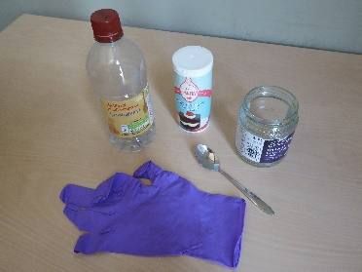
- Bicarbonate of soda
- Vinegar
- Teaspoon
- Small jam jar, cup or beaker (neck should be wide enough to give a tight seal with the gloves)
Latex gloves will be available at most supermarkets. However, you can also source medical gloves at pharmacies and through school and online suppliers. If you have learners who are allergic to latex, use Nitrile or PVC gloves. Do not use washing up gloves, as they are too heavy for the experiment to work effectively.

Method
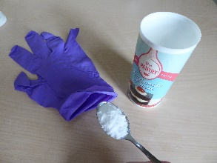
This experiment is simply an old party trick that the learners may have seen before. Before they see the freaky hand, ask the learners what they predict will happen when the vinegar and bicarbonate of soda mix together.
Start with a demonstration:
- Fill the jar with approximately 60 ml of vinegar (about ¼ of a cup).
- Place two heaped teaspoonfuls (~15 g) of bicarbonate of soda into the fingers of the gloves.

- Carefully place the bottom of the glove over the jar. Be careful not to spill any powder into the jar and make sure that the glove is tightly over the jar.
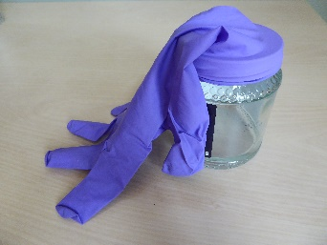
- Tip the powder from the glove into the jar. You may need to shake each finger to release all the powder.
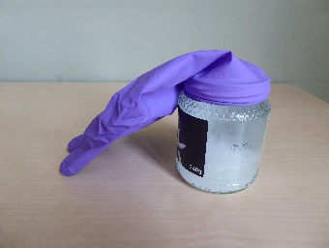
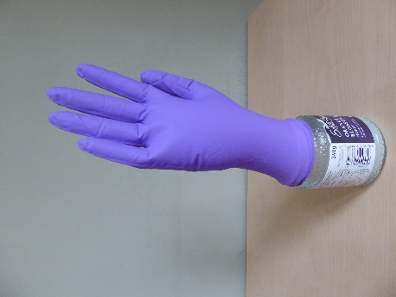
The glove should slowly inflate as the carbon dioxide gas is produced from the chemical reaction between the vinegar and the bicarbonate of soda.
NOTE: Depending on the size of the jar, you may need to experiment by adding more or less of each substance. If you add too much of each substance, the gas may exert so much pressure inside the glove that it bursts off the jar. If you do not have enough of each substance, there may not be enough gas produced to inflate the glove.
Carbon dioxide is produced in a number of everyday chemical reactions. Effervescent tablets, such as Alka Seltzer or fizzy vitamin tablets (which are designed to dissolve in water) also produce carbon dioxide and can be used to inflate a glove in the same way.
After seeing the demonstration, learners can discuss and plan their own investigations.
Explore with them which variables they could change and investigate. For example, could the amount of vinegar or bicarbonate of soda affect the amount of gas produced? This would be an excellent starting point for planning a pupil-led fair test. Support learners to carry out their own tests on a ‘freaky hand’.

Question prompts
- How do we know that a gas is produced?
When you add the powder, it starts to become foamy and fizzy. The hand will start to inflate.
- Can you see any change to the liquid?
Once the foaming and fizzing stops you will see that the vinegar looks like fizzy juice. This is because there is carbon dioxide in the liquid.
- How do we know that this an irreversible reaction?
A new material (carbon dioxide) is produced. We cannot put the carbon dioxide back into the vinegar and bicarbonate of soda mixture. Therefore, we cannot reverse the reaction.
- What do you think would happen if you diluted the vinegar or added more bicarbonate of soda?
If you dilute the vinegar or changed the quantities, you will produce different quantities of carbon dioxide. You can test this by repeating the experiment with different concentrations of the vinegar or with more or less of the bicarbonate of soda.
- What do you predict would happen if you used a thicker glove?
You can test this by using different gloves. The thin glove is easier to inflate.
- Can you think of any other chemical reactions that produce carbon dioxide? Other reactions of acids and alkalis release carbon dioxide, for example citric acid and bicarbonate of soda in sherbet sweets. Burning fossil fuels also releases carbon dioxide.

FAQs
- Will this reaction inflate other objects?
Yes, you can use the same chemical reaction to inflate a balloon covering the mouth of a bottle, or a plastic bag tied over the mouth of a jar with an elastic band. This is an excellent opportunity to allow learners to design their own experiments and test their predictive skills based on their prior knowledge.
- How much bicarbonate of soda and vinegar would it take to make the glove burst from the jar?
This is another a brilliant question to begin to design further investigation using fair testing. Learners will need to use a significant amount of reactants to build enough pressure for the glove to burst from the jar. It may, however, result in a very smelly classroom. Definitely an investigation to consider taking outdoors!
- Will the glove stay inflated?
Eventually the glove will become deflated, as the material of the glove is not completely airtight. Molecules of gas will escape and the pressure inside the glove will be reduced. The same thing happens when you blow up party balloons – after a few days they become deflated because molecules of gas have escaped through the membrane of the balloon or any point of tying/sealing. You could test this by leaving the jar and glove on the side in the classroom and seeing how long it takes to deflate.

All images © Royal Society of Chemistry.

