Large molecules
Contents
- Guidance notes
- Learning objectives
- Starter activity: how might chemistry help?
- Introducing polymers
- Activity 1: modelling polymerisation
- Activity 2: polymerisation
- Activity 3: thermosoftening polymers
- Quick quiz: polymer review

Acknowledgements
This resource was originally developed by Liverpool John Moores University to support outreach work delivered as part of the Chemistry for All project.
To find out more about the project, and get more resources to help widen participation, visit our Outreach resources hub: rsc.li/3CJX7M3.

Guidance notes
This activity should take approximately one hour to complete in full. It was initially created for 11–14 year-old learners but can be adapted when teaching polymers to other age groups.
Download the PowerPoint presentation, technician notes and student workbook that accompany this resource at rsc.li/3yPjVIC.
In this activity, learners review monomers and polymers and look at a thermosoftening polymer.
There are also career profiles throughout the resource to highlight the value and importance of science. Use them to show learners how chemistry can lead to interesting and well-paid jobs.
Read our health & safety guidance, available from rsc.li/3IAmFA0, and carry out a risk assessment before running any live practical.
The safety equipment suggested is in line with CLEAPSS requirements. For non-hazardous substances, wearing lab coats can help to protect clothes. The safety rules might be different where you live so it is worth checking local and school guidance.
Learning objectives
- Identify the properties of a monomer.
- State what a polymer is.
- Explain the similarities and differences between polymers.
- Describe the properties and uses of thermosoftening polymers.

Starter activity: how might chemistry help?
(5 minutes)
Project slide 3 of the PowerPoint on the board as learners enter the room. It asks, ‘How might chemistry help?’
As learners enter the room, ask them to look at the PowerPoint slide and to discuss the question, ‘Why is chemistry important in each of these jobs?’ in groups of four.
Give learners four minutes to discuss their ideas before sharing as a class.
Possible suggestions for points of discussion:
- Physiotherapist – Link chemistry to the design of physiotherapy equipment and materials used for splints, supports and tape to help recovery from injuries.
- Diver – Link chemistry to the design and material used for diving suits. Ask learners about the breathing apparatus and gas supplied while the diver is under the water.
- Research scientist – Link chemistry skills and knowledge to the ability to understand problems and create solutions in a wide range of areas such as medicine, material science and reducing pollution.
Patent attorney
Tell learners there are lots of examples of jobs they may not have considered as having any links to chemistry. Introduce them to Charley, a patent attorney, by watching his video job profile on slide 4 and at rsc.li/3JR4Yfx. He uses his chemistry skills and knowledge to understand research into problems to get legal protection for inventions, such as new medicines or compounds for carbon capture.

Introducing polymers (5 minutes)
Use slides 5–7 of the PowerPoint to introduce:
- the idea of polymers being the basis of most manufactured materials
- monomers and polymers
- the mechanism of how monomers bond to become polymers.
Slide 5 asks learners to consider what the four materials have in common. (Answer: they all contain carbon-based polymers.)
Slide 6 introduces polymers. Point out to learners that polymers are all around them. Tell them that their school blazers (or other clothing), laminating sheets, DNA, glue and most ‘plastic’ items in the room will contain polymers.
Senior director of chip research
Introduce learners to Jason, a senior director of chip research, who uses his chemistry skills and knowledge to sequence DNA and identify viruses or new species. Watch his video job profile on slide 6 at rsc.li/3ZMJAh1 to find out more.

Slide 7 recaps the key terms ‘monomer’ and ‘polymer’. Remind learners that a monomer is the unit that is repeated and a polymer is a long chain of monomers bonded together.

Activity 1: modelling polymerisation (10 minutes)
This activity involves the learners moving around the room and working together to model the process of polymerisation.
During the activity learners will work in pairs to model monomers. Each ‘monomer pair’ will demonstrate how the double bond breaks and ‘opens up’ to allow them to bond with two other monomer pairs to form a polymer chain.
Slide 9 provides instructions for learners to form the monomer pair. They will only have C atoms to visualise the carbon chain, but you can tell them that every individual is representing a ${CH}_{2}$ group before introducing the monomer ethene.
Slide 10 provides instructions for learners to form the polymer chain.
Once the polymer is formed, ask the class to consider whether (and how) the monomers have changed. (Answer: the chemistry of the monomers has changed because they no longer have double bonds.)
Slide 11 provides a visual representation of what is happening at a molecular level and should be shown once the learners get the idea of how to bond their monomers.
You could also extend this by discussing the change of name using ethene and poly(ethene) as an example. If you have time, draw and explain the repeat unit to show the relationship between the monomer and polymer.

Activity 2: polymerisation (10 minutes)
Use slides 13–18 of the PowerPoint to review polymerisation. Learners could answer the questions on mini whiteboards.
Slide 13 asks learners to draw a section of the polymer formed from three molecules of the monomer chloroethene. Slide 14 shows the answer of poly(chloroethene), its structure and uses.
Slide 15 shows the structure of the monomer propene and learners are asked to draw the structure of the polymer formed from four molecules of propene. Slide 16 provides the section of poly(propene) made from four propene monomers. Ask learners to give examples of uses of each material. (Possible answers: packaging, labelling, underwear, carpets, stationary etc.)
Show the section of the polymer polystyrene on Slide 17 and ask learners to draw the structure of the monomer. You could also ask them to suggest some uses of polystyrene. (Possible answers: packaging, insulation and hot drink cups.) Slide 18 provides the structure of styrene.
Answers
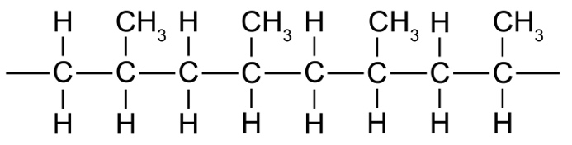
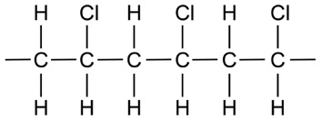
- Poly(chloroethene)
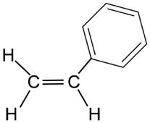
- Poly(propene)
- Styrene

Use Slide 19 to show two images of plastic objects. Ask learners to suggest what the difference(s) between the two are. (Answer: the plastic tubes are flexible and the plastic tubs are rigid.) Get learners to point out differences between other polymers. What’s the difference between a water bottle and a plastic tub? What’s the difference between a blazer and a bike helmet?
These differences in materials (flexibility, rigidity, hardness, strength) are due to different molecules making up the polymer and different amounts of cross-linking between the molecules.
Introduce the idea of cross-linking by discussing why some plastics are rigid and why some are flexible.
Slide 20 includes an image with cross-links between the polymer chains. Use this image to discuss how these cross-links ‘lock’ the polymer chains in place and prevent them from moving over each other and that this makes the polymer more rigid.
Polymers without these cross-links are more flexible as the polymer chains can slide over each other.
Research innovations manager
Draw learners’ attention to the importance of studying the properties of polymers and their suitability as materials. Introduce them to Margot, a research innovations manager, who develops ways to make plastic break down quickly in the natural environment. Find out more with her video job profile, available on slide 20 and from rsc.li/3JRakaD.
Note, the effects of cross-links in polymers can be shown using the PVA polymer slime investigation. This experiment is easy to set up and can be done in 30 minutes. Find the method for this experiment at rsc.li/42nBbm1.

Activity 3: thermosoftening polymers (10 minutes)
Use slide 22 to introduce thermosoftening polymers. Ask learners why they may be useful. (Answer: they can be heated and remoulded hundreds of times, so can be recycled.)
Analytical technician, plastics
Use slide 23 to introduce learners to Celine, an analytical technician in plastics. She uses her chemistry knowledge to develop the structure of plastics so they will biodegrade in the environment to reduce plastic pollution. Watch her video job profile at rsc.li/3LBvfA0.
Slide 24 shows the instructions for the practical. Learners will place 10 $g$ polymorph in very hot water and wait for the material to turn translucent in appearance. They can then remove the polymer material from the beaker and quickly mould it into a pencil topper or other shape and leave it to set in that shape.
Remind learners that the hot water is hazardous and could cause burns. Remind them to take care when handling the hot water and use heatproof gloves to handle hot apparatus.

Quick quiz: polymer review (5 minutes)
Slide 25 presents four review questions that learners can answers in pairs, writing their answers in their student workbooks.
Answers (also on slide 26)
- A monomer is a small molecule that can be bonded to other molecules and usually contains a carbon–carbon double bond. Polymers are made when monomers bond together to form very large molecules. In the process of addition polymerisation, the carbon-carbon double bonds of the monomers break and the monomers bond together to form a polymer chain.
- Examples may include poly(ethene), poly(styrene), poly(propene), poly(vinyl chloride) (or any sensible example).
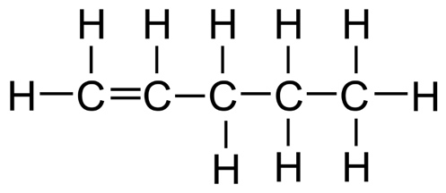
- Either
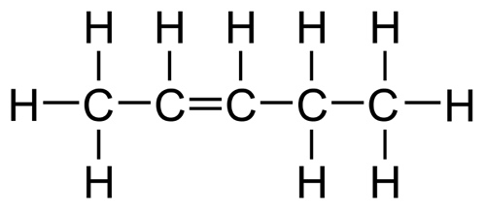
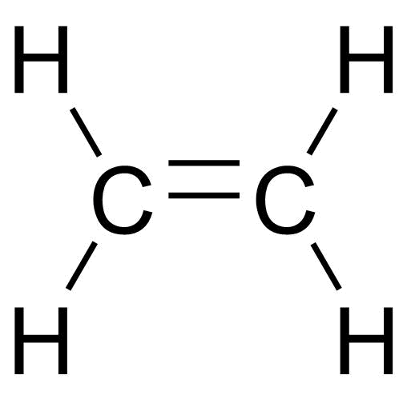
or
- Ethene

