Making ice

Learning objectives
- Plan a method to investigate how quickly ice forms.
- Make careful observations and accurately record them in a table.
- Use experimental data to draw conclusions.
- Write an investigation report.

Introduction

The Mpemba effect is a phenomenon named after a Tanzanian teenager called Erasto Mpemba.

Mpemba was a student at Magamba Secondary School in Tanzania where one day, he and his classmates were making ice cream. The recipe for the ice cream said the mixture should be allowed to cool down before putting in the refrigerator. However, to ensure he could get a free space in the refrigerator, Erasto put his ice cream mixture into the fridge without letting it cool first. At the same time, one of his friends, who had let his mixture cool, also put his mixture into the fridge.

Whose ice cream do you think froze quicker?

Method

Working in small groups (2–3 students), plan an investigation to answer the question: ‘Which makes ice faster, hot or cold water?’. Use your method writing, planning and problem-solving skills to answer the question using the equipment listed below.

You may need to ask your teacher for some additional equipment.

Before you begin your planning, make a prediction and write it down. A good place to start your group discussions is to identify all the different variables.

Equipment (per group)
- Deionised water
- Beakers, 100 and 250 cm³
- Thermometers, –5 to +100°C
- Access to a refrigerator and freezer

Safety and hazards

Wear safety glasses and take care when dealing with hot or boiling water.

Which makes ice faster, hot or cold water?

Planning your method
- Before you start your investigation:
- Predict what you think the result will be. ______________________________________________________________________________
- Suggest a reason for your answer to (a). _______________________________________

______________________________________________________________________________

______________________________________________________________________________

- Identify the variables.
- What will you change (__________________________ variable)?

______________________________________________________________________________

______________________________________________________________________________
- What will you measure (__________________________ variable)?

______________________________________________________________________________

______________________________________________________________________________
- What will you keep the same (__________________________ variable)?

______________________________________________________________________________

______________________________________________________________________________

- Name the equipment you will use to:
- Measure the volume of water.

______________________________________________________________________________

- Pour the water into.

______________________________________________________________________________

- Measure the temperature of the water.

______________________________________________________________________________

- Heat the water.

______________________________________________________________________________

______________________________________________________________________________

- Measure how long the water takes to freeze.

______________________________________________________________________________

- How many different water temperatures will you test? __________________________

Remember, to label all your samples.

- How many times will you repeat each experiment?

______________________________________________________________________________

- Write a method on a separate sheet. Before you start, think carefully about the order you will do things in.

Recording your results and conclusions

Here are some example tables you could use to record your results.
Sample | Temperature (°C) | Notes
A
B

Sample | Time in the fridge/ freezer (mins) | Temperature (°C) | Observations  (Describe what you see)
A
B

- Draw your own results table. What headings will you write in each column?

Don’t forget to include the units.
- Interpret your results.
- Which sample cooled the fastest?

__________________________________________________________________________________

__________________________________________________________________________________

- Which sample became ice first?

__________________________________________________________________________________

__________________________________________________________________________________
- Was your prediction correct?

___________________________________________________________________________

___________________________________________________________________________
- Write a conclusion to answer the question ‘which makes ice faster, hot or cold water?’

__________________________________________________________________________________

__________________________________________________________________________________

__________________________________________________________________________________

__________________________________________________________________________________

__________________________________________________________________________________

__________________________________________________________________________________

__________________________________________________________________________________

Questions

These follow-up questions are adapted from Review my learning: the particle model.
- Add the following labels to the diagram below.

gas liquid solid

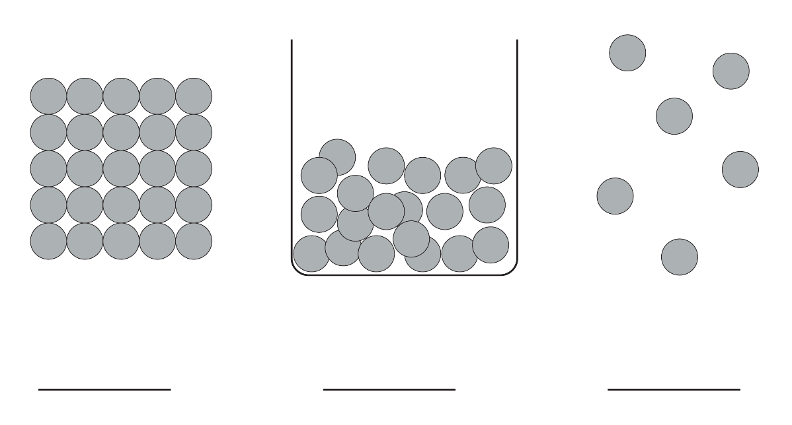
- Use the words to complete the sentences.

close together

regular

shape

vibrate

In ice, the particles are very close together in a ________________________________ pattern. The particles ________________________________ around a fixed position. Solids have a fixed ________________________________. Solids cannot be easily compressed because their particles are ________________________________ with no space to move into.
- Use the words to complete the sentences.

compressed flow less more

particles randomly shape

In water, the particles are very close together and are ________________________________ arranged, but still touching. The particles move around each other and have ________________________________ energy than in a solid but ________________________________ than in a gas.

Liquids do not have a fixed ________________________________. Liquids can ________________________________ and take the shape of their container, because their ________________________________ can move around each other. Liquids cannot be easily ________________________________ because their particles are close together with little space to move into.
- Choose a word to complete the sentence:

melting

freezing

evaporating

condensing

When water changes into ice, the change of state is __________________________.

- Choose words to complete the sentences:

increases stay the same decreases exothermic endothermic

When a liquid changes to a solid, the kinetic energy of the particles __________________________. This means that an __________________________ change has taken place.

