Ionic bonding mats

This resource accompanies the poster How to draw ionic bonds from Education in Chemistry which can be viewed at rsc.li/3AMzz9J

Learning objectives
- Draw dot and cross diagrams for ionic compounds.
- Show how electrons are transferred in ionic bonding.

Introduction

Activities 1 and 2 introduce ionic bonding dot and cross diagrams in a format that allows learners to easily transfer electrons between atoms. They can try out, amend and erase answers, before capturing the final dot and cross diagram in an exercise book. The worksheet for activity 3 will build on their confidence and understanding.

Activity 1 includes ionic compounds where the charges on the ions are equal in magnitude. Activity 2 introduces ionic compounds where the charges are of different magnitudes, so learners will need to work out the charge and the ratio of the ions. The sheets can be used as a progression sequence or to differentiate within the same class. The templates can also be used with your own examples.

Activity 3 checks understanding by testing learners’ ability to spot what is missing from the ionic bonding dot and cross diagrams. The difficulty increases, with more aspects missing from later diagrams and more complex compounds. The final question is a real challenge and tests learners’ understanding of both ionic and covalent bonding dot and cross diagrams in one question.

How to use

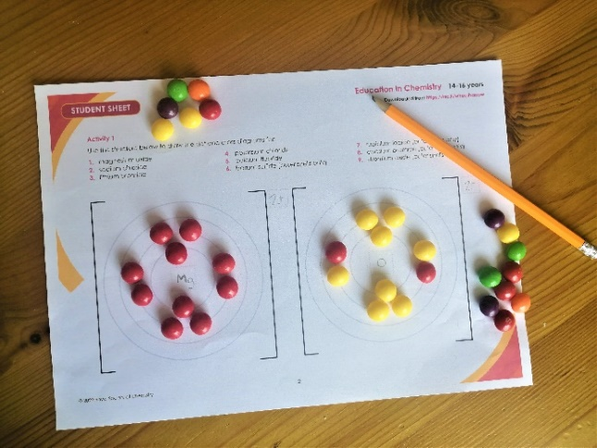
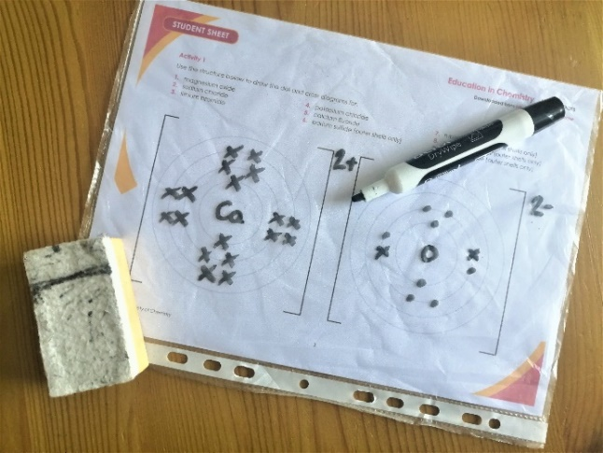
The mats for activities 1 and 2 are intended to be reusable. They can be laminated or used inside a plastic wallet. Use the worksheets with a whiteboard marker (below left) or with small beads, counters, Blu Tack, plasticine or small sweets (below right).

Answers

Activity 1

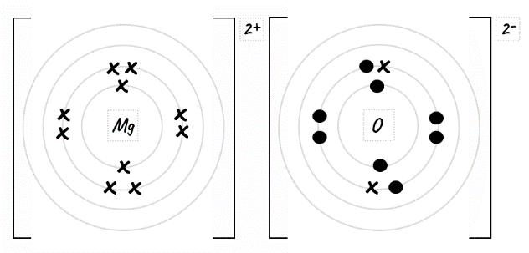
- Magnesium oxide
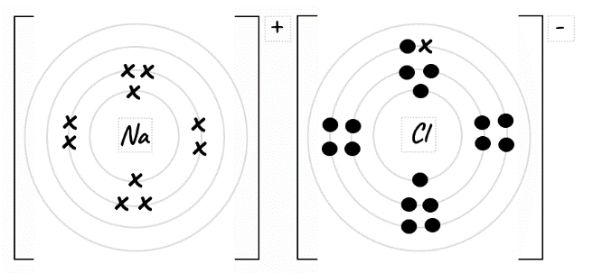
- Sodium chloride
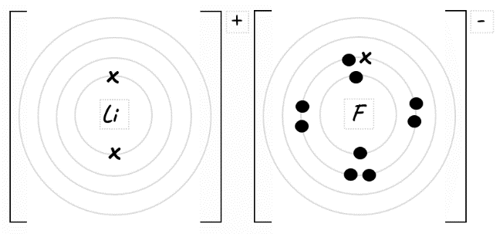
- Lithium fluoride
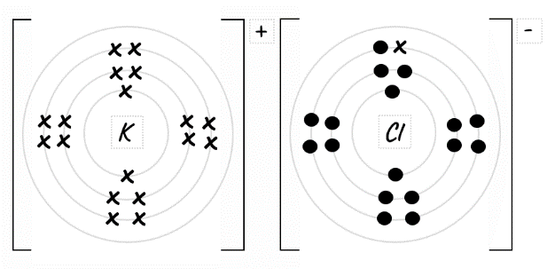
- Potassium chloride
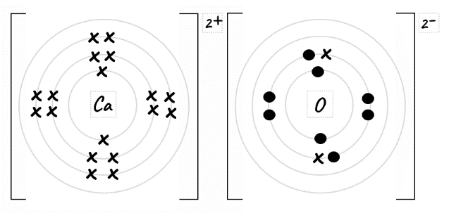
- Calcium oxide
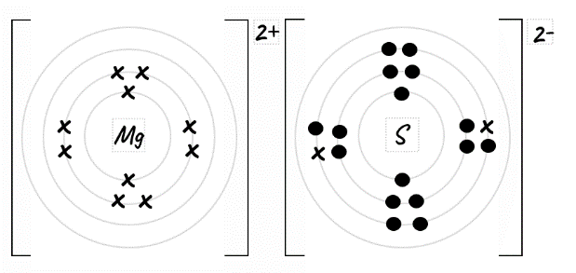
- Magnesium sulfide
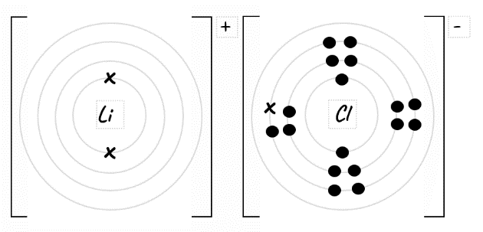
- Lithium chloride
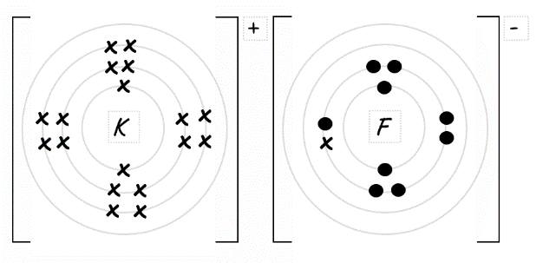
- Potassium fluoride
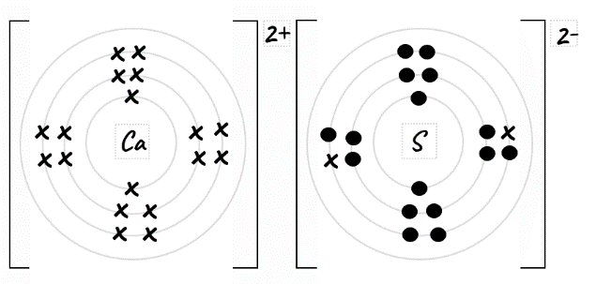
- Calcium sulfide

Activity 2

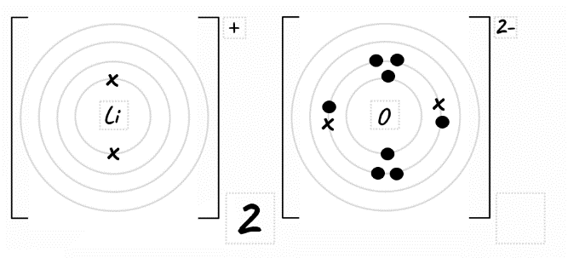
- Lithium oxide
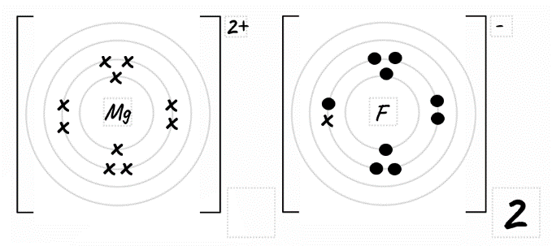
- Magnesium fluoride
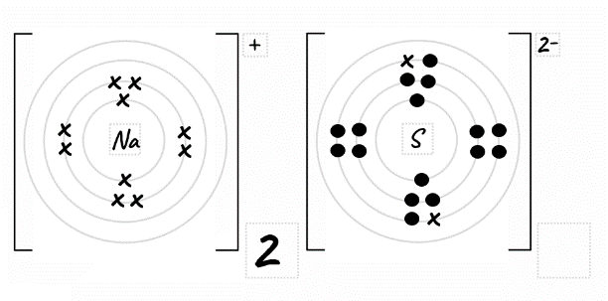
- Sodium sulfide
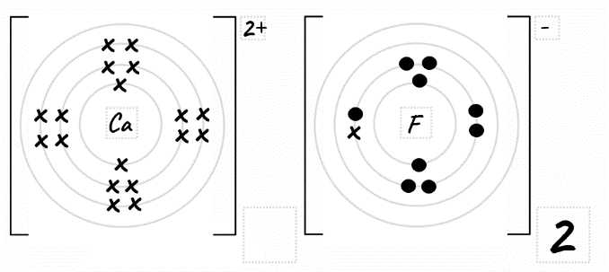
- Calcium fluoride
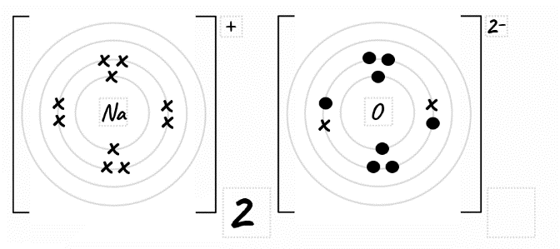
- Sodium oxide
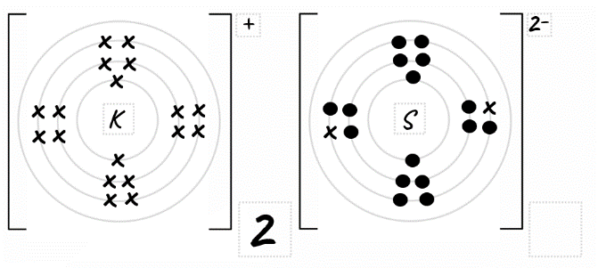
- Potassium sulfide
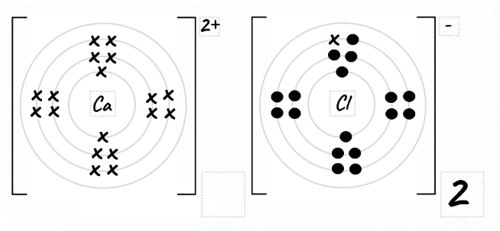
- Calcium chloride
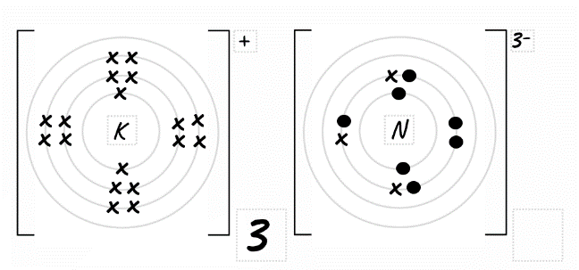
- Potassium nitride
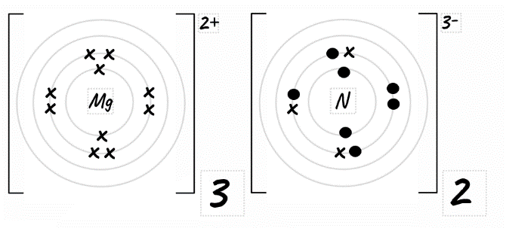
- Magnesium nitride

Activity 3

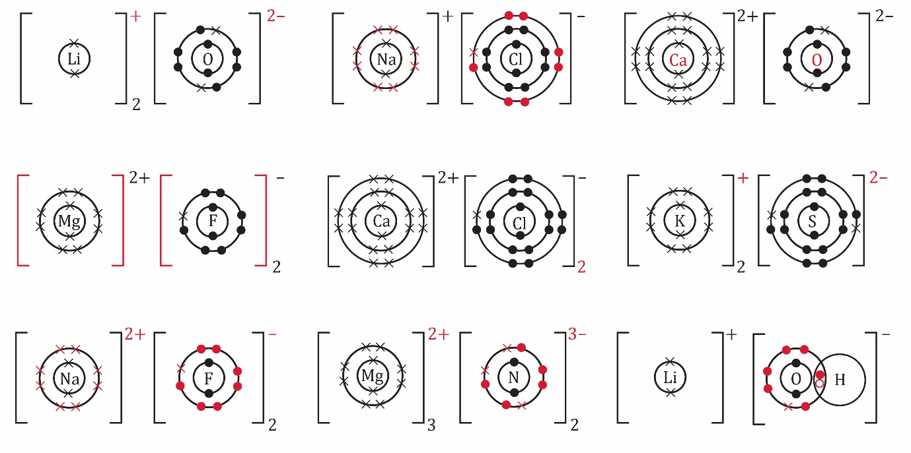
1. Lithium oxide 2. Sodium chloride 3. Calcium oxide
4. Magnesium fluoride 5. Calcium chloride 6. Potassium sulfide

7. Sodium fluoride 8. Magnesium nitride 9. Lithium hydroxide

