Thin-layer chromatography – student sheet

Introduction
The range of over-the-counter analgesics (painkillers) is quite extensive. In this activity you use thin-layer chromatography (tlc) to separate the components of these medicines and, by comparing the samples, positively identify them.

In the first part of the activity you will make a reference plate. Then samples of analgesics are run on a separate plate and compared with the reference.

Method
You need two tlc plates and six capillary tubes as micropipettes. Make sure that you do not touch the surface of the tlc plates with your fingers during this activity. Handle the plate only by the edges and use tweezers if possible.

Part A
- Take a tlc plate and using a pencil (not a biro or felt tip pen) lightly draw a line across the plate about 1 cm from the bottom. Mark off three equally spaced points.
- You are provided with reference solutions which contain, respectively, aspirin, caffeine and a known mixture of aspirin and caffeine. Use three of the micropipettes to spot samples of these reference solutions onto the tlc plate. Allow the spots to dry and then repeat three more times. The spots should be about 1–2 mm in diameter.

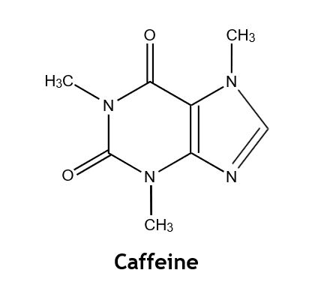

- When all the spots are dry, place the tlc plate in the developing tank making sure that the original pencil line is above the level of the developing solvent – ethyl ethanoate. Put a lid on the tank and allow to stand in a fume cupboard until the solvent front has risen to within a few millimetres of the top of the plate.
- Remove the plate from the tank and quickly mark the position of the solvent front. Allow the plate to dry.
- Observe the plate under a short wavelength UV lamp and lightly mark with a pencil any spots observed.
- Place the plate in a jar or beaker containing a few iodine crystals. Put a cover on the jar and warm gently on a steam bath until spots begin to appear. Do this in a fume cupboard.

Part B
- Prepare a tlc plate with four points on the base line.
- Place half a tablet of one of the analgesics to be analysed on a piece of paper and crush it with a spatula. Transfer it to a small labelled test-tube and add 5 cm3 of the solvent (a 1:1 mixture of ethanol and dichloromethane). Warm gently on a steam bath to dissolve as much of the tablet as possible. Any residue is likely to be a binding agent: allow it to settle for a few minutes. This may be starch. How could you confirm this? Repeat this procedure to make solutions of the other two analgesics.
- Using similar procedures to Part A 2, spot a sample of each of the clear solutions onto your prepared tlc plate. On the fourth spot place the reference mixture used in Part A.
- Repeat 3–6 from Part A. Draw diagrams to show how your results appear under UV light and in iodine

Conclusions
Set out your results to show which of the tablets contain, aspirin, which contain caffeine and which, if any, contain other compounds. What is the purpose of the caffeine?

Discuss some of the advantages and disadvantages of using tlc in the analysis of medicines.

