- The diagram shows the process called polymerisation.
Which of the following statements are true or false about this process?
Write a ‘T’ if true, and an ‘F’ for false in the box.
- The particles on the left are called monomers.

- In this process, many molecules bond together to form a very long chain molecule.

- The number of molecules on each side is the same.

- Different monomers can be used to make new substances having different properties and uses.

- Ethane is an example of a monomer.

- Many polymers break down in the environment and are biodegradable.

- Propene forms a polymer called poly(propane).

- Unsaturated molecules can form addition polymers.

- This question is about making poly(ethene) from ethene.

- Draw the structure of an ethene molecule showing all of the chemical bonds.

- Draw the missing bonds on this section of a poly(ethene).
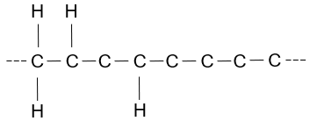

- How many ethene molecules are needed to make the part of the chain shown in part b)?

- Complete the table below that describes the differences between ethene and poly(ethene):
 | Ethene | Poly(ethene)
Carbon double bonds present?
Unsaturated or saturated
Observation on adding bromine water

- This question is about the molecule below.

- Name this molecule.

The structure below shows part of a polymer made from the molecule in part a).
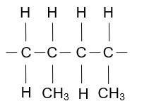

- What is the name of this polymer?

- Describe what happens to the carbon double bond in the molecule in part a) when it makes a polymer.

