Quantitative chemistry: knowledge check
- This diagram represents a chemical equation. Label the diagram using the words below.

compound element molecule

product reactants
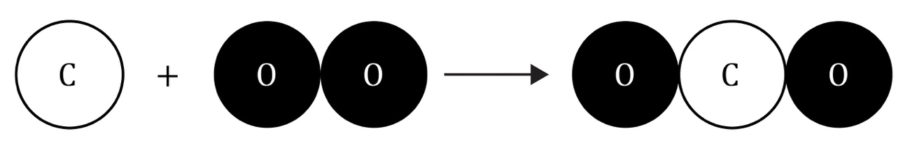
- Choose suitable words to complete the sentences:

The diagram in question 1.1 shows an equation summarising a ___________________________. The ___________________________ can be found on the right-hand side of the arrow. The ___________________________ can be found on the left-hand side of the arrow. The reactants are ___________________________ and ___________________________.

- Choose suitable words to complete the sentences:

The formula of the hydrogen molecule is ___________________________.
The formula of the oxygen molecule is ___________________________. The formula of the water molecule is ___________________________. Both the reactants are ___________________________ that contain one type of atom only. The product is a ___________________________, which is a substance made up of two (or more) different atoms bonded together.
- Choose suitable words to complete the sentences:

During a chemical reaction, ___________________________ are neither created nor destroyed. Instead, the atoms are just ___________________________ to form a new substance. This means that the total mass of the ___________________________ will be the same as the total mass of the ___________________________. In this example, there are four atoms of ___________________________ and two atoms of ___________________________ on both sides of the arrow. The equation is balanced and shows that the mass is conserved. The total ___________________________ stays the same during a chemical reaction. This is the law of ___________________________ of mass.

Quantitative chemistry: test myself
- What does the formula H₂O mean in terms of the number and type of atoms? Complete the sentences.

There are ___________________________ atoms of ___________________________ and ___________________________ atom of ___________________________ in one molecule of water.
- Write a word equation for the chemical reaction shown in the diagram.

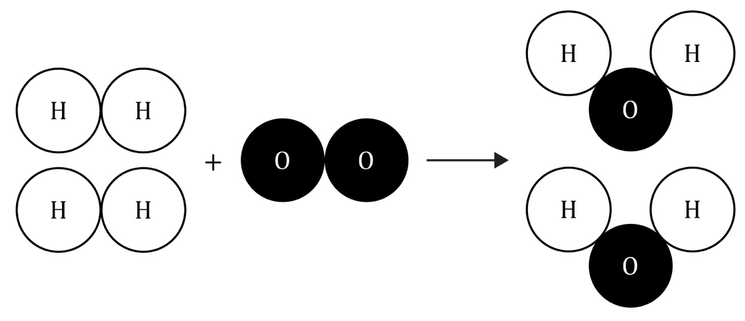

________________________ + ________________________ $→$ ________________________
- What is the formula for one molecule of hydrogen? For example, the formula for water is H₂O.

Circle the correct answer.
H2 H h₂ H₂ h2

- What is the formula for one molecule of oxygen? For example, the formula for water is H₂O.

Circle the correct answer.
O₂ O o2 o o₂
- Using your answers from questions 2.3 and 2.4, write a balanced symbol equation for the reaction shown in the diagram in question 2.2.

________________________ + ________________________ $→$________________________
- Why does the number of hydrogen and oxygen atoms on the left-hand side of the arrow have to be equal to those on the right-hand side? Explain your answer in terms of conservation of mass by completing the sentences.

During a chemical reaction, ___________________________ are only ___________________________; they cannot be ___________________________, and new ones are not made.
- How much water would you expect to make from 4 g of hydrogen and 32 g of oxygen?

Show your working.

- How much water would expect to make from 20 kg of oxygen and 160 kg of hydrogen?

Show your working.

- How much hydrogen would you need to react with 48 g of oxygen to make 54 g of water?

Show your working.

- This is the word equation for heating calcium carbonate:

calcium carbonate $→$ calcium oxide + carbon dioxide

How much calcium carbonate produces 28 g calcium oxide and 22 g carbon dioxide when it completely decomposes?

Show your working.

Quantitative chemistry: feeling confident?
- Use the Periodic table to complete the table.
Element | Symbol | Relative atomic mass
hydrogen | H
oxygen | O
chlorine | Cl
carbon | C
nitrogen | N
iron | Fe
sodium | Na
magnesium | Mg
copper | Cu
sulfur | S

- Use the relative atomic masses from question 3.1 to calculate the relative formula mass of the compounds in the table. Some have been done for you.
Compound name | Formula | Calculation | Relative formula mass
water | H₂O | (2 × H) + (1 × O)  = (2 × 1) + (1 × 16) | 18
sodium chloride (salt) | NaCl
carbon dioxide | CO₂
methane | CH₄
ammonia | NH₃
copper sulfate | CuSO₄
glucose | C₆H₁₂O₆
sodium carbonate | Na₂CO₃
magnesium hydroxide | Mg(OH)₂ | (1 × Mg) + (2 × O) + (2 × H)  = (1 × 24) + (2 × 16) + (2 × 1)
ammonium sulfate | (NH₄)₂SO₄

Quantitative chemistry: what do I understand?

Think about your answers and confidence level for each mini-topic. Decide whether you understand it well, are unsure or need more help. Tick the appropriate column.
Mini-topic | I understand  this well | I think I understand this | I need more  help
I understand that all substances are made up of atoms and molecules.
I can identify elements and compounds.
I can identify reactants and products in a chemical equation.
I can write simple chemical formulas.
I can understand and use the law of conservation of mass.
I can write simple word equations.
I can write simple balanced symbol equations.
I can calculate the mass of a reactant or product in a chemical reaction given all other reacting masses.
Feeling confident? topics | I understand  this well | I think I understand this | I need more  help
I can use the Periodic table to find the relative atomic masses of named elements.
I can calculate relative formula mass.

