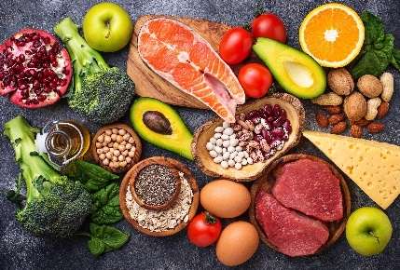
- Salmon, french beans, basil, eggs and some nuts are some examples of superfoods.

These types of food contain many important nutrients.
- What is a ‘nutrient’?
Source: Envato Elements

Answer: A substance in the diet that is important for good health and growth.
- Give two examples of important nutrients needed in our diet.
Answer: Two from – carbohydrates, fats, proteins, water, and in smaller amounts: vitamins and minerals.

Many important nutrients are polymers made from many smaller molecules.
- Describe a polymer.
Answer: A very long chain molecule made of many smaller molecules bonded or joined together.
- Give the term to describe the small molecules that make a polymer.
Answer: Monomers.

The diagram shows a natural polymer being made from many glucose molecules.
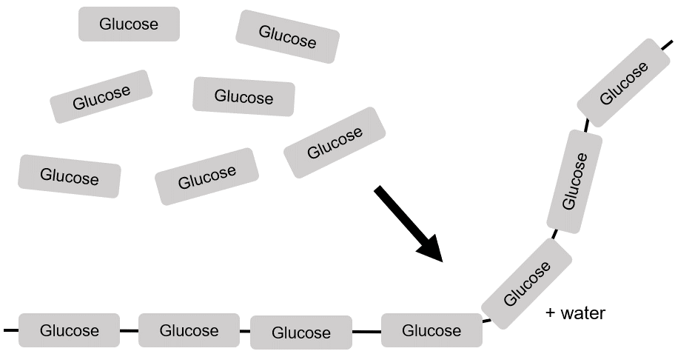

- State the name of the polymer being formed.
Answer: Starch or cellulose.
- What type of polymerisation takes place when glucose forms the polymer in part e)?
Why does it have this name?
Answer: Condensation polymerisation.
A small molecule of water is formed as well as the polymer.

Another important type of polymer is made from amino acids.
- Complete this diagram to show a polymerisation taking place.
Use the previous diagram to help you.
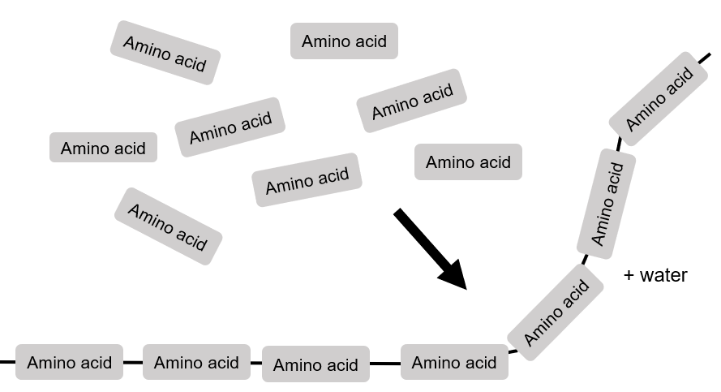
- What is the name of this type of polymer?
Answer: A protein.
- Give one similarity between the polymer in part g) and the one in part e).
Answer: Both are condensation polymers.

- This question is about chicken eggs.
The diagram shows the mass of different nutrients in 100 g of chicken eggs.

Use the diagram to answer the questions.
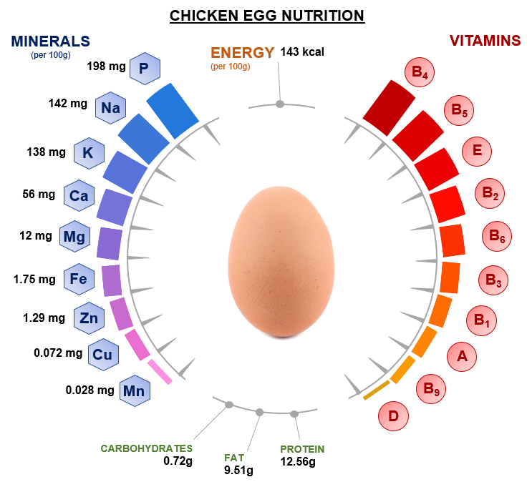

Source: International bunch / adapted from Shutterstock
- What is the mass of fat in 100 g of chicken eggs?
Answer: 9.51 g
- What percentage of chicken eggs, by mass, is due to protein?
Answer: 12.56%
- Write the mass of iron in grams.
Answer: 0.00175 g

- Write the mass of vitamin A in grams.
Answer: 0.16 g
- Write the mass of manganese in grams and in standard form.
Answer: 2.8 × 10^{–5} g
- State the name of a nutrient in chicken eggs that is a polymer.
Answer: Protein.
- Which of the nutrients in the diagram has the:

i) largest mass?
Answer: Protein.
ii) smallest mass?
Answer: Vitamin D.
- Why is the total mass of all of the nutrients in the diagram not equal to 100 g?
Answer: Water is not included.

