Addition polymers

Learning objectives
- Explain how alkenes react to form addition polymers.
- Understand how addition polymers are named and structured.

Introduction

Fabrics and plastics are made from macromolecules called polymers. Some polymers are formed by reacting alkenes (a type of hydrocarbon). Unsaturated alkene monomers undergo addition reactions to form long chains of repeating units. The name of the polymer comes from the monomer used with the Greek word ‘poly’ (meaning ‘much’) in front of it. These questions will help you understand how addition polymers are formed, named and structured.

How to draw a polymer structure

To draw a polymer structure from a monomer, align three unsaturated monomers in a row in an ‘H’ formation (see below). The double bond forms the horizontal cross of the H.

Remove the unsaturation by forming a new single covalent bond to the next monomer with an addition reaction. The polymer will be saturated (only containing single bonds) with an unattached ‘floating bond’ at each end to show continuation of the polymer chain.

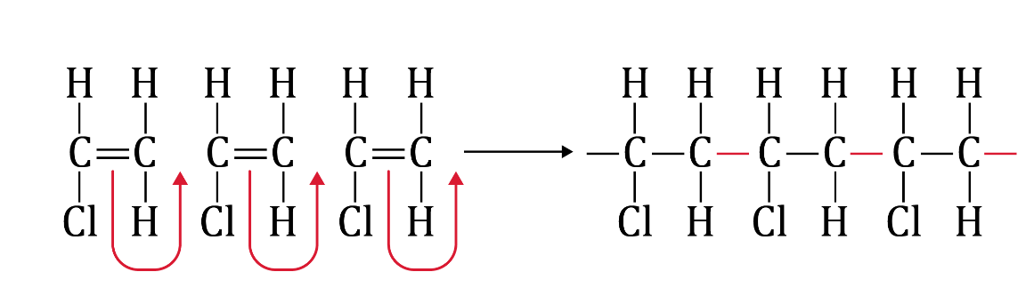

Questions
- The homologous series, the alkenes, are hydrocarbons. Which of the following molecules is an alkene? Circle your answer.

(a)  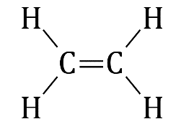 | (b)  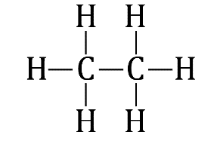 | (c)  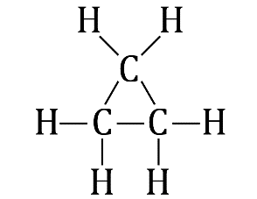

- Alkenes can undergo reactions like the one shown below, where one molecule adds to the other.

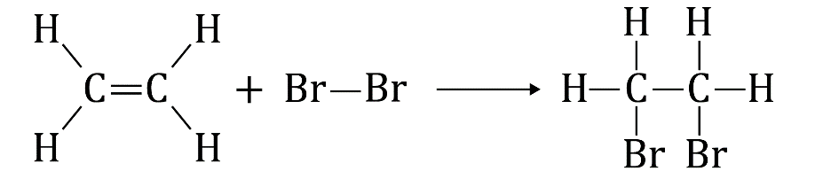

- What is this type of reaction called?

__________________________________________________________________________________

__________________________________________________________________________________

__________________________________________________________________________________

- What is the main property of alkenes that enables them to undergo this type of reaction?

__________________________________________________________________________________

__________________________________________________________________________________

- Alkene monomers can react with themselves to form long chain polymers. In the table below, draw the polymer formed from the monomer. Draw three repeating units and write the name of the polymer. An example is provided in the first row. Hint: use the ‘how to draw a polymer structure’ section in the introduction.

Monomer | Polymer
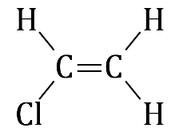  Chloroethene  or vinyl chloride | 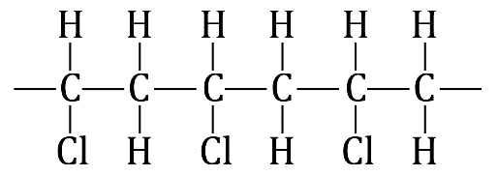  Name: poly(chloroethene) or poly(vinylchloride)
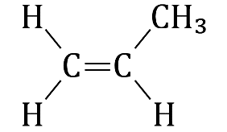  Propene | Name: ______________________________________________
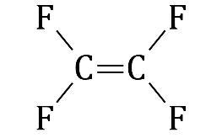  Tetrafluoroethene | Name: ______________________________________________
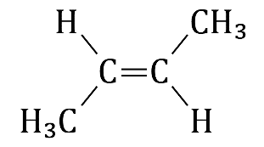  But-2-ene | Name: ______________________________________________
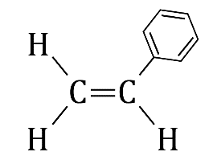  Styrene | Name: ______________________________________________
- Using the polymer shown below, draw the structure of the repeating unit and the monomer.

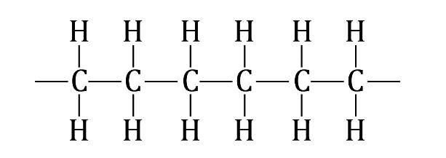

Polymer

Repeating unit Monomer

Extension question
- Poly(methylmethacrylate) is better known as Perspex.
- Using the section of poly(methylmethacrylate) shown below, draw the structure of the repeating unit and the monomer.

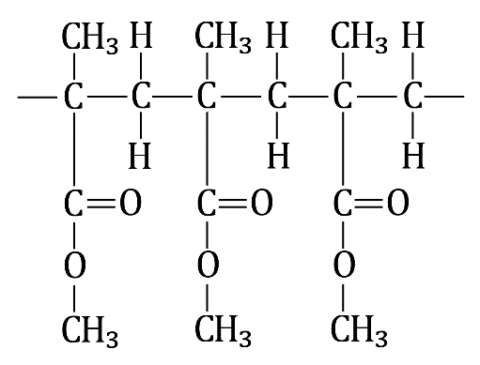

Repeating unit Monomer
- Poly(methylmethacrylate) is used as a substitute for glass. What properties would you expect this polymer to have?

__________________________________________________________________________________

__________________________________________________________________________________
- What advantages do you think are there to using poly(methylmethacrylate) over glass in windows?

__________________________________________________________________________________

__________________________________________________________________________________
- Are there any disadvantages?

__________________________________________________________________________________

__________________________________________________________________________________

