Extracting metals
Education in Chemistry
January 2020
rsc.li/2E4K8qs
Note: while malachite is copper carbonate hydroxide, this worksheet uses copper carbonate to keep the chemistry accessible.

Extracting iron
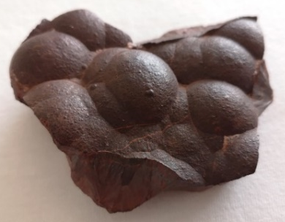
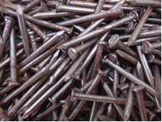
Haematite (iron oxide) Iron nails (iron)
The ore of iron is called haematite. Iron can be extracted by reducing iron oxide with carbon.
- Define the word ore.
- Complete the word equation for the reaction between iron oxide and carbon:
iron oxide + carbon → _____ + _______ dioxide
- State the reactants.
- State the products.
- Copy and complete by adding the word reduction or oxidation above the arrow.
iron oxide |  | iron
 | →

- Copy and complete by adding the word reduction or oxidation above the arrow.
carbon |  | carbon dioxide
 | →

- Describe the reaction by stating when iron is an element or in a compound.
- Explain whether iron is oxidised or reduced when an element or in a compound.
- Describe the reaction by stating when carbon is an element or in a compound.
- Explain whether carbon is oxidised or reduced when an element or in a compound.
- State whether oxygen has changed from being part of a compound to an element.
- Therefore, explain if the oxygen has been reduced, oxidised or neither.

Iron is a neutral atom when an element and a positive ion when in a compound.
- Describe reduction and oxidation in terms of atoms and positive ions.

Extracting lead
 |  | 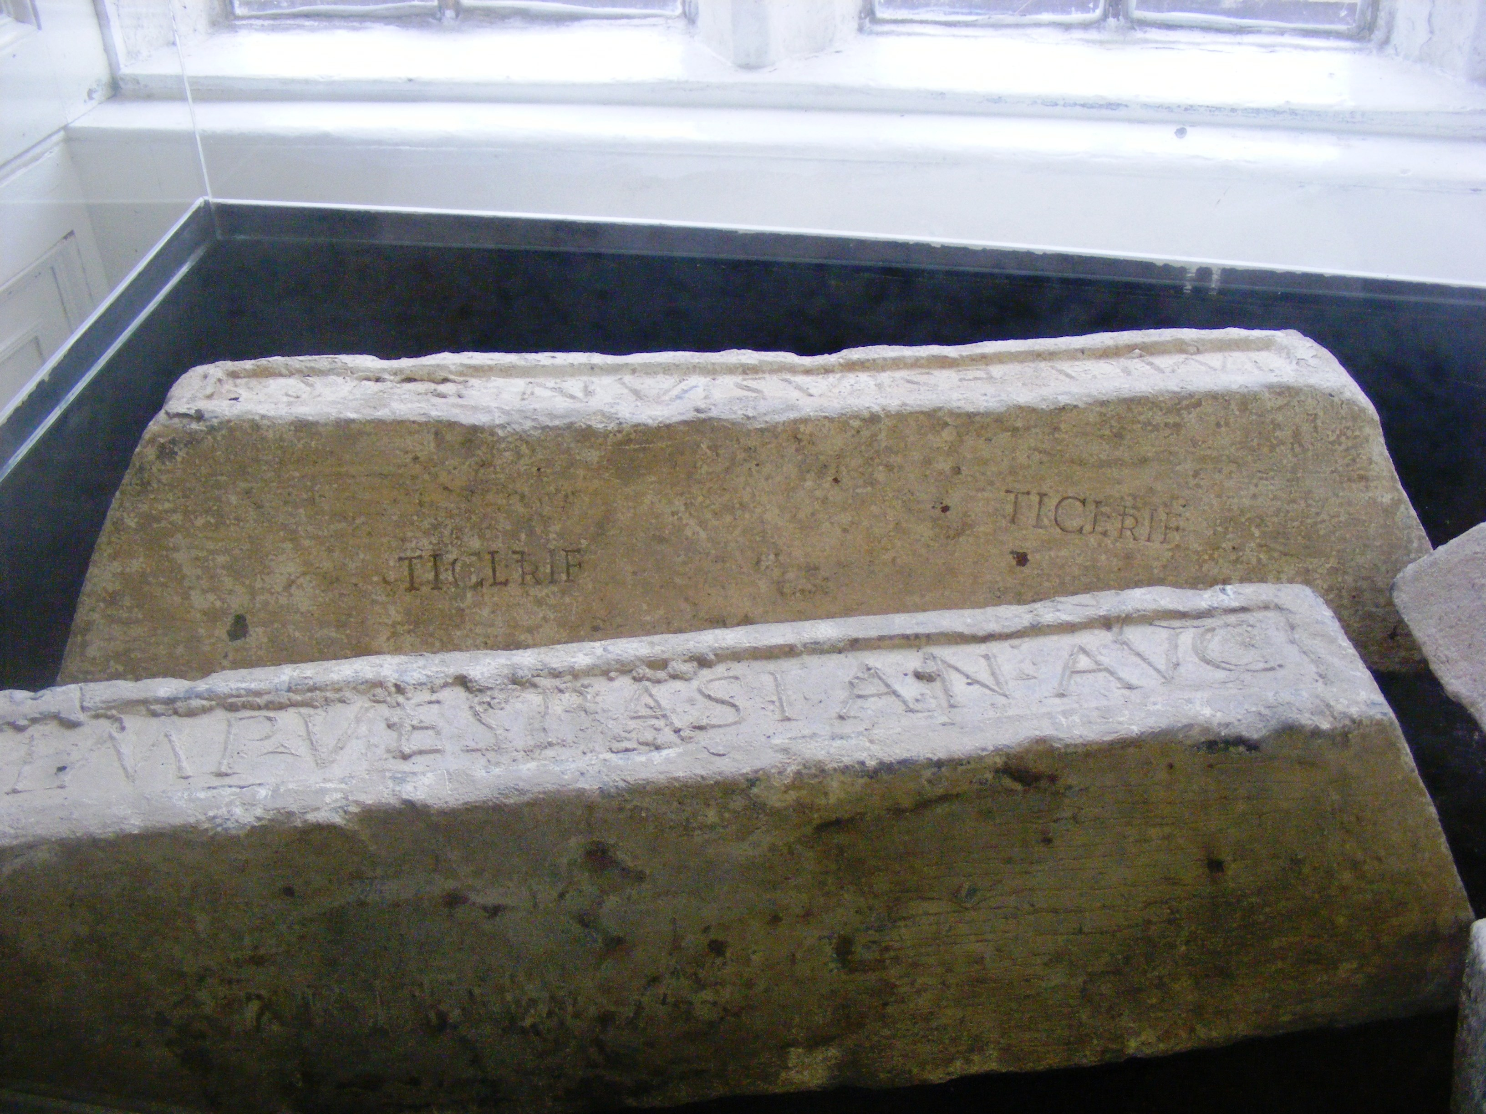
Galena (lead sulfide) |  | Lead ingots (lead)
The ore of lead is called galena, and contains lead sulfide. A student predicts that lead sulfide could be directly reduced by heating with carbon.
- Complete the word equation for the predicted reaction between lead sulfide and carbon.
lead sulfide + carbon → _____ + _______ disulfide
- Copy and complete by adding the word reduction or oxidation above the arrow.
lead sulfide |  | lead
 | →

- Copy and complete by adding the word reduction or oxidation above the arrow.
carbon |  | carbon disulfide
 | →

- Describe the predicted reaction by stating when lead is an element or in a compound.
- Explain whether lead is oxidised or reduced when an element or in a compound.
- Describe the predicted reaction by stating when carbon is an element or a compound.
- Explain whether carbon is oxidised or reduced when an element or in a compound.
- State whether sulfur (called sulfide when in a compound) has changed from being part of a compound to an element.
- Therefore, explain if the sulfur has been reduced, oxidised or neither.
- Explain why this is a redox reaction.
- Describe reduction and oxidation in terms of atoms and positive ions for this reaction.
- Discuss whether this can still be a redox reaction even though there is no oxygen. Use parts of previous answers to support your argument.
Galena is actually extracted by first heating in air, which converts lead sulfide to lead oxide. Lead oxide is then reduced by heating with carbon.

Extracting copper
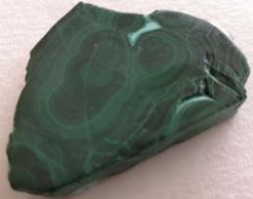 | 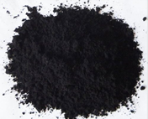
Malachite (copper carbonate hydroxide) | Copper oxide | Copper
The ore of copper is called malachite. Copper can be extracted by roasting (thermal decomposition) followed by reduction with carbon.
- Complete the equation showing copper carbonate thermally decomposing in copper oxide and carbon dioxide.
CuCO₃ → CuO + ___
- Identify the reactants and products in the reaction and state if they are elements or compounds.
- Explain whether anything has been reduced or oxidised in the reaction above.
After roasting the copper is produced by reducing copper oxide with carbon.
- Define redox reaction.
- Write the word equation for the reaction between copper oxide and carbon.
- Explain how the reaction between copper oxide and carbon is a redox reaction using the following definitions of reduction and oxidation.
  - Reduction is the loss of oxygen, oxidation is the gain of oxygen.
  - Reduction is when a metal in a compound turns into a metal element.
When copper is exposed for a long period of time it turns a green colour. As seen on this statue of Queen Victoria in Birmingham.
- Suggest the name of the green compound form on the surface of the statue.
- Explain what is happening in terms of reduction and/or oxidation to the copper in the statue.

Image credits
All images by William Baron de Burgh unless other stated:
Iron nails: By Gausanchennai - Own work, CC BY-SA 4.0, https://commons.wikimedia.org/w/index.php?curid=75706916
Lead ingots: By Rodw - Own work, Public Domain, https://commons.wikimedia.org/w/index.php?curid=8044059
Copper: By Dmitry G - Own work, CC BY-SA 3.0, https://commons.wikimedia.org/w/index.php?curid=26606254

