High levels of nanoplastics found in bottled water

Original article by Julia Robinson. Adapted by Nina Notman.

New analytical technique reveals previously hidden tiny plastic particles

Scientists have discovered that bottled water contains many more tiny plastic particles than previously detected. Nanoplastics – plastic particles less than 1000 nm (1μm) in length – make up the vast majority of these.

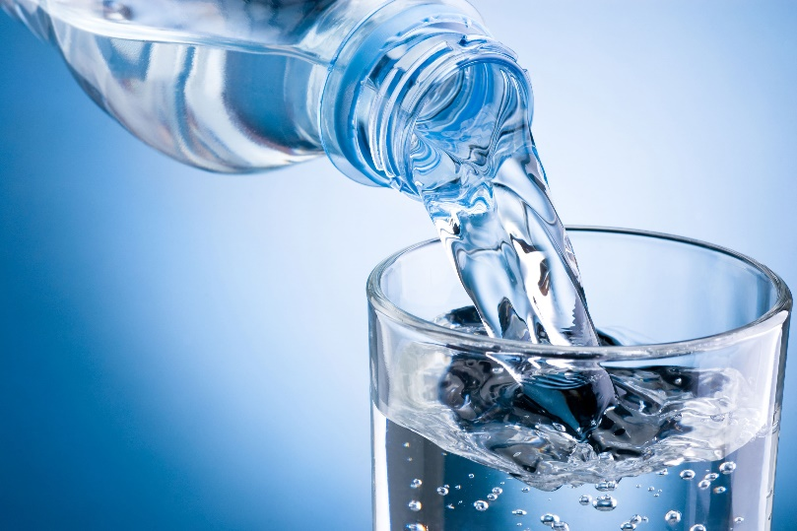
Over the last decade, there has been growing awareness about the abundance of microplastics in our oceans, lakes and rivers. Rubber from car tyres and shoe soles, microfibers from synthetic fabrics, and large pieces of plastic that have broken down in the environment – such as carrier bags and food and drink containers – are all sources of microplastics.

Problem plastics

Source: © TEK Image/Science Photo Library

Unbottle the truth of what's inside your drinking water

We know now that these plastic particles find their way from the oceans, lakes and rivers into our food and drink. Microplastics have been found in various places such as salt, fish, fruit, vegetables and drinking water. But our understanding of the prevalence of the smallest of these particles, nanoplastics, in our foods and drinks is currently lacking. This is because it is challenging to detect such tiny particles.

Nanoplastics are thought to be more toxic to humans than microplastics because they’re smaller and can get into the body more easily from the gut.

Analytical advances

To address this issue, a team led by Wei Min and Beizhan Yan at Columbia University developed a powerful optical imaging technique able to rapidly and accurately detect nanoplastics. The scientists used their novel method to analyse three popular brands of bottled water. They successfully detected and identified plastic particles in the water down to just 100 nm in size. The seven plastic types they found include poly(ethylene terephthalate) and polyamide, which are two materials commonly used in plastic bottles.

The researchers calculated that the average litre of bottled water they tested held 240,000 particles of micro- and nanoplastics, with nanoplastics making up around 90% of the particles detected. The authors said these concentrations were ‘two or three orders of magnitude more’ than the abundance reported previously in bottled water by studies focused only on detecting larger microplastics.

This is adapted from the article ‘Nanoplastics make up around 90% of the plastic particles found in bottled water’ in Chemistry World. Read the full article: rsc.li/3UzoPFT

