Evaporation, filtration and crystallisation
Education in Chemistry, July 2018, rsc.li/2KnJJRd

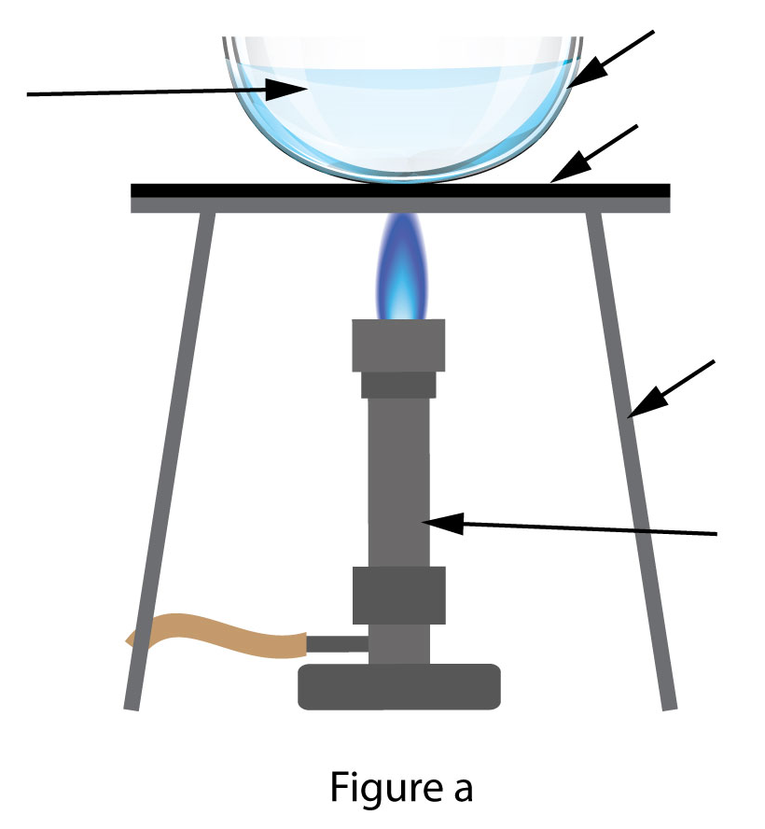
Evaporation – direct heating with a Bunsen burner
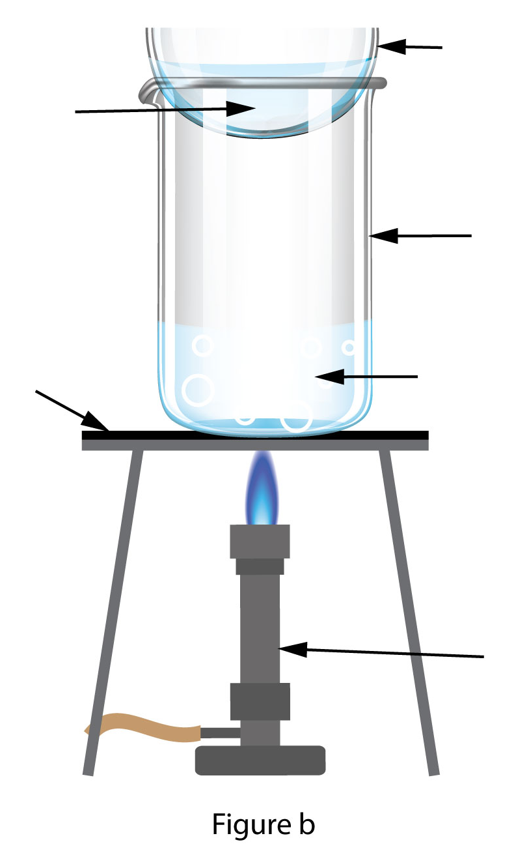
Evaporation – heating over a beaker of water
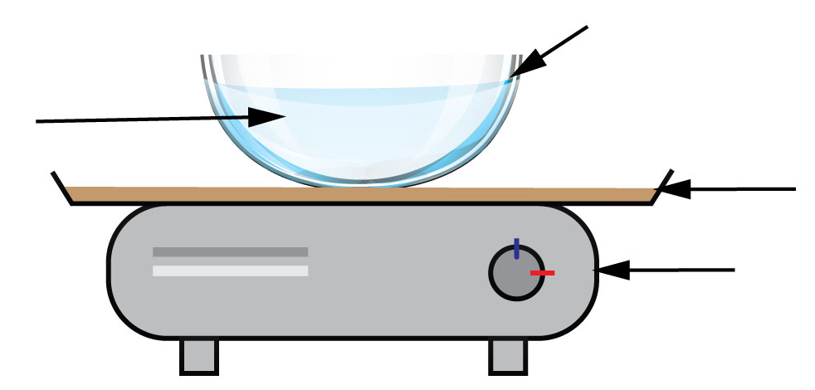
Evaporation – heating using a sand bath
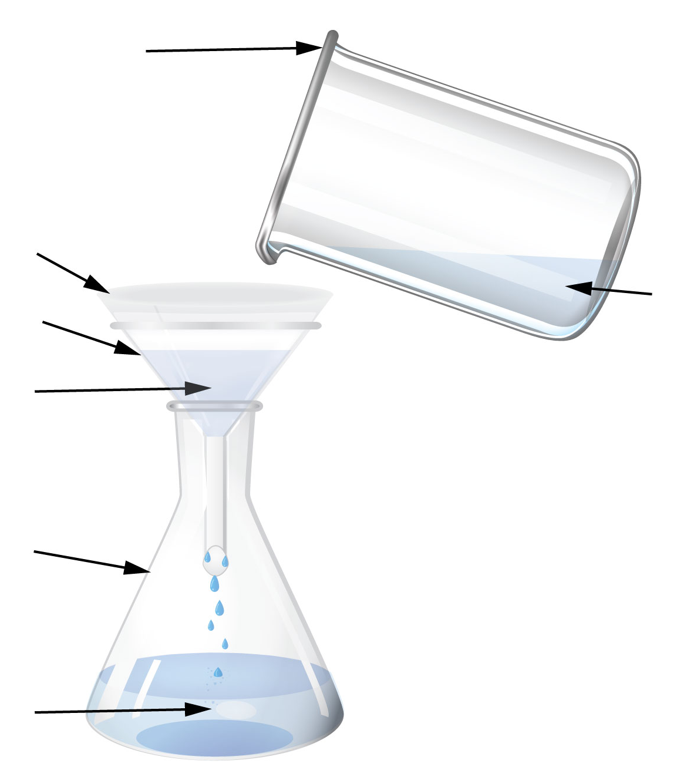
Filtration
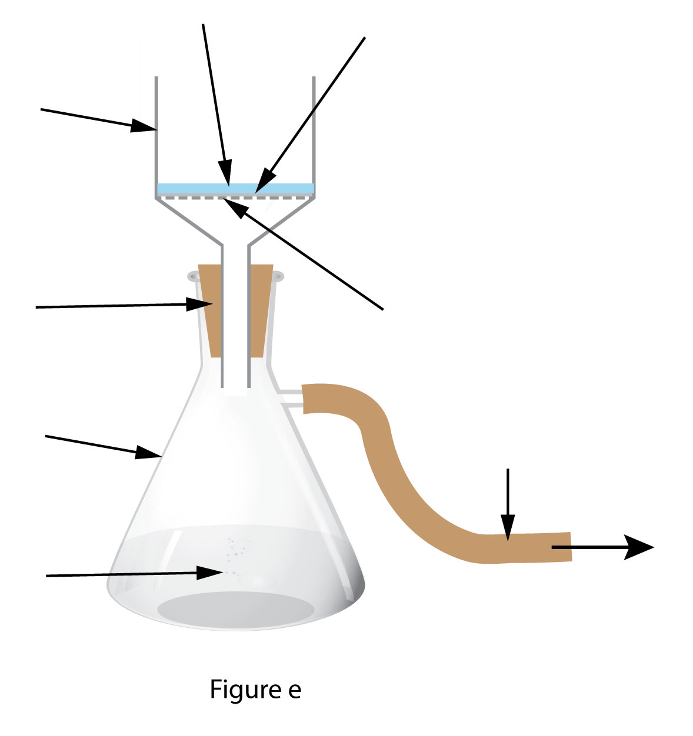
Filtration under reduced pressure

