Monitoring local pollutant levels
Education in Chemistry
Sustainability in chemistry 2021
Goal 11: make cities and human settlements inclusive, safe, resilient and sustainable
rsc.li/2UhW9EO
With air pollution currently responsible for 9% of deaths globally, we must reduce it if we are to meet the requirement of Goal 11 for our cities to be safe in the future. It is important to monitor levels of key pollutants to see how well initiatives such as congestion pricing zones and electric vehicles are affecting air quality.
The following activity will give you a chance to look at current and historical levels of the pollutant nitrogen dioxide in the town or area where you live.
- Go to the online interactive map of monitoring sites for [insert region name] which can be found here [insert URL of air quality site, see teacher notes]. You can use this QR code for quick access on your device.
- On the map, find the monitoring station nearest to your home and click on its label to see the most recent levels of nitrogen dioxide and other pollutants. Note the time that this data was recorded.
- Compare the most recently recorded concentration of nitrogen dioxide in μg/m³ at your local site with the daily air quality index scale below.
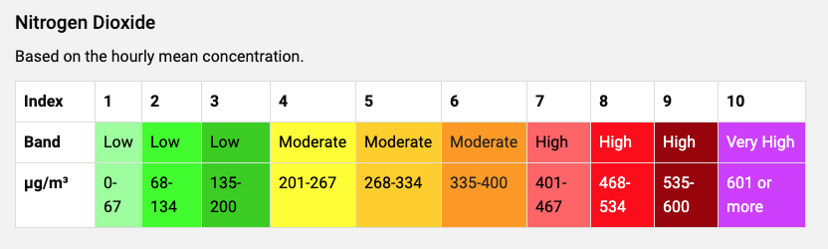
Note that low levels are considered safe for all, while moderate levels may cause health problems for those with heart or lung conditions. High and very high levels may cause health problems for anyone. See: https://uk-air.defra.gov.uk/air-pollution/daqi for more detail on the levels.
- Use the interactive map again and find the nitrogen dioxide levels for some different situations. Here are some examples of comparisons you can make.
  - Choose a different monitoring site that is more urban or more rural than your local site.
  - Choose a different time of day when there might be more or less road traffic at your local site.
  - Choose the same time of day at your local site on different days in the last week or month.
Suggest explanations for the differences in nitrogen dioxide levels between the situations you have chosen.
- The World Health Organisation (WHO) has set a guideline maximum annual mean daily value of 40 μg/m³ of nitrogen dioxide to protect the public from adverse health effects. Levels may exceed this for short periods of time during busy periods but should not exceed 200 μg/m³ during any one-hour period. See: https://www.who.int/news-room/fact-sheets/detail/ambient-(outdoor)-air-quality-and-health
Comment on how the nitrogen dioxide levels at the situations you have looked at compare with the WHO guidelines.
- Outline three ways in which levels of nitrogen dioxide due to road vehicles are being reduced from the higher levels that existed in previous decades.

Extension questions (16–18)
- Convert the value of the current nitrogen dioxide level at your local monitoring site from μg/m³ into mol/dm³.
Note that 1 μg = 1 x 10⁻⁶ g and 1 m³ = 1 x 10³ dm³.
Atomic masses: N = 14, O = 16.
- Your answer to question 7 will give a very small number of mol/dm³. However, there are still a large number of nitrogen dioxide molecules breathed in by the average person every breath.
If the volume of a typical breath is 0.5 dm³, use your answer to question 7 and Avogadro’s number
(6.02 x 10²³) to find out just how many nitrogen dioxide molecules there are in every breath you take near to your local monitoring site.

“Our World In Data’ https://ourworldindata.org/air-pollution#air-pollution-is-one-of-the-world-s-leading-risk-factors-for-death

