Science turns the taps on in drought-hit areas

Original article by Rebecca Trager. Adapted by Nina Notman.

Harvesting water directly from air offers a potential method that could fight water scarcity caused by climate change

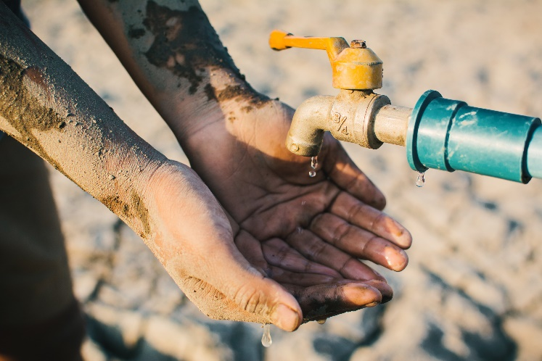
Scientists have observed water spontaneously condensing and moving across the surface of an organic crystal that is slowly subliming. This finding could pave the way for a new approach to collecting drinking water from the air in arid regions.

Nearly two-thirds of the global population currently live in regions with severe fresh water shortages for at least one month each year. Climate change will see even more people affected by drought in the future. Technical solutions are increasingly being sought to supply water to those in need.

Source: © Sawitree Pamee/EyeEm/Getty Images

Drought and desertification caused by climate change will be a growing challenge

Sublime secrets

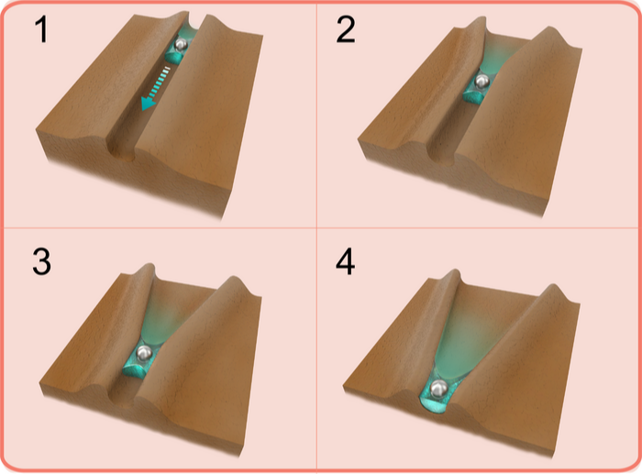
Researchers are particularly keen to develop tools to tap into water supplies in the air. This is a vast resource, with many times more water existing as vapour in the atmosphere than liquid water in our rivers at any given moment. Researchers at New York University Abu Dhabi in the United Arab Emirates hope their observations will lead to a novel way to harvest water vapour.

The scientists made their findings when studying the surface of crystals of hexachlorobenzene, a fungicide banned worldwide. They noticed that water droplets were condensing on the surface of the crystals. They also observed that the water droplets were triggering the solid hexachlorobenzene to be slowly converted into vapour – a process called sublimation. The team saw that the sublimation caused tiny channels to form on the crystal surface, and that the water droplets were being funnelled along these channels in a single direction.

Source: Courtesy of NYUAD

Water droplets condense on the surface of the crystal (brown). The droplets carry dust particles through channels that widen as the crystal material sublimes

‘This [directional movement] was found to be caused by changes in the width of small channels over time,’ the research team noted in their paper.

The research team suggest that this previously unseen phenomenon could inspire new technologies for the collection of water vapour from the air that do not require electricity. Situations in which passive water harvesting could be helpful include disaster relief, where normal drinking water supplies are disrupted or contaminated, and military operations in remote locations.

This is adapted from the article Harvesting water from the air with organic crystals in Chemistry World. Read the full article: rsc.li/3Lag1kN

