Practical planning: spot the mistakes

Learning objectives
- Identify the mistakes in methods for planned practical experiments.
- Explain why the mistakes you have found would not lead to a valid outcome.
- Select the appropriate equipment needed to carry out a given investigation.
- Plan a method that would lead to a valid outcome.

Introduction

These exam-style questions will check your understanding of experimental skills and strategies. In your answers, you will evaluate the methods described, make suggestions for improvements, select the appropriate apparatus and plan experiments. All of these are fundamental parts of working scientifically. The questions are based on chromatography, making salts and neutralisation.

Questions

Chromatography

A student was investigating the pigments in different leaves (1, 2 and 3). The pigments are insoluble in water but soluble in ethanol.

This is the method they used:
- Leaf 1 was crushed using a pestle and mortar.
- Ethanol was added using a pipette.
- The mixture was filtered.
- Spots of the filtrate were put on to the chromatography paper.
- Steps 1–4 were repeated with leaves 2 and 3.

On the next page, there is a diagram of the apparatus the student used.

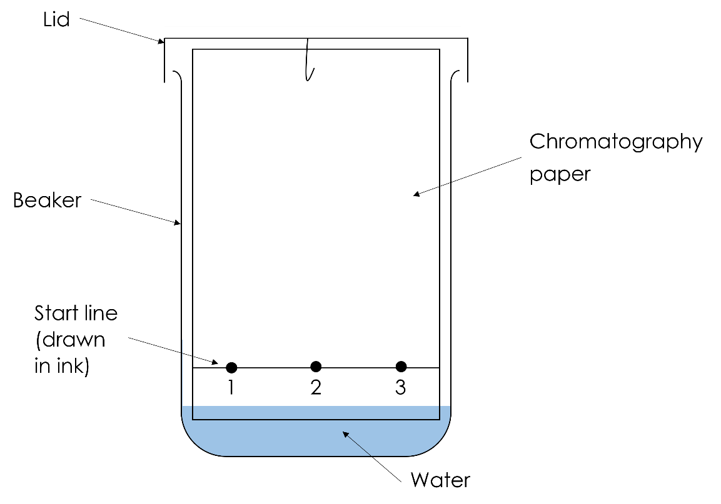

The student made two mistakes when this apparatus was set up.

1.
- Name the mistakes and give one issue caused by each mistake.

HINT: look carefully at the diagram and think about solubilities.

Mistake | Issue caused
______________________________________  ______________________________________  ______________________________________  ______________________________________ | ______________________________________  ______________________________________  ______________________________________  ______________________________________
______________________________________  ______________________________________  ______________________________________  ______________________________________ | ______________________________________  ______________________________________  ______________________________________  ______________________________________

(4 marks)

On the next page is a diagram of an investigation into the chromatography of three different inks.

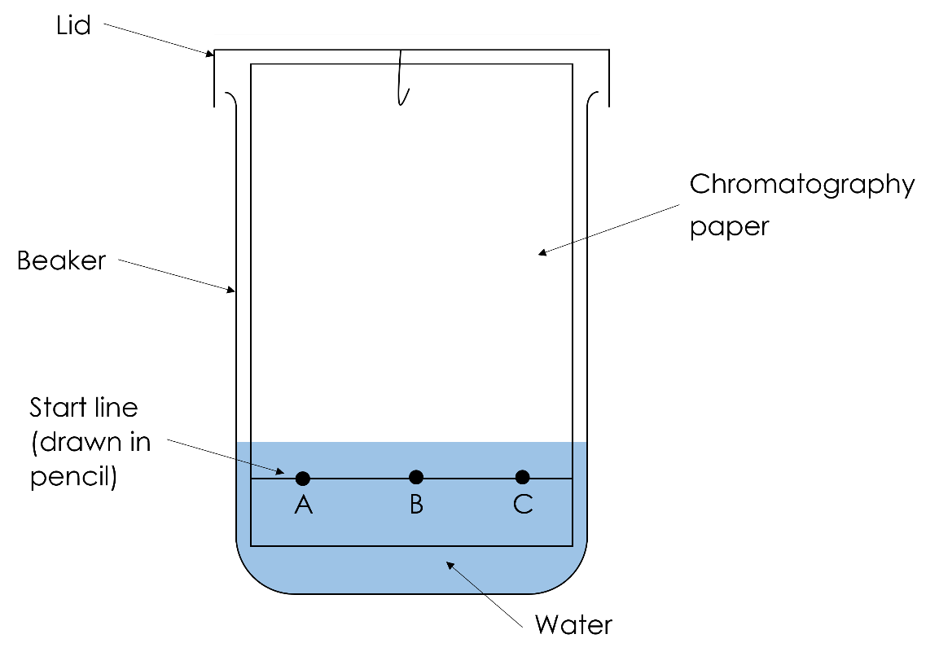
- Too much water was added to the beaker. Explain what the issue caused by the mistake is.

Mistake | Issue caused
The water level is above the start line. | ______________________________________  ______________________________________  ______________________________________

(1 mark)
- Explain why the start line was drawn in pencil.

HINT: think about why pen is not used to help you think about why pencil is used.

__________________________________________________________________________________

__________________________________________________________________________________

(1 mark)

Making salts

A student wanted to make copper sulfate crystals. This is the method they used:
- Measure out 25 cm³ of nitric acid and add it to a beaker.
- Gently warm the acid.
- Add excess calcium oxide and stir.
- Heat the solution in an evaporating basin over a water bath to the crystallisation point.
- Leave the solution on a windowsill to crystallise and pat the crystals dry with filter paper.

The student’s method did not lead to the production of copper sulfate crystals.

2.
- Identify three mistakes the student made.

Mistake 1

________________________________________________________________________________

________________________________________________________________________________

Mistake 2

________________________________________________________________________________

________________________________________________________________________________

Mistake 3

________________________________________________________________________________

________________________________________________________________________________

(3 marks)

The student corrected the mistakes they made. They used the new method (below) and made copper sulfate crystals:
- Measure out 25 cm³ of sulfuric acid and add it to a beaker.
- Gently warm the acid.
- Add excess copper oxide and stir.
- Filter the solution using a funnel and filter paper to remove excess copper oxide.
- Heat the solution in an evaporating basin over a water bath to the crystallisation point.
- Leave the solution on a windowsill to crystallise and pat the crystals dry with filter paper.
- Select the reason why copper oxide was added in excess. Tick one box.

To ensure the sulfuric acid fully reacted.

Because copper oxide is a solid.

To ensure the sulfuric acid is not a limiting reactant.

Because copper oxide is a base.

(1 mark)
- Explain why the acid was gently warmed.

__________________________________________________________________________________

__________________________________________________________________________________

(1 mark)

Neutralisation

A student wants to carry out a titration to find out the volume of potassium hydroxide that reacts with 25.0 cm ³ of sulfuric acid.

3.
- Name the apparatus below.

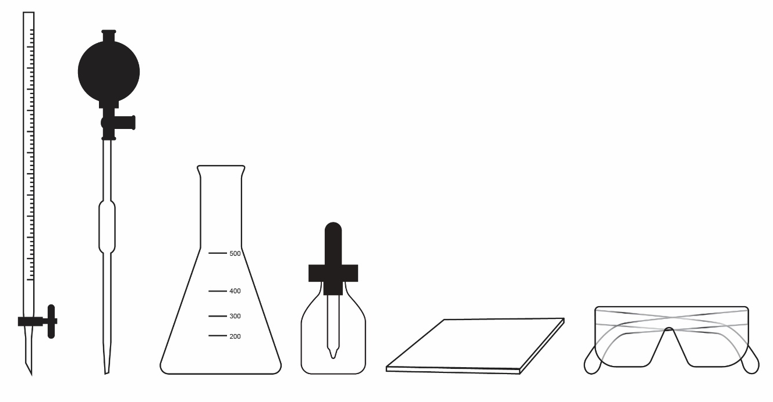

- __________________________________________________________________________

- __________________________________________________________________________

- __________________________________________________________________________

- __________________________________________________________________________

- __________________________________________________________________________

- __________________________________________________________________________

(6 marks)

- Rearrange the steps below that would lead to us find out the volume of potassium hydroxide that reacts with 25.0 cm ³ of sulfuric acid.

- Fill a burette with potassium hydroxide.
- Repeat until you have concordant results (results within 0.1 cm³ of each other).
- Read the volume used from the burette and record it.
- Add a few drops of indicator to the conical flask.
- Add 25.0 cm ³ of sulfuric acid to a conical flask and place on a white tile.
- Stop adding potassium hydroxide when the indicator colour changes.
- Add the potassium hydroxide from the burette to the sulfuric acid and indicator while swirling the conical flask.
- Add the potassium hydroxide dropwise as the indicator colour is starting to change (nearing the endpoint).
- Take an average of the concordant results – this is the volume needed to react.

Write the correct order below. Step 1 is the correct first step and step 9 is the correct last step:

__________________________________________________________________________________

__________________________________________________________________________________

__________________________________________________________________________________

__________________________________________________________________________________

__________________________________________________________________________________

__________________________________________________________________________________

__________________________________________________________________________________

__________________________________________________________________________________

__________________________________________________________________________________

__________________________________________________________________________________

__________________________________________________________________________________

__________________________________________________________________________________

__________________________________________________________________________________

__________________________________________________________________________________

__________________________________________________________________________________

__________________________________________________________________________________

__________________________________________________________________________________

__________________________________________________________________________________

(7 marks)

