Fact sheet: ionic bonding dot and cross diagrams

When a metal and a non-metal react, the metal atom loses electrons to become a positively charged ion and the non-metal atom gains electrons to become a negatively charged ion. An ionic bond is the strong electrostatic force of attraction between the metal ion and the non-metal ion due to their opposite charges.

A dot and cross diagram is one way to model the transfer of electrons that occurs during this process.

Did you know …? The group number on the periodic table tells you how many electrons there are in the outer shell of the atom. You can use this to work out the charge of the ion.

Draw a dot and cross diagram for magnesium oxide

Magnesium is a metal in group two of the periodic table, so will form a 2⁺ ion. Oxygen is a non-metal in group six of the periodic table, so will form a 2⁻ ion.
- While you are learning how to draw dot and cross diagrams it’s useful to start with something you are already familiar with: electron configuration diagrams (see rsc.li/2WHSi4F if you need a reminder). Draw the electron configuration diagrams for each atom in the compound.
- Look at the number of electrons on the outer shell of each atom. Magnesium has two, oxygen has six. Swap the crosses for dots in one of your diagrams. You don't need to put a circle around the symbol for the nucleus.
- During ionic bonding the atoms form ions by gaining or losing electrons to obtain electron configurations with a full outer shell. Magnesium loses two electrons and oxygen gains two electrons. This leaves an Mg²⁺ ion and an O²⁻ ion.
- Draw a square bracket around each ion. Magnesium now has an empty third shell so there is no need to draw a third shell.
- Add the charge outside the brackets at the top right corner. Write the size of the charge first, followed by the plus or minus.

Did you know …?
- The charge is distributed throughout the ion, the square brackets denote this.
- In an ionic compound the metal ion doesn’t just form a bond with the ion it donated electrons to. It forms strong ionic bonds with any ions of opposite charge that fit close enough to it in the ionic lattice.
- Magnesium oxide is not soluble in water because the attraction between the polar water molecules and the ions is not strong enough to break the ionic bonds between the magnesium and oxygen ions.

Drawing more complex ionic compounds

In magnesium oxide, the charges on the metal and non-metal ions are equal and opposite. What happens when the charges on the ions are not equal in magnitude? In aluminium oxide the charge on the positive metal ions is 3⁺ while the charge on the negative oxide ions is 2⁻. The table shows some different ways to draw aluminium oxide (Al₂O₃).
Variation | Diagram | Details
1 | 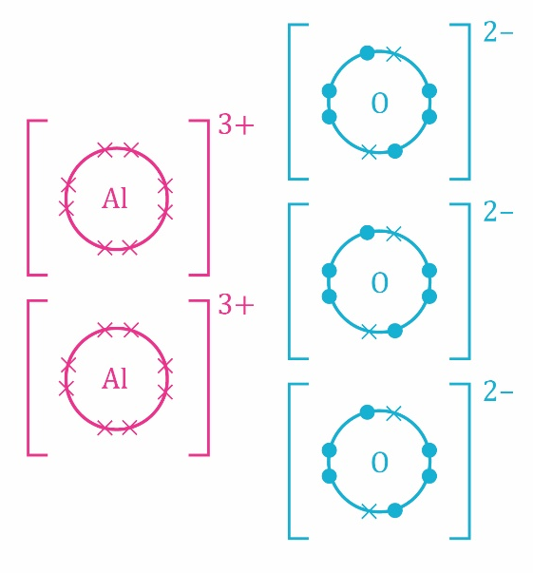 | Draw the two positive aluminium ions on the left and the three negative oxygen ions on the right. The number of ions indicates the ratio of aluminium to oxygen.
2 |  | This diagram looks more like the chemical symbol for the compound Al₂O₃.
3 |  | The large numbers in this diagram are multipliers. They mean that there are two aluminium ions for every three oxygen ions.

