- The diagram shows a fractionating tower used to separate crude oil.
The names of each fraction are missing from the diagram.
Distillation Column
Write the correct fraction into the correct box.

Bitumen
Lubricating oil
Naphtha
Petrol
Gas
Kerosene
Diesel
Fuel oil
Bitumen
Lubricating oil
Naphtha
Gasoline (petrol)
Gas
Kerosene
Diesel oil
Fuel oil

Source: International bunch / adapted from Shutterstock

- On moving up the fractionating column, there are gradual trends seen in the properties of each fraction.

- Place into the blank spaces in the table the words increase or decrease to show how each of the following changes:
Distillation Column
Property | Increase or decrease?
Boiling point
Volatility
Viscosity
Flammability

- Explain the change in boiling point stated in the table.
Use ideas of molecular size in your answer.

- Crude oil – true or false.
The following are statements about the separation of crude oil.
State whether each statement is true or false by writing T or F in the boxes.
- Crude oil is a complicated mixture containing carbohydrates.

- Crude oil is formed when biomass, for example plankton, is compressed and heated over millions of years.

- The process of fractional distillation is used to separate crude oil into its components.

- As we move up a fractionating column, the temperature of the column increases.

- Crude oil is heated before it is pumped into the fractionating column.

- Molecules with higher boiling points move further up the column.

- Crude oil vapour condenses at different heights depending on the boiling point.

- The fractions produced contain molecules of exactly the same boiling point.

- Most of the fractions from crude oil are used as fuels.

- Here are some molecules found in crude oil.
Which one is which?
Write A, B or C in the table below.
A
C
B
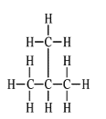
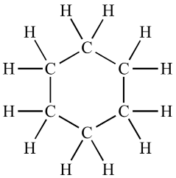
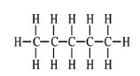

One is a straight chain molecule.

One is a branched-chain molecule.
One is a cyclic molecule.

