Finding the empirical formula
Education in Chemistry
May 2019
rsc.li/2WXXaxn
Once students are confident using mol = mass/M_{r}, start determining empirical formulas. Working through empirical formula equations improves students’ grasp of ratios, without the demanding chemical concept of relating that to balancing.

An oxide of copper
The chemical formula gives the types of atom in the substance. It also gives the relative number of each type. From the mass of each element in a sample, the number of moles can be calculated. The lowest whole number ratio provides the simplest chemical formula.

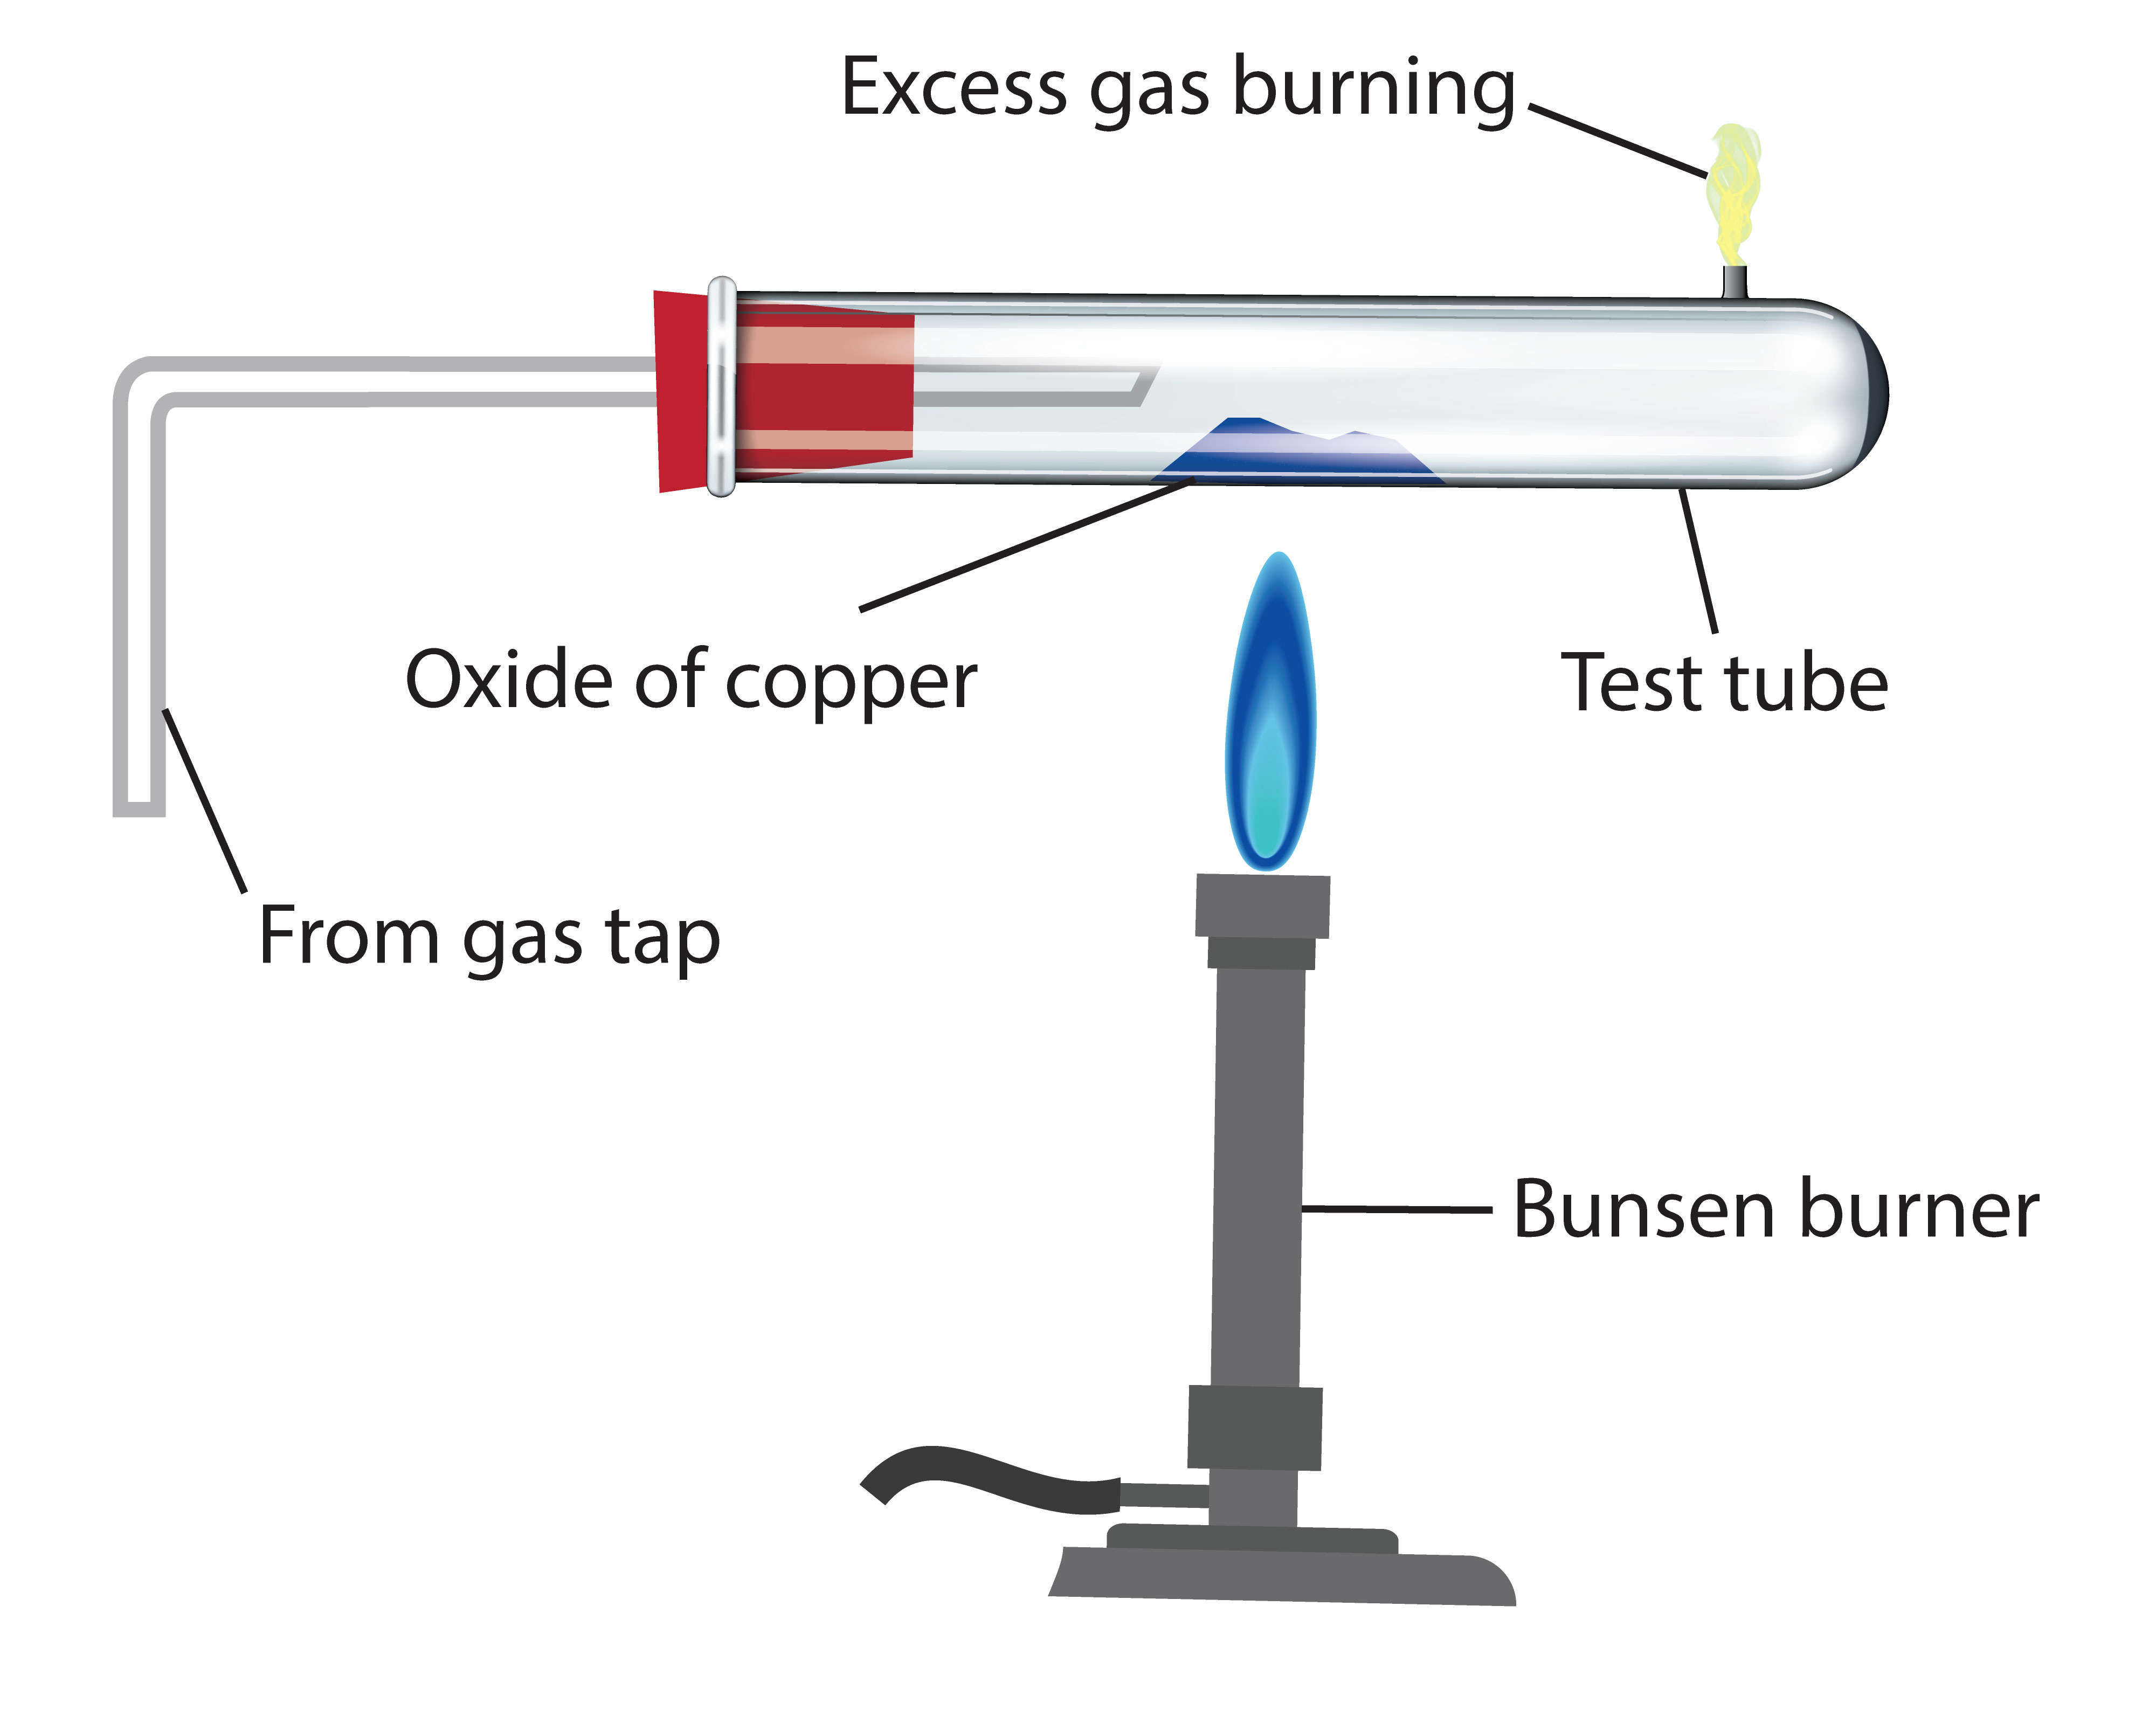

The practical method
A teacher carried out a demonstration following the instructions below:
1. Weigh the test tube and bung.
2. Place two spatulas of dry copper oxide in the centre of the tube. Try to spread it out.
3. Weigh the tube, bung and copper oxide.
4. Assemble the apparatus as shown in the diagram above.
5. Pass a gentle stream of gas through the tube without lighting it. This will flush out the air. After a few seconds set light to the gas and adjust the height of the flame coming out of the test tube to about 3 cm.
6. Heat the copper oxide strongly and move the flame slowly to and fro. Continue to heat for five minutes after the solid has turned a brownish pink colour.
7. Stop heating the tube but keep the gas flowing through the test tube and burning at the end. This prevents re-oxidation of the copper.
8. Let the test tube cool, turn off the gas and reweigh the tube, bung and copper.

What to record
Mass of empty tube = 52.2 g
Mass of tube + copper oxide (before experiment) = 66.6 g
Mass of tube + copper (after experiment) = 65.0 g

Questions
1. What is the mass of copper oxide used?

2. What is the mass of copper formed?

3. What is the mass of oxygen lost?

4. How many moles of copper were formed?

5. How many moles of oxygen were combined with this number of moles of copper?

6. What is the simplest whole number ratio of moles of copper to moles of oxygen?

7. What is the formula of copper oxide?

An oxide of vanadium
The teacher then used the same method to determine the formula of an oxide of vanadium. This time the solid turned a silvery grey colour instead.

Results
Mass of empty tube = 52.20g
Mass of tube + vanadium oxide (before experiment) = 59.16g
Mass of tube + vanadium (after experiment) = 56.10g

Questions
1. What is the mass of vanadium oxide used?

2. What is the mass of vanadium formed?

3. What is the mass of oxygen lost?

4. How many moles of vanadium were formed?

5. How many moles of oxygen were combined with this number of moles of vanadium?

6. What is the simplest whole number ratio of moles of vanadium to moles of oxygen?

7. What is the formula of vanadium oxide?

