Kinetics

Rate determining step

1. For each of the everyday processes described below, identify the step that slows the process down.

- Making a cup of tea

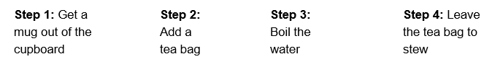
- Playing with a model helicopter received as a Christmas present

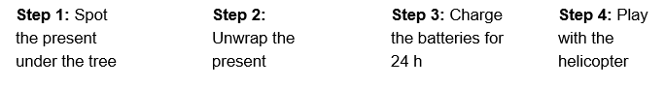
- Getting out of the house in the morning on time
(3 marks)

The overall rate of these processes is controlled by the rate of the slowest step. For a chemical reaction we call this step the rate determining or rate limiting step.
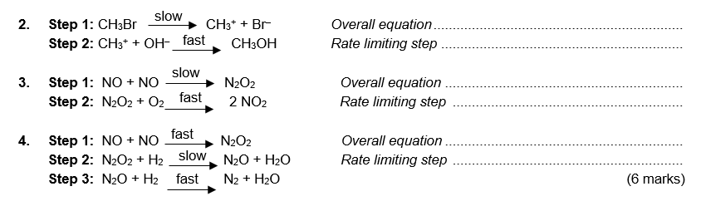
For each of the multi-step reactions below, write the overall equation for the reaction and identify the rate limiting step.

BONUS MARK
In a chemical reaction, any step that occurs after the rate determining step will not affect the rate. Therefore any species that are involved in the mechanism after the rate determining step do not appear in the rate expression. Use this information to predict which of the options below is the correct rate expression for the reaction shown in question 2.

(a) Rate = k [CH₃Br] or (b) Rate = k [CH₃Br][OH–]
(1 mark)

Calculating reaction rate
- What is the definition for the rate of a reaction?

(2 marks)

- A simple way to determine the rate of a reaction is to measure the change in concentration of one reagent with time. The graph below shows the change in concentration of [C₄H₉Cl] during the reaction;

C₄H₉Cl + OH– → C₄H₉OH + Cl–
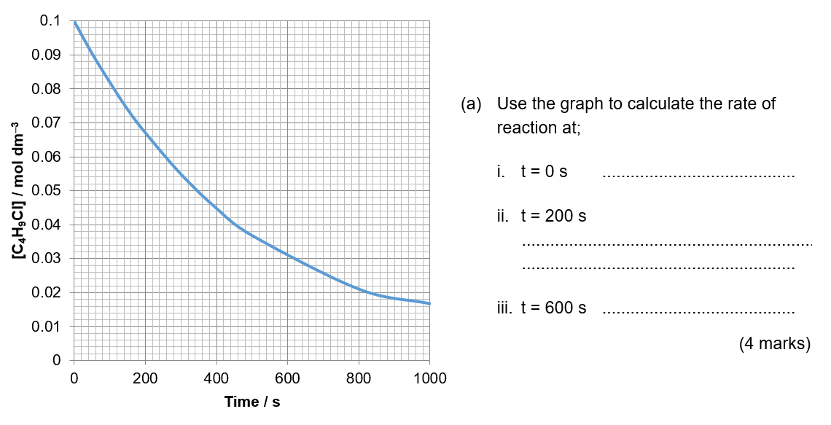
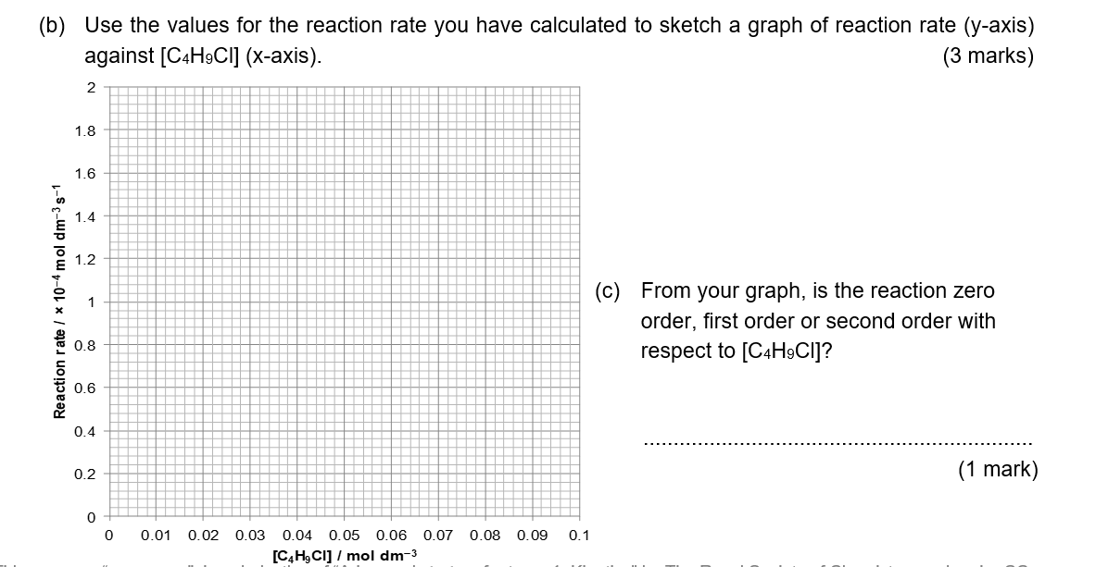

Measuring reaction rate in the lab

The rate of a reaction is defined as the change in concentration of reactants or products per unit time. The units of rate are mol dm⁻³ s⁻¹.
The method chosen to measure the rate of a reaction depends on the individual reaction.
For each of the reactions below, use the observations made to calculate the initial rate of the reaction.

- Measuring the rate of a reaction when a precipitate is formed;

Na₂S₂O₃(aq) + 2 HCl(aq) → 2 NaCl(aq) + H₂O(l) + S(s) + SO₂(g)

A student wished to investigate how temperature affected the rate of the reaction between sodium thiosulfate and acid. He reacted 10 cm³ of a 0.02 mol dm⁻³ solution of sodium thiosulfate with 40 cm³ of hydrochloric acid (excess) at 22 °C. The time taken to produce a precipitate of 1 × 10^{–4} mol of sulfur was found to be 56 s.

Initial rate of production of sulfur = mol dm^{–3} s^{–1}
(2 marks)
- Measuring the rate of a reaction in which there is a change in colour;

CH₃COCH₃(aq) + I₂(aq) → CH₃COCH₂I(aq) + H⁺(aq) + I⁻ (aq)
colourless brown colourless colourless

A student followed the reaction between iodine and propanone to produce iodopropanone. She set up the first experiment as described in the table below and found it took 279 s for the brown colour of the iodine to disappear.

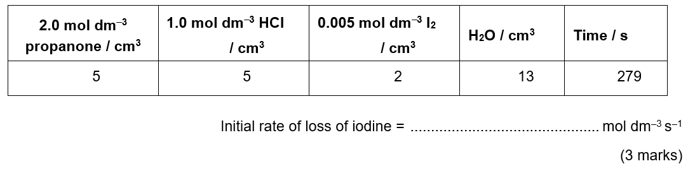
- Measuring the rate of a reaction in which a gas is produced;

Mg(s) + 2 HCl(aq) → MgCl₂(aq) + H₂(g)

The student reacted a 3 cm strip of magnesium ribbon with 25 cm³ of 2.0 mol dm^{–3} HCl (an excess). He found that 14 cm³ of gas was produced in the first 10 seconds of the reaction.

(You may assume the reaction was carried out at RTP where 1 mole of gas has a volume of 24 dm³.)

Initial rate of loss of hydrochloric acid = mol dm^{–3} s^{–1}
(4 marks)

Determining the rate equation

For each of the following sets of experimental data determine;

(a) The rate equation for the reaction,
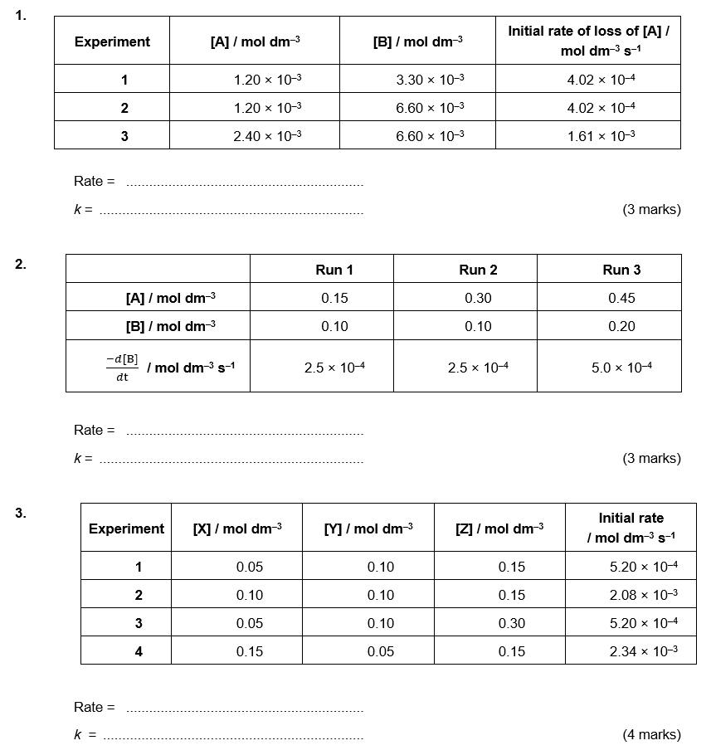
(b) The value of the rate constant, k including its units.

Arrhenius and rate

1. A reaction between A and B was found to be first order with respect to both.
(a) Write the rate equation for the reaction

(1 mark)

(b) The rate constant k varies with temperature. Use the data together with the rate equation you have written in part (a) to complete the table below;
(4 marks)
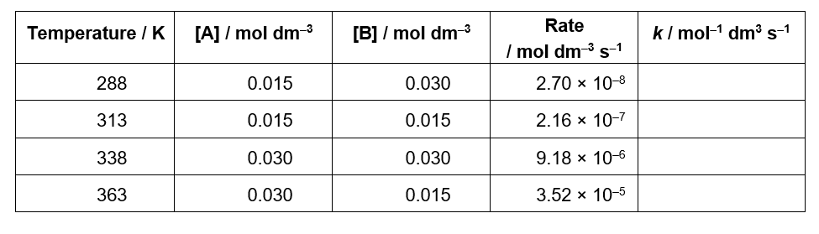
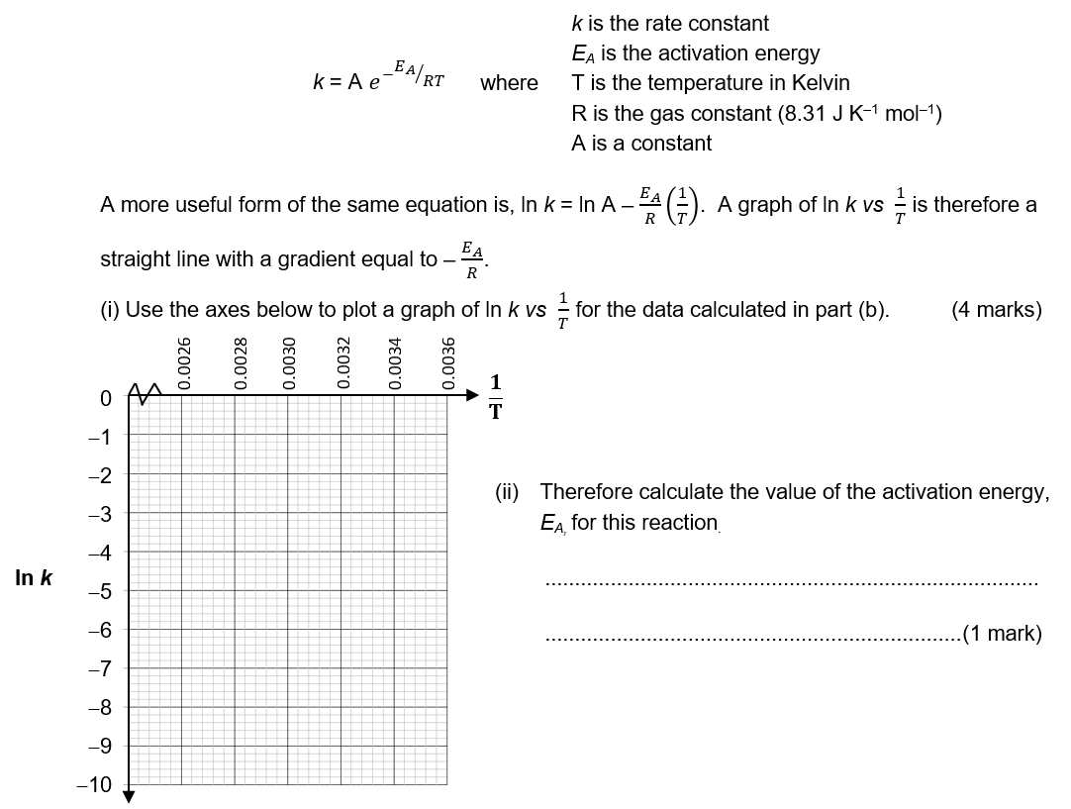
(c) A scientist wishes to use this data to determine the activation energy for the reaction. He can do this using the Arrhenius equation;

Kinetics – Answers

Rate determining step
1. (a) Step 3 Boil the water
(b) Step 3 Charge the batteries for 24 h
(c) Step 2 Get out of bed (although this may depend on the individual!)
(3 marks)
2. Overall equation: CH₃Br + OH– → CH₃OH + Br–
Rate limiting step: CH₃Br → CH₃⁺ + Br⁻ (Step 1)
(2 marks)
3. Overall equation: 2 NO + O₂ → 2 NO₂
Rate limiting step: NO + NO → N₂O₂ (Step 1)
(2 marks)
4. Overall equation: 2 NO + 2 H₂ → N₂ + 2 H₂O
Rate limiting step: N₂O₂ + H₂ → N₂O + H₂O (Step 2)
(2 marks)
BONUS MARK Answer = (a) Rate = k [CH₃Br]
(1 mark)

Calculating reaction rate

1. The rate of a reaction is the change in concentration of reactants or products per unit time (2 marks)
2. (a) i. 2.0 × 10^{–4} mol dm^{–3} s^{–1}
ii. 1.3 × 10^{–4} mol dm^{–3} s^{–1}
iii. 5.5 × 10^{–5} mol dm^{–3} s^{–1}
(1 mark for each correct value, 1 mark for the correct units for rate)
(b)
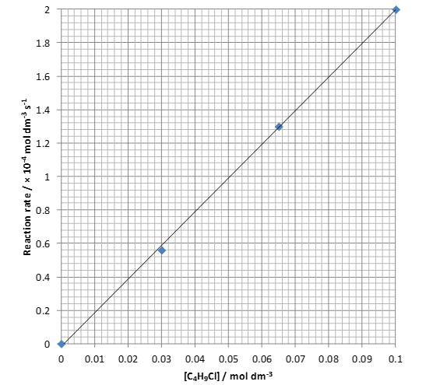
- marks)
(c) The reaction is first order with respect to C₄H₉Cl.
(1 mark)

Measuring reaction rate in the lab
1. Change in concentration of sulfur = (1 × 10^{–4} mol – 0 mol) / 0.05 dm³ = 2 × 10^{–3} mol dm^{–3}
(1 mark)
Initial rate of production of sulfur = 2 × 10^{–3} mol dm^{–3} / 56 s = 3.6 × 10^{–5} mol dm^{–3} s^{–1}
(1 mark)
2. Moles of iodine in reaction mixture at start = 0.002 dm³ × 0.005 mol dm^{–3} = 1 × 10^{–5} mol
(1 mark)
Change in concentration of iodine = (1 × 10^{–5} mol – 0 mol) / 0.025 dm³ = 4 × 10^{–4} mol dm^{–3}
(1 mark)
Initial rate of loss of iodine = 4 × 10^{–4} mol dm^{–3} / 279 s = 1.4 × 10^{–6} mol dm^{–3} s^{–1}
(1 mark)
3. Moles in 14 cm³ of hydrogen at RTP = 0.014 dm³ / 24 dm³ = 5.8 × 10^{–4} mol
(1 mark)
Moles of acid used up to produce this many moles of hydrogen = 5.8 × 10^{–4} mol × 2 = 1.17 × 10^{–3} mol
(1 mark)
Change in concentration of acid = 1.17 × 10^{–3} mol / 0.025 dm³ = 0.047 mol dm^{–3}
(1 mark)
Initial rate of loss of hydrochloric acid = 0.047 mol dm^{–3} / 10 s = 0.0047 mol dm^{–3} s^{–1}
(1 mark)

Determining the rate equation
1. Rate = k[A]²; k = 280 mol^{–1} dm³ s^{–1}
(2 marks for the identification of the correct order wrt A and B, 1 mark for k with correct units)
2. Rate = k[B]; k = 2.5 × 10^{–3} s^{–1}
(2 marks for the identification of the correct order wrt A and B, 1 mark for k with correct units)
3. Rate = k[X]²[Y]; k = 2.08 mol^{–2} dm⁶ s^{–1}
(3 marks for the identification of the correct order wrt X, Y and Z, 1 mark for k with correct units)

Arrhenius and rate
1. (a) Rate = k[A][B]
(1 mark)
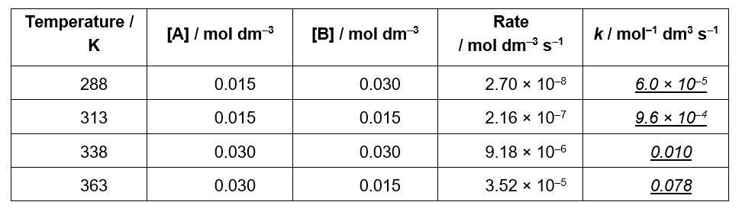
(b)

(c)
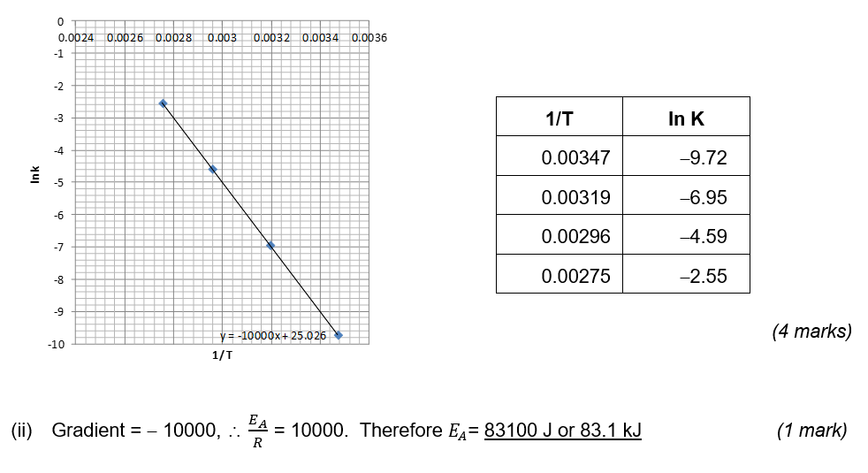
(I)

