Understanding climate change as a process – teacher notes
Education in Chemistry
Sustainability in chemistry 2021
Goal 13: take urgent action to combat climate change and its impacts
rsc.li/3Coivp5
Earth’s atmosphere is incredibly complex and human activities have changed its composition in ways that result in extreme changes of climate. This activity looks at the chain that leads from human action in one place to an effect on the environment in another place.
Construct a flow diagram in class – see next page – to help learners better understand how the different elements they have learnt about fit together into one integrated whole. This will also give you a chance to check their understanding. Follow these steps to help get the most from using a live drawing approach.
- Start with a blank canvas (ie an empty board).
- Start drawing the diagram, explaining aloud as you go.
- Then add your label to the diagram silently.
- Allow students to read it.
- Bring your students’ attention back to you, then start drawing the next section.
- Explicitly gesture and point to the bits you want students to look at while you are explaining eg by saying ‘look at this’.
- Repeat the cycle until your diagram is complete.
Dual coding boosts memory gives more guidance and information about why drawing in front of the class helps them learn.

Using the questions
The questions gradually escalate in difficulty. They can be used at the end of your teaching of this topic, though many of them would be good checks for understanding throughout teaching.
The calculation questions might be particularly challenging for your learners if they don’t see how they relate to what they have learnt about moles and masses. It may be worth letting them try on their own for a little bit before reminding them that the questions are analogous to ones they have already studied.
You may also need to give a little more support to some of your students for the longer-response questions to improve the success rate. This might be simple prompts, or you might want to use similar examples as a whole class activity first (eg explain why cattle farming in South America can result in forests in Siberia experiencing less rainfall).

Model for flow diagram

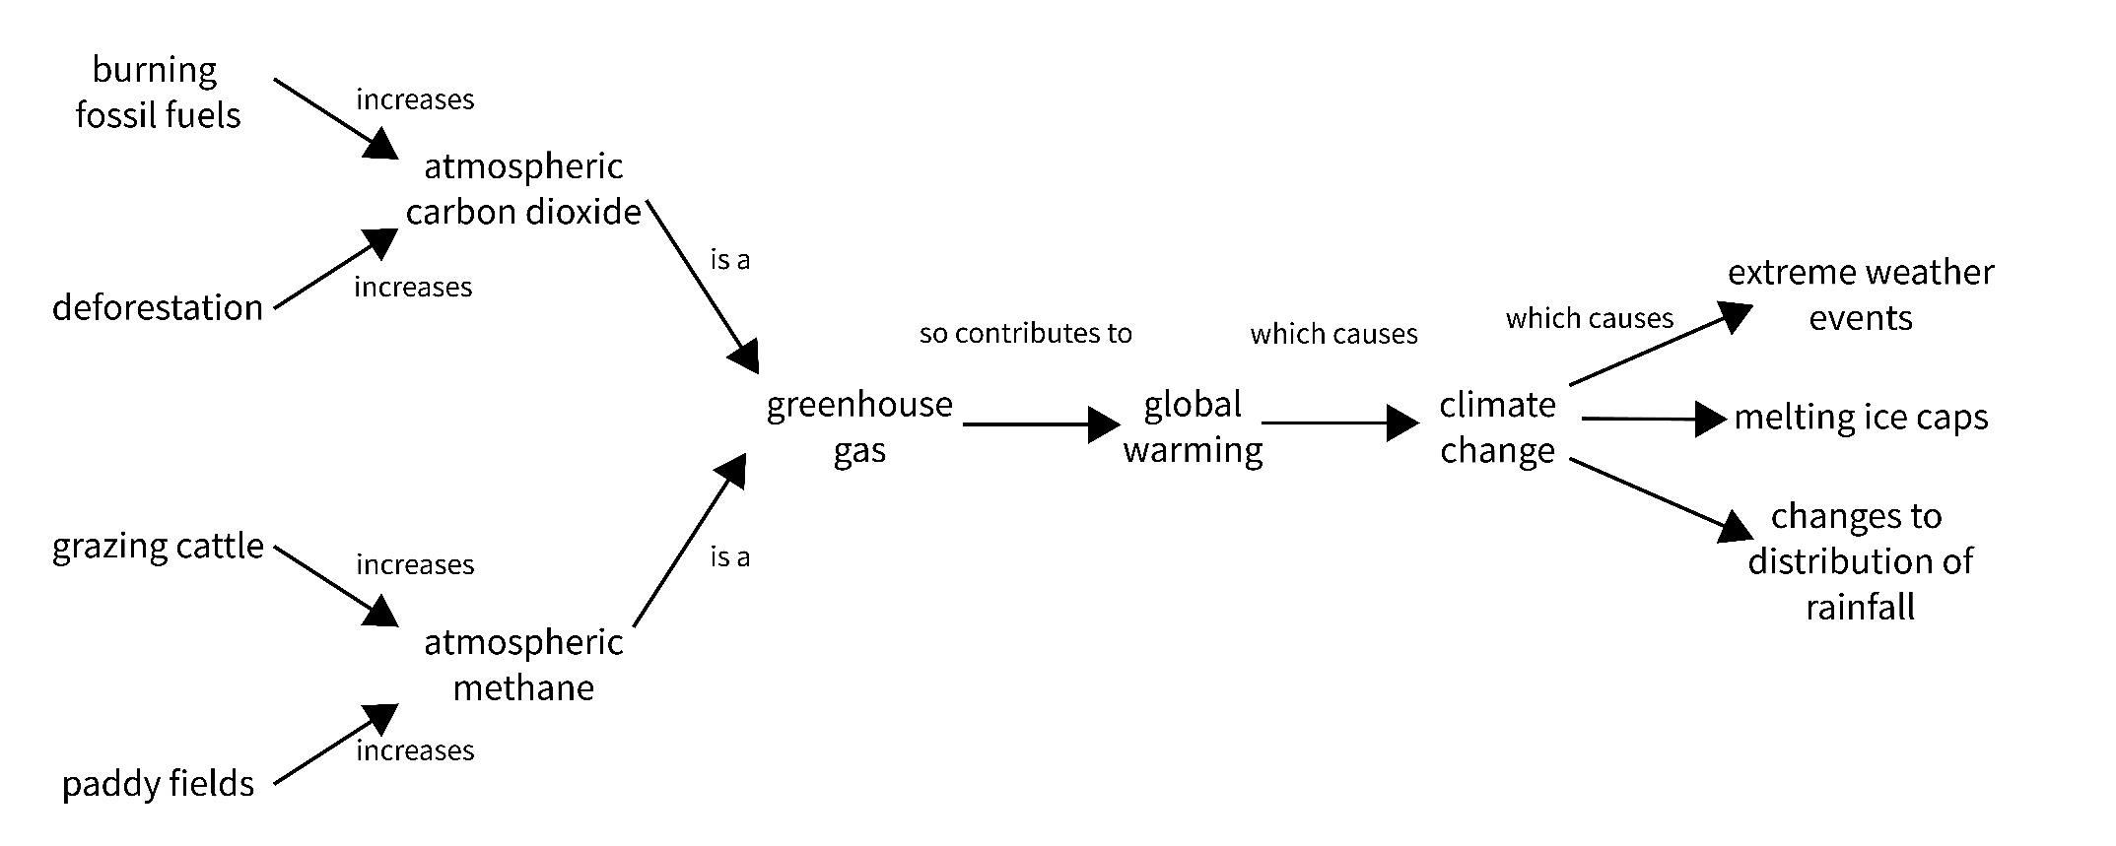

Answers to the questions
- What do ‘burning fossil fuels’ and ‘deforestation’ have in common?
They both contribute to an increase in atmospheric carbon dioxide.
- What two things can increase the amount of atmospheric methane?
Rice farming, cattle farming, (other processes that release natural gas like melting permafrost).
- Why does question 2 say ‘atmospheric methane’ and not just ‘methane’?
Some methane is stored underground.
- Why are greenhouse gases called greenhouse gases?
They cause the greenhouse effect (a process of warming similar to how greenhouses work).
- If we have a winter that’s colder than usual, does that prove global warming isn’t happening?
No, global warming is an increase in the average temperature across the entire planet over time. One winter in one place at one time does not fit that definition.
- What is the difference between global warming and climate change?
Global warming is an increase in the average temperature of the planet over time. Climate change includes this warming and other effects like changes in rainfall distribution and extreme weather events.
- What are the effects of changes to the distribution of rainfall?
Crops cannot grow as well, leading to food shortages. The same applies to wild plants, resulting in loss of species and habitat.
Next, answer the calculation questions below:
A molecule of methane is approximately 30 times more effective as a greenhouse gas than a carbon dioxide molecule.
- How many molecules of carbon dioxide would need to be released to have the same greenhouse effect as 5 molecules of methane?
150
- How many molecules of methane are in one mole of methane?
6.02 x 10²³
- What is the mass of one mole of methane?
16 g
- What mass of carbon dioxide would need to be released to have the same greenhouse effect as 10 kg of methane?
10 kg of methane = 625 moles methane
625 moles methane x 30 = 18,750 moles carbon dioxide
Mass of 18,750 moles carbon dioxide = 18,750 x 44 = 825,000 g or 825 kg of carbon dioxide
The questions below deal with atmospheric methane:
- Methane can be combusted in oxygen as below:
CH₄ + 2O₂ 2H₂O + CO₂
Balance the equation.
- A student says that combusting atmospheric methane increases the greenhouse effect because it releases carbon dioxide. Explain why the student could be wrong.
Combusting one molecule of methane results in one molecule of carbon dioxide, but methane is a more significant greenhouse gas than carbon dioxide, so you are losing a very potent greenhouse gas and gaining a much less potent greenhouse gas. The overall effect is to decrease the amount of greenhouse effect, not increase it.
- Over time, methane in the atmosphere breaks down. Carbon dioxide does not break down. Given this new information, explain why the student could be right.
If the methane breaks down into something that is not a greenhouse gas, then leaving it to break down means you lose the greenhouse gas completely (whereas if you combust methane, you get carbon dioxide).
- What more information do you need before you can tell for sure if the student is right?
You need to know if any of the products of methane breakdown are greenhouse gases and whether they would be more, or less, potent than carbon dioxide.
Finally, answer these longer-response questions:
- Polar bears live on the ice in the Arctic Circle. Explain how rice farming in India can affect polar bears in the Arctic Circle over 4000 km away.
Answers will vary, look for the following key points:
- Rice farming releases methane into the atmosphere
- Methane is a greenhouse gas
- Greenhouse gases contribute to global warming
- Global warming causes climate change
- Climate change is across the planet, not just over India
- As Earth’s temperature rises, ice melts (even though it is far from India)
Polar bears have less space to live, breed and hunt

- A student says, ‘In order to stop climate change, all we need to do is to plant more forests’.
Prepare a one-minute speech stating whether you agree or disagree with the student and explaining why.
Answers will vary.
Common arguments in favour:
- Trees photosynthesise
- Photosynthesis removes carbon dioxide from the atmosphere
- Carbon dioxide contributes to global warming and climate change
Common arguments against:
- You would need to establish the number of trees required
- Planting trees would not necessarily offset the increased production of carbon dioxide
- It might be too late to plant the number of trees needed – trees take time to grow
- There might not be enough land to plant the number of trees needed
- The sources of greenhouse gases remain
- Other greenhouse gases (like methane) cannot be absorbed by trees

