Transition metal chemistry

Transition metals recap

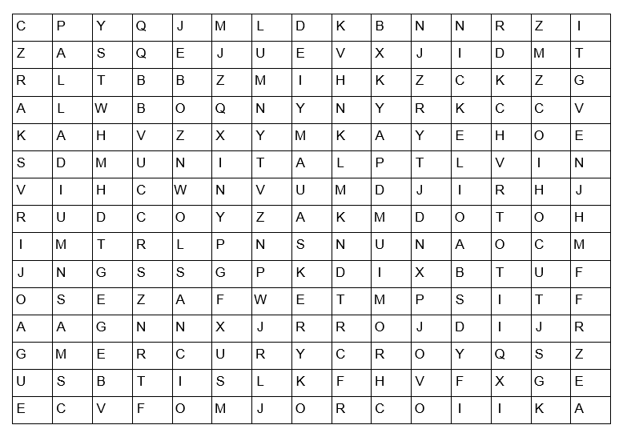

Find in the word search above, the answers to each of the questions below to gain the mark(s);

1. The catalyst in the Haber process used to make ammonia
(1 mark)
2. 3 Common catalysts found in the catalytic converter

(3 marks)
3. The aqueous solution of this metal sulphate is blue
(1 mark)
4. This metal has a melting point of −38.3 ^{º}C
(1 mark)
5. These two transition metals are found in the smart alloy, nitinol.
(2 marks)
6. These two metals when in oxidation states +6 and +7 respectively and combined with oxygen are common oxidising agents used in organic chemistry.
(2 marks)

Transition metal complexes

A transition metal complex consists of a central metal ion surrounded by ligands. A ligand is an ion or molecule with a lone pair of electrons that forms a coordinate bond with a transition metal ion.

1. For each of the ligands below, mark on any lone pairs which are able to form coordinate bonds, and identify the ligand as unidentate (can form one coordinate bond), bidentate (can form two coordinate bonds) or multidentate (can form three or more coordinate bonds).
(4 marks)

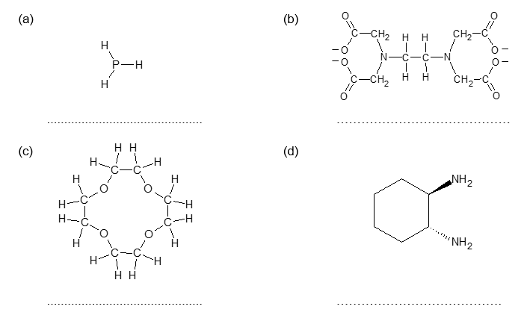
2. For each of the complexes listed (a)-(c) below, draw a 3-dimensional representation of its structure, and identify the name given to its shape.

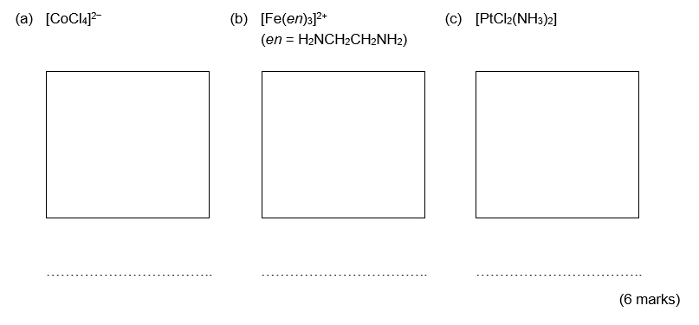

Colours of complex ions

1. Despite being a d-block element, zinc is not considered a transition element. Explain why.

(2 marks)

2. Anhydrous solid copper (II) sulfate is white but once hydrated, copper(II) sulfate solution is blue.
Use the diagrams below to help you explain why.
Decide on the best order for the diagrams and then add a few words of explanation to each.
(8 marks)
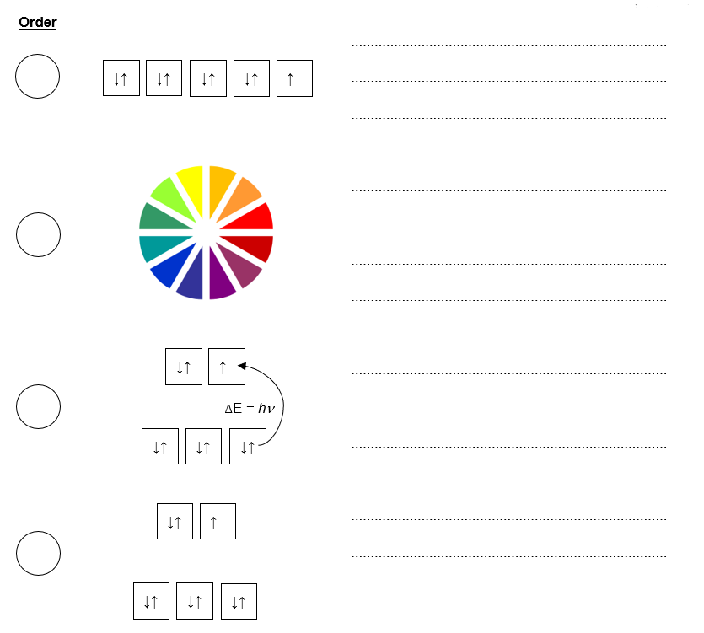

Colorimetry

1. Nick is trying to determine the formula of the complex formed between Cu²⁺ ions and NH₃. He mixes different volumes of solutions containing the two ions and measures the absorbance of the resulting solution. His results are shown in the table opposite.
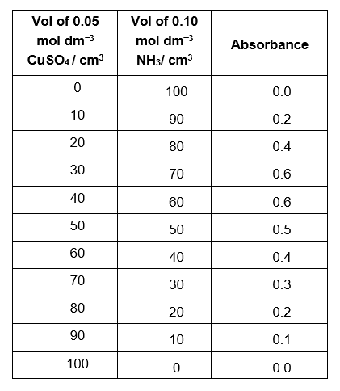
(a) Plot Nick’s results on the graph paper below.
(1 mark)
(b) Use the graph to;

(i) Determine the stoichiometry of the Cu²⁺ : NH₃ complex,

(ii) Suggest a formula for the complex ion formed.
(4 marks)

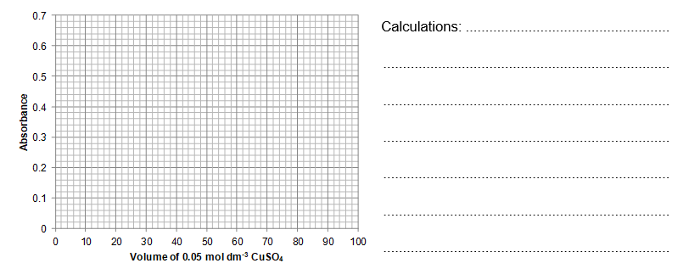

2. In a different experiment, Nick wishes to determine the concentration of the blue dye, E133 (Blue no. 1) in a new sports drink, “Go Go Go.”

Outline the experiment Nick could perform in order to determine the concentration of the blue dye in “Go Go Go.” You can assume he has access to a solution of E133 of known concentration (0.20 mol dm⁻³) and a sample of the sports drink as well as access to common laboratory equipment.
(5 marks)

Redox titrations

The pharmacists have had an accident and managed to mix up all their iron tablets. They have three foils of tablets (labelled A-C) which they know must have come from one of the bottles below;

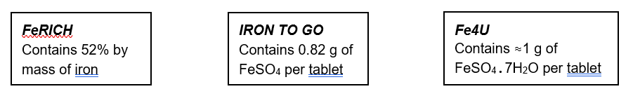
Help the pharmacists work out which tablets are which by interpreting the results of their analyses below.

One of Tablet A (1.05 g) was dissolved in excess sulfuric acid and made up to 250 cm³ in a volumetric flask. A 25.00 cm³ aliquot of this solution required 21.65 cm³ of a 0.005 mol dm⁻³ solution of KMnO₄ for complete oxidation.

Tablet A is from

(3 marks)

2.10 g of Tablet B (2 tablets) were dissolved in excess sulfuric acid and made up to 500 cm³ in a volumetric flask. A 25.00 cm³ aliquot of this solution required 19.45 cm³ of a 0.010 mol dm⁻³ solution of KMnO₄ for complete oxidation.

Tablet B is from

(3 marks)

One of Tablet C (1.21 g) was dissolved in excess sulfuric acid and made up to 500 cm³ in a volumetric flask. A 20.00 cm³ aliquot of this solution required 10.5 cm³ of a 0.0022 mol dm⁻³ solution of K₂Cr₂O₇ for complete oxidation.

Tablet C is from

(3 marks)

BONUS MARK How could you check that all of the iron in the FeRICH tablets is in the form of iron(II) and not iron(III)?
(1 mark)

Redox chemistry of transition metals

One of the important properties of transition metals is that they can exist in a range of oxidation states in their compounds. The different oxidation states can be readily inter-converted.

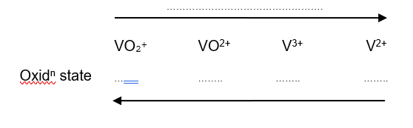
1. Vanadium has an extensive redox chemistry.
(a) Complete the diagram by;
(i) Identifying the oxidation state of vanadium in each of the vanadium containing species
(ii) Adding labels to indicate if the change shown by the arrows is oxidation or reduction.
(2 marks)
(b) Use the electrode potentials in the table to explain the following;
(i) Nitric acid will oxidise V²⁺ to VO²⁺ but no further.
(2 marks)
(ii) Zinc will reduce VO₂⁺ to V²⁺.
(2 marks)
2. Write two half equations and combine to give a full redox equation for the following oxidations;
(a) The oxidation of [Cr(OH)₆]³⁻ to CrO₄²⁻ using hydrogen peroxide under alkaline conditions.
(2 marks)
(b) The oxidation of [Co(NH₃)₆]²⁺ to [Co(NH₃)₆]³⁺ by oxygen in the air under alkaline conditions.
(HINT: O₂ is reduced to OH⁻ ions under these conditions)
(2 marks)

Transition metals as catalysts
A phase is defined as a distinct form of matter with uniform properties throughout, that is separated by its surface from other forms. Catalysts can be referred to as either;
Heterogeneous if the catalyst is present in the reaction in a different phase to the reactants, or
Homogeneous if the catalyst is present in the reaction in the same phase as the reactants.
1. For each of the reactions (a)-(g) below, identify the transition metal catalyst and state whether it is an example of a heterogeneous catalyst or a homogeneous catalyst. (7 marks)
(a) Hydrogenation of ethene to make ethane; Catalyst =
CH₂=CH₂ + H₂ → CH₃CH₃ homogeneous / heterogenous
(b) The Haber process to make ammonia; Catalyst =
N₂ + 3 H₂ ⇌ 2 NH₃ homogeneous / heterogenous
(c) The Contact process Catalyst =
2 SO₂ + O₂ ⇌ 2 SO₃ homogeneous / heterogenous
(d) A catalytic converter Catalyst =
2 NO + 2 CO → N₂ + 2 CO₂ homogeneous / heterogenous
(e) The oxidation of iodide by peroxodisulfate ions Catalyst =
S₂O₈²⁻ + 2 I⁻ → 2 SO₄²⁻ + I₂ homogeneous / heterogenous
(f) The decomposition of hydrogen peroxide Catalyst =
2 H₂O₂ → 2 H₂ + O₂ homogeneous / heterogenous
(g) The oxidation of ethanedioic acid by MnO₄⁻ ions Catalyst =
2 MnO₄⁻ + 16 H⁺ + 5 C₂O₄²⁻ → 2 Mn²⁺ + 8 H₂O + 10 CO₂ homogeneous / heterogenous

2. The reaction in 1. (g) is an example of autocatalysis.
(a) Explain what is meant by autocatalysis
(1 mark)
(b) By writing balanced symbol equations for the stages involved in the reaction, explain how autocatalysis in this case works.
(2 marks)

Transition metal chemistry – Answers

Transition metals recap
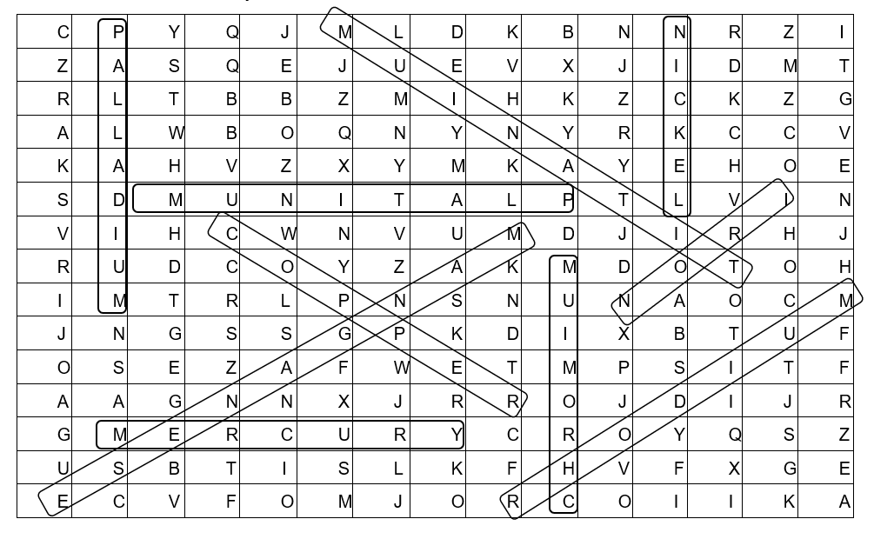
Coordinates are for the first letter of each answer.

1. iron (14 across, 6 down) (1 mark)
2. platinum (10 across, 6 down), rhodium (9 across, 15 down) or palladium (2 across, 1 down) (3 marks)
3. copper (4 across, 7 down) (1 mark)
4. mercury (2 across, 13 down) (1 mark)
5. nickel (12 across, 1 down) and titanium (13 across, 8 down) (2 marks)
6. chromium (10 across, 15 down) and manganese (9 across, 7 down) (2 marks)

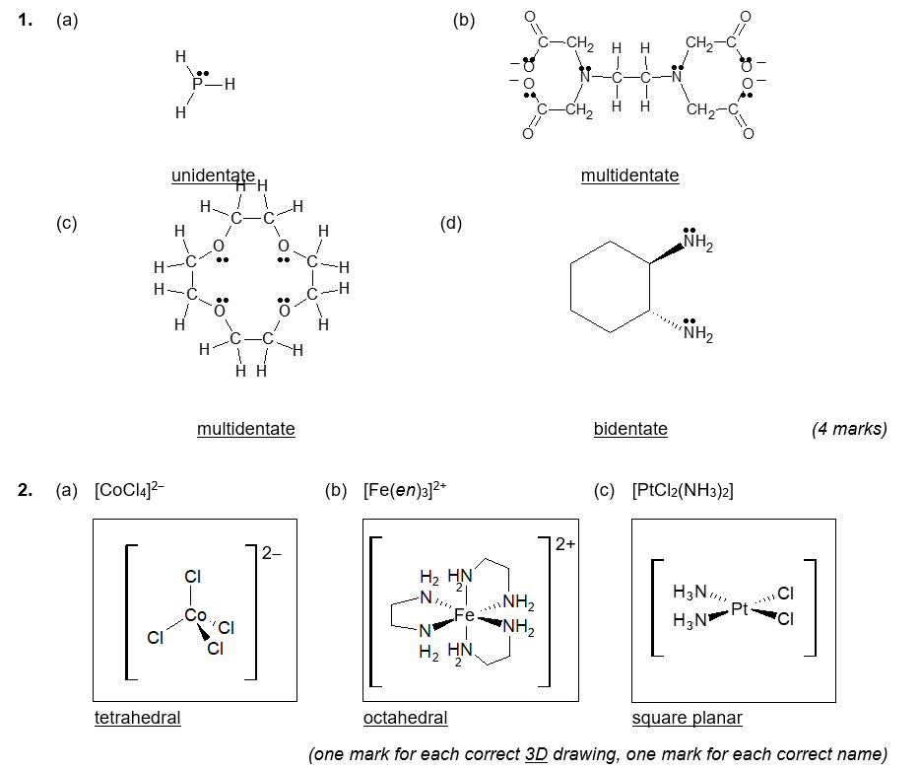
Transition metal complexes

Colours of complex ions
1. The formal definition of a transition metal is ‘an element that forms at least one stable ion with a partially full d-shell.’ Zinc forms only one stable ion, Zn²⁺ which has an electronic configuration of [Ar] 4sº 3d¹⁰ i.e. has a full d shell.
(1 mark for definition, 1 mark for full explanation of why zinc does not meet the criteria)

NOTE IUPAC gives the definition of a transition element as ‘An element whose atom has an incomplete d sub-shell, or which can give rise to cations with an incomplete d sub-shell.’ Elemental zinc does not contain an incomplete d sub-shell either ([Ar] 4s² 3d¹⁰) so can also be ruled out on the basis of this criteria.

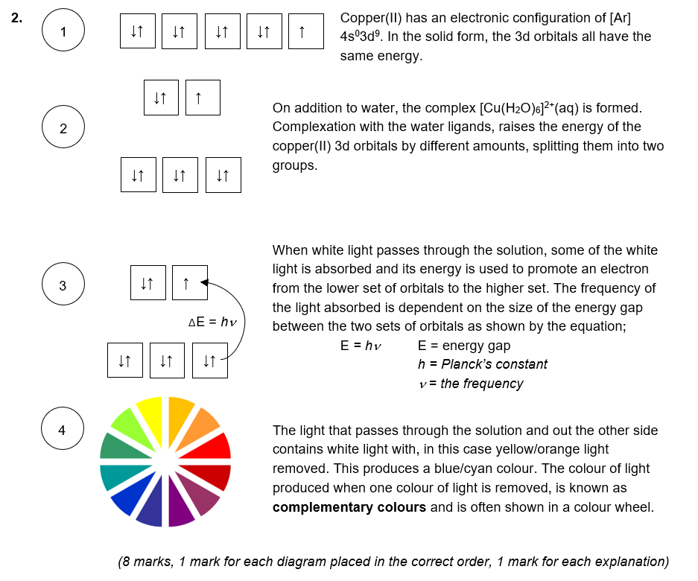

Colorimetry
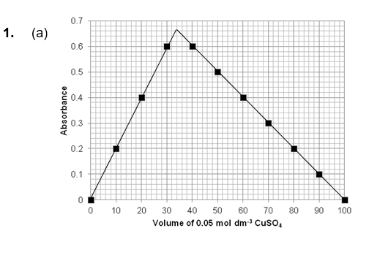(1 mark for correctly plotting points)
(b) (i) Maximum absorbance at 33 cm³ 0.05 mol dm⁻³ CuSO₄ : 67 cm³ of 0.10 mol dm⁻³ NH₃ solution
In moles this is, 1.65 × 10⁻³ mol : 6.70 × 10⁻³ mol
Stoichiometric ratio 1 : 4

(1 mark for reading correct volume of graph, 1 mark for mol calculations, 1 mark for stoichiometry)

(ii) Since copper is normally hexacoordinate, the formula of the complex formed must be;
[Cu(NH₃)₄(H₂O)₂]²⁺ (1 mark)

2. Key features of the experiment described include;

1. Initially the sample of E133 of known concentration must be diluted with water to produce dilute samples of known concentration. Five or more solutions must be produced. Possible dilutions would be;

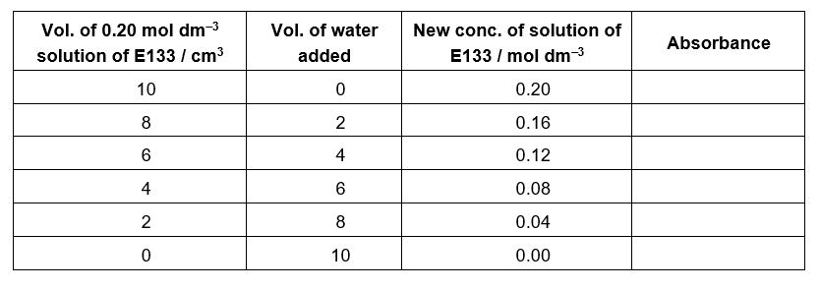

2. Measure the absorbance of each new known concentration of E133 and record these results in a suitable table.
3. Plot a calibration graph of concentration of E133 (x-axis) against absorbance (y-axis).
4. Measure the absorbance of the sports drink ‘Go, go, go.’
5. Use the calibration graph plotted in 3. to determine the concentration of E133 in ‘Go, go, go.’
(5 marks)

Redox titrations

Tablet A
5 Fe²⁺ + MnO₄⁻ + 8 H⁺ → 5 Fe³⁺ + Mn²⁺ + 4 H₂O

No. of moles in 21.65 cm³ of 0.005 mol dm⁻³ KMnO₄
= 1.08 × 10⁻⁴ mol

Therefore, no. of moles of Fe²⁺ in 25.00 cm³ aliquot
= (1.08 × 10⁻⁴ mol) × 5 = 5.41 × 10⁻⁴ mol

Therefore, no. of moles of Fe²⁺ in 250 cm³ and hence in one of Tablet A
= (5.41 × 10⁻⁴ mol) × 10
= 5.41 × 10⁻³ mol
(1 mark)
Molar mass of FeSO₄ = 151.9 g mol⁻¹
Therefore mass of FeSO₄ per tablet = 5.41 × 10⁻³ mol × 151.9 g mol⁻¹ = 0.82 g (1 mark)
Therefore Tablet A comes from the IRON TO GO pack.
(1 mark)

Tablet B

5 Fe²⁺ + MnO₄⁻ + 8 H⁺ → 5 Fe³⁺ + Mn²⁺ + 4 H₂O

No. of moles in 19.45 cm³ of 0.010 mol dm⁻³ KMnO₄
= 1.945 × 10⁻⁴ mol

Therefore, no. of moles of Fe²⁺ in 25.00 cm³ aliquot
= (1.08 × 10⁻⁴ mol) × 5 = 9.725 × 10⁻⁴mol

Therefore, no. of moles of Fe²⁺ in 500 cm³ and hence in two of Tablet B
= (9.725 × 10⁻⁴ mol) × 20
= 0.01945 mol
(1 mark)

Mass of iron in two tablets of B = 0.01945 mol × 55.8 g mol⁻¹ = 1.085 g (1 mark)
Therefore the % by mass of iron in Tablet B
= (1.085 g / 2.10 g) × 100% = 51.6 %

Therefore Tablet B comes from the FeRICH tablets. (1 mark)

Tablet C

6 Fe²⁺ + Cr₂O₇²⁻ + 14 H⁺ → 6 Fe³⁺ + 2 Cr³⁺ + 7 H₂O

No. of moles in 10.5 cm³ of 0.0022 mol dm⁻³ K₂Cr₂O₇
= 2.31 × 10⁻⁵ mol

Therefore, no. of moles of Fe²⁺ in 20.00 cm³ aliquot
= (2.31 × 10⁻⁵ mol) × 6 = 1.386 × 10⁻⁴ mol

Therefore, no. of moles of Fe²⁺ in 500 cm³ and hence in one of Tablet C
= (1.386 × 10⁻⁴ mol / 20) × 500
= 3.465 × 10⁻³ mol
(1 mark)

Molar mass of FeSO₄.7H₂O = 151.9 + (7 × 18.0) = 277.9 g mol⁻¹
Therefore mass of FeSO₄.7H₂O per tablet
= 3.465 × 10⁻³ mol × 277.9 g mol⁻¹ = 0.96 g (1 mark)
Therefore Tablet C comes from the Fe4U tablets. (1 mark)

BONUS MARK
Either
Add an excess of zinc to a 25.0 cm³ aliquot of the original solution. This will reduce any Fe³⁺ ions to Fe²⁺ ions. Filter off the unreacted zinc and titrate the mixture against KMnO₄. If the titre is the same (i.e. the amount of KmnO₄ needed for complete oxidation has not changed) then only Fe²⁺ ions were present in the original solution. If the titre has increased (i.e. more KmnO₄ is needed for complete oxidation) then the original sample must have contained some Fe³⁺ ions.
Or
Dissolve the tablet in water and add sodium hydroxide solution until present in excess. If Fe²⁺ is present a green precipitate of [Fe(H₂O)₄(OH)₂] would form. Any Fe³⁺ present would form an orange/brown precipitate of [Fe(H₂O)₃(OH)₃].
(1 mark for either method)

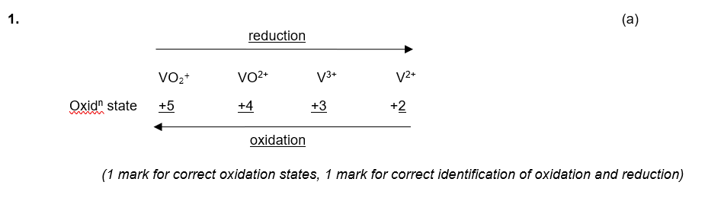
Redox chemistry of transition metals
(b) (i) The electrode potentials for the V³⁺/V²⁺ electrode and the VO²⁺/V³⁺ electrode are each more negative that the NO₃⁻/NO electrode potential. Therefore, NO₃⁻ will initially oxidise V²⁺ to V³⁺ which will then be oxidised further to VO²⁺. Since the electrode potential for the VO₂⁺/VO²⁺ electrode is more negative than that of the NO₃⁻ / NO electrode no further oxidation is possible.
(2 marks; 1 mark for comment on electrode potentials and 1 mark for explaining comment)

(ii) The electrode potential of the Zn²⁺/Zn electrode is more negative than each of the VO₂⁺/VO²⁺, VO²⁺/V³⁺ and the V³⁺/V²⁺ electrodes. Therefore it will reduce each of the vanadium species in turn i.e. VO₂⁺ will be reduced to VO²⁺ which in turn will be reduced to V³⁺ which in turn will be reduced to V²⁺.

(2 marks; 1 mark for comment on electrode potentials and 1 mark for explaining comment)

2. (a) In acid conditions the first half equation would be (this is purely a theoretical simplification, as [Cr(OH)₆]³⁻ would not exist under these conditions);

[Cr(OH)₆]³⁻ → CrO₄²⁻ + 2 H₂O + 2 H⁺ + 3 e⁻

But the oxidation is in alkali conditions so it becomes (just add enough OH⁻ equally to both sides of the equation to remove any H+ ions);

2 OH⁻ + [Cr(OH)₆]³⁻ → CrO₄²⁻ + 4 H₂O + 3 e⁻ (× 2)

The hydrogen peroxide half equation is;

2 e⁻ + H₂O₂ → 2 OH⁻ (× 3)

Combining to give the full redox equation;

2 [Cr(OH)₆]³⁻ + 3 H₂O₂ → 2 CrO₄²⁻ + 8 H₂O + 2 OH⁻

(2 marks; 1 for correct half equations, 1 for correct full redox equation)

(b) [Co(NH₃)₆]²⁺ → [Co(NH₃)₆]³⁺ + 1 e⁻ (× 4)

4 e⁻ + 2 H₂O + O₂ → 4 OH⁻

4 [Co(NH₃)₆]²⁺ + 2 H₂O + O₂ → 4[Co(NH₃)₆]³⁺ + 4 OH⁻

(2 marks; 1 for correct half equations, 1 for correct full redox equation)

Transition metals as catalysts

1. (a) Nickel, heterogeneous
(b) Iron, heterogeneous
(c) Vanadium pentoxide (V₂O₅), heterogeneous
(d) Platinum, palladium or rhodium, heterogeneous
(e) Fe²⁺ ions, homogeneous
(f) Manganese dioxide, MnO₂, heterogeneous
(g) Mn²⁺ ions, homogeneous (7 marks)

2. (a) Autocatalysis is when one of the products of the reaction acts as a catalyst for the reaction.
(1 mark)

(b) Initially a little of the Mn²⁺ catalyst is made by the reaction. Once a little is made, it reacts with MnO‹ ions to form Mn³⁺ as an intermediate species. The Mn³⁺ then reacts with the C₂O₄²⁻ ions to form CO₂ and reform the Mn²⁺ catalyst;
4 Mn²⁺(aq) + MnO₄⁻(aq) + 8 H⁺(aq) → 5 Mn³⁺(aq) + 4 H₂O(l)
2 Mn³⁺(aq) + C₂O₄²⁻ (aq) → 2 CO₂(g) + 2 Mn²⁺(aq)
(2 marks)

