Fire extinguisher

Fire extinguisher demonstration: A demonstration video can be viewed at rsc.li/3ejZSs7
The investigation allows learners to explore changing materials, reversible and irreversible changes and gases around us.

Age group: 9–11

Learning objectives
- To describe the difference between a reversible and an irreversible change.
- To explain that some changes result in the formation of new materials (in this case, one of these is carbon dioxide) and that this kind of change is not usually reversible.
- To understand that some gases are heavier than others.
Enquiry skills:
- To understand what variables are.

Background science
Around your school there are probably several types of fire extinguishers for different types of fire. A carbon dioxide fire extinguisher is usually used with electrical fires.
This experiment shows how carbon dioxide, created here from the chemical reaction between bicarbonate of soda and vinegar, can be used to extinguish a candle flame.
Fire needs a heat source, oxygen and fuel to burn. Taking just one of these things away will make the fire go out. In this experiment, you will be removing the source of oxygen from the candle, by covering the flame in a ‘blanket’ of carbon dioxide. (Extinguishers contain compressed carbon dioxide which is released over the flames.)

Prior learning
Learners would benefit from investigating burning as an irreversible process.
Learners must understand the properties of solids, liquids and gases and the behaviour of the molecules in each state.
Learners should also have previously investigated reversible changes and be able to give scientific examples.
Learners should have some knowledge of fair testing and the effect of changing variables.

Links
The creation of carbon dioxide using these ingredients is also used in the investigations Bath bombs, Freaky hand and Lava lamp.

Key words and definitions
Reversible change – a change where no new materials are created, and the original material can be recovered. Examples include melting, evaporating, freezing and dissolving.
Irreversible change – a chemical change where new materials are formed.
Gas – a ‘state of matter’ where particles have high energy and large spaces between them. A gas takes the shape of the container it is in and will flow.
Variable – a condition or object that is observed or measured that could change during a science experiment, eg temperature, amount of substance.
Teachers may wish to hide the meanings/examples on the PowerPoint slide and discuss the learners’ ideas first.

Equipment list
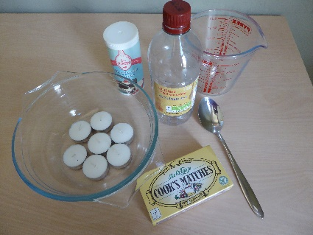
- Vinegar
- Bicarbonate of soda
- Long matches (short matches will work but long ones help avoid burnt fingers)
- Large jug (approx. 2 litre)
- Tea light candles
- Glass bowl (large enough to contain at least 5–6 tea lights for best effect)
- Dessert spoon
- Water/fire blanket (as a safety measure)

Method
Prior to the investigation, you may wish to demonstrate how a candle needs oxygen to burn, by covering a burning tea light with a glass jar and watching until the flame is extinguished.
- Fill a bowl with tea lights.

- Light to each tea light with a long match.

- Place two large dessertspoonfuls of bicarbonate of soda in the jug and add approximately 250 ml of vinegar. These will immediately begin to react, forming bubbles of carbon dioxide and other new materials.

- Allow the mixture to stop fizzing. Because the carbon dioxide gas is heavy compared with the air (denser), the carbon dioxide will settle in the jug, above the other products. Slowly, pour the carbon dioxide over the candles to extinguish their flames. Make sure that you do not do this quickly, or the mixture will pour out too.

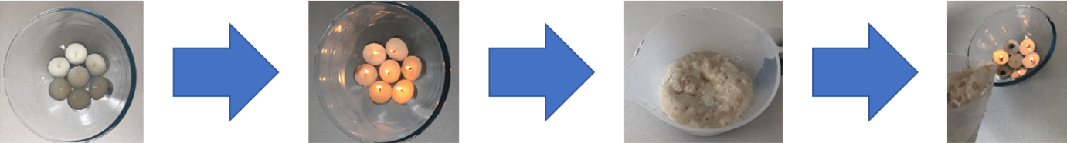
Be mindful that this is a very smelly experiment; try to avoid spillages and consider conducting the experiment outdoors or with windows open to dissipate the smell.
NOTE: It is important to pour the carbon dioxide carefully. You can lose all the CO₂ by spilling it without realising, as it is an invisible gas. If the experiment does not work, try repeating it, but stir the vinegar and bicarbonate of soda before pouring the carbon dioxide out of the jug.
RISK ASSESSMENT: Fire safety should be taken very seriously. Make sure that learners are supervised at all times, long hair is tied back and water and fire blankets are readily available. Learners could carry out the activity themselves with a single tea light and smaller quantities of reactants.

Question prompts
- How do we know that a gas is produced?
When we add the bicarbonate of soda the vinegar starts to bubble and hiss. The gas is invisible but is heavier than the air around us, so it sits on top of the vinegar and bicarbonate mixture. Pouring the gas on to the flame extinguishes it.
- How do we know that this an irreversible reaction?
A new material (carbon dioxide) is produced. This is an irreversible reaction because we cannot put the carbon dioxide back into the vinegar and bicarbonate of soda mixture.
- What might happen if you diluted the vinegar or changed the quantity of vinegar or bicarbonate of soda?
If you dilute the vinegar or changed the quantities, you will produce different quantities of carbon dioxide. You can test this by placing a balloon or a latex glove over the top of a bottle or the beaker with various concentrations of the vinegar and bicarbonate of soda mixture. The more the balloon or glove inflates the more carbon dioxide is collected.
- Can you think of any other chemical reactions that produce carbon dioxide?
Other reactions of acids and alkalis release carbon dioxide, for example citric acid and bicarbonate of soda in sherbet sweets. Burning fossil fuels also releases carbon dioxide.
- How do real fire extinguishers work? Do you have a carbon dioxide extinguisher in your classroom?
Fire extinguishers work by stopping the fire getting any oxygen, because without oxygen the fire can’t burn. Different types of fire extinguishers might be in the classroom. This would be a good time to introduce why there are different types of fire extinguishers such as foam and water.

You may also wish to consider
If you repeated the experiment, which variables could the learners change and investigate? For example, could the amount of vinegar affect the amount of gas produced? This would be an excellent starting point for planning a pupil-led fair test.

FAQs
- Can other gases be used to extinguish flames?
Helium could be used to extinguish flames, as it is not a flammable gas. However, because it is so light, it will not sink down and form a blanket over the flames like carbon dioxide does. Recent research in the International Space Station has found that although they currently use carbon dioxide fire extinguishers, helium fire extinguishers may be more effective as, in space, the effects of gravity on gases are different.
- What is the maximum number of candles that could be blown out with 250 ml of vinegar?
This is a brilliant question to use to begin further investigations. It may, however, result in a very smelly classroom! Experimenting to see the maximum number of candles would be a simple investigation for the learners to plan and undertake. Definitely an investigation to think about taking outdoors!

All images © Royal Society of Chemistry.

