Sticky cups

Sticky cups demonstration: A demonstration video can be viewed at rsc.li/2VGAzKt
The demonstration helps learners to visualise that gases expand on heating and affect the air pressure inside a container. Learners can then explore this themselves using a balloon and bottle.

Age group: 7–9

Learning objectives
- To understand that air is a fluid: it flows, can change shape and fills its container.
- To learn that when air is warmed, the gases expand due to the increased heat.
- To learn that particles in a gas move around and when heated, this movement is quicker and causes an expansion of the air inside its container.
- To understand that when we consider the force of air over a specific area, we call this air pressure.
Enquiry skills:
- Identify variables that can be changed, measured and controlled.
- Record observations and explain what has been found.

Background science
Air is all around us and is made up of different gases. Learners should already recognise solids, liquids and gases as the ‘states of matter’ and understand how these are different. Gas particles move around more quickly and are spaced further apart than in liquids, so gases can flow (they are fluid) but unlike liquids, will also spread out to fill their container.
Learners will have experienced movement of air outdoors when the wind blows or indoors with a fan or draught. They may not recognise that air particles are moving all the time, bumping into each other and their container. When heated, the particles have more energy so they move more quickly and the space between them increases – this is expansion. Learners may have seen hot air balloons inflate as the air inside them is heated and expands.

Prior learning
Learners should understand the particle differences between solids, liquids, and gases. They should recognise that gases cannot be seen. They should be aware that air is made up of different gases and is all around us, and that gas particles move around freely.

Links
The concept of air pressure is also explored in The leaky bottle and Anti-gravity bottle.

Key words and definitions
Air – a mixture of gases that surround us and which we breathe. It is not ‘nothing’ as some learners may describe it, but is a gas made up of physical matter. It consists of approximately 78% nitrogen; 20% oxygen; less than 1% argon; less than 1% carbon dioxide and other gases, and the rest is water vapour.
Thermal expansion – the increase in volume due to heat.
Pressure – a measure of a force over a specific area. A force on a large area creates less pressure than the same force on a much smaller area. So, air pressure, is the amount of force exerted by the air on a given area.
Teachers may wish to hide the meanings/examples on the PowerPoint slide and discuss the learner’s ideas first.

Equipment list
Demonstration
- 2 identical translucent plastic cups
- Kettle
- Kitchen roll
- Plastic beaker
Individual investigation (each group will need)
- Balloon
- 500 ml plastic drink bottle
- 2 bowls
- Hot water (hot from tap, but not boiling)
- Ice and water

Method
Demonstrate the ‘sticky cups’ as shown in the video.
Explain how the hot water made the air in each cup expand and leave the cups. They were placed together when hot, but as they cool, the air contracts. There is the same amount of air in the cups as before, so it can’t push as hard as before (the air pressure is less). Air around the container has greater pressure (a bigger push on the cups) and holds them together.
Learners can investigate expansion and contraction themselves:
- Fill one bowl with hot water (~40°C is fine) and another with water and ice.
- Inflate and release a balloon a few times (so that it inflates easily). Stretch the empty balloon over the neck of a 500 ml water bottle (or similar).

- Stand the bottle in the hot water and observe what happens (the balloon inflates) – the bottle must be held in the water (it will not stay upright without support).
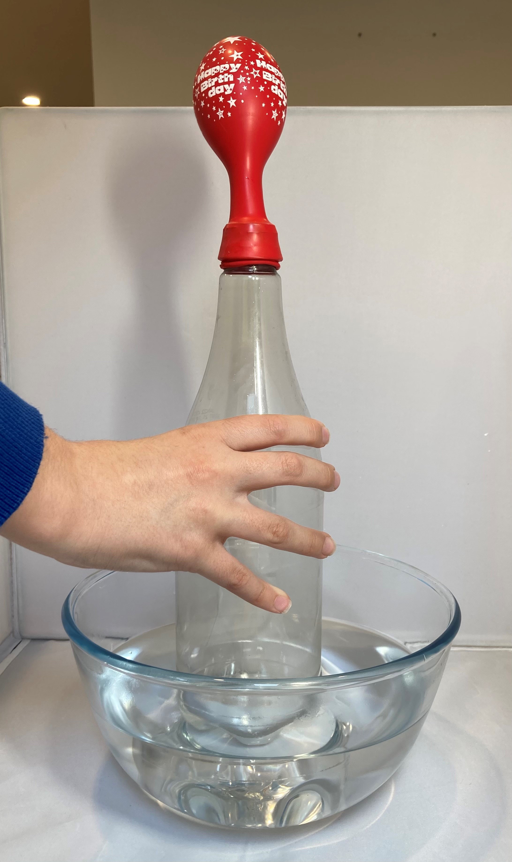
- Next stand the bottle (with the inflated balloon) in the icy water and observe the change (the balloon deflates).
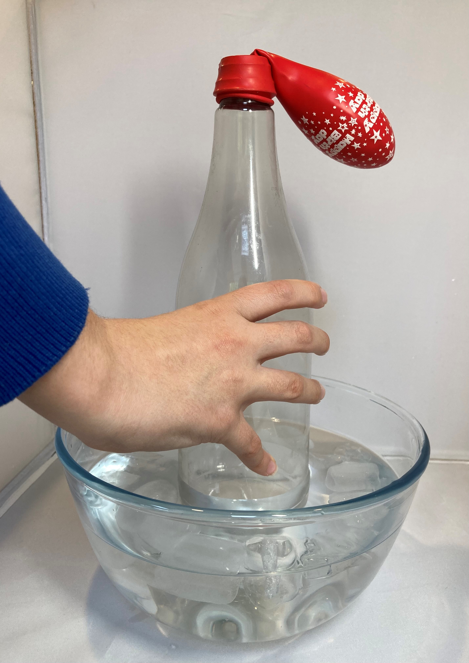
Can the learners explain what is happening? What do they think could be changed and might affect the results? Eg temperature of water, size of bottle or balloon. You might consider investigating their ideas further.

Question prompts
For the demonstration
- Can you explain why we could not separate the plastic cups?
The air pressure outside the cups was greater than inside.
- What happened to the air as the cups cooled?
The gas contracted (particles moved closer together).
- Why did they separate easily after a short while?
The cups were not sealed together, so air could come in.
Individual investigation
- What is in the plastic bottle?
Air
- What can you see happening to the balloon when the bottle is in hot water?
It inflates.
- What makes this happen?
The air (gas) is heated and expands (takes up more space) as the particles get more energy, and this makes the balloon expand too.
- What happens to the balloon when the bottle is in cold water?
It deflates.
- Why does this happen?
The air cools and the gas contracts (particles move closer together), so the air takes up less space.

FAQs
- Where does the air ‘go’ when it expands in the cup?
It spreads out, so there is less in the cup than before (fewer particles) and goes into the wider room around it.
- If the air is moving all the time, why doesn’t it come back into the cup?
It does – the particles constantly move but when they are hot, they have more energy and spread further apart (so particles coming in do this too) so there are fewer there.
- How does the air come back into the cups later?
The kitchen roll is porous (it has holes in it that let water and air through). Particles are incredibly tiny, so even when the cups seem tight together, the air particles can get in if there isn’t a complete seal.
- Does a hot air balloon work in the same way as the balloon on the bottle in hot water?
Yes! The burner heats up the gas in the balloon; it expands and fills the balloon. Hot air is less dense than cold air (density measures how much mass there is in a given volume), so it floats up above the colder air, carrying the balloon up too.

Images © Royal Society of Chemistry.

