Chromatography of sweets

Learning objectives
- Recap the keywords behind chromatography.
- Investigate the dyes that are in different coloured sweets by successfully following a method.
- Analyse the results and write a conclusion.

Introduction

Food colourings contain different dyes. Your aim is to investigate the number of different dyes in coloured sweets using chromatography.

Starter question

Match up the keywords to the definitions with a single line.

Solute |  | Two or more different substances that are not chemically bonded together.
Solvent |  | A mixture of the solute dissolved in the solvent.
Solution |  | A substance that the solute dissolves into.
Mixture |  | A separation technique used to separate the pigments in a mixture, like ink or food colouring.
Chromatography |  | A substance that is soluble (can dissolve in a solvent).

Method
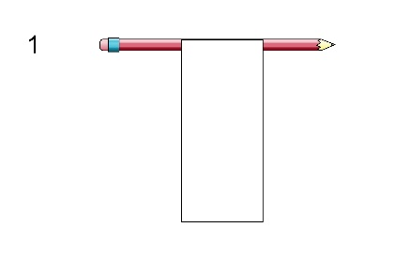Attach the chromatography paper to a pencil with a paperclip. | 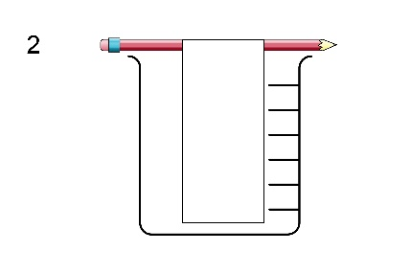Make sure the paper doesn’t touch the bottom of the beaker. | 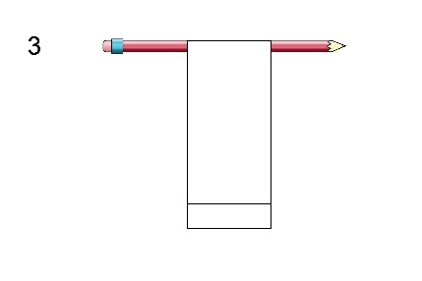Draw a pencil line 2 cm from the bottom.
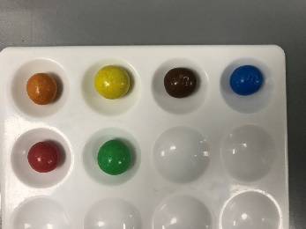  4  Put different coloured sweets in separate wells on a spotting tile. | 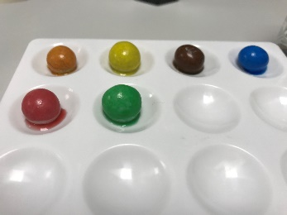  5  Add three drops of water to each well. | 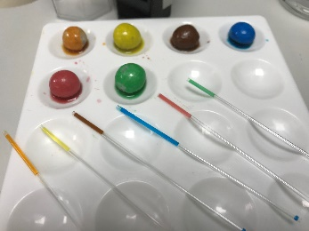  6  Use a small paint brush or a melting point tube to pick up some of the coloured water.
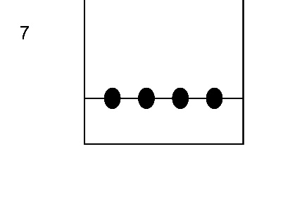Make a dot with the dye from each sweet along the pencil line. Make sure the dots don’t touch. | 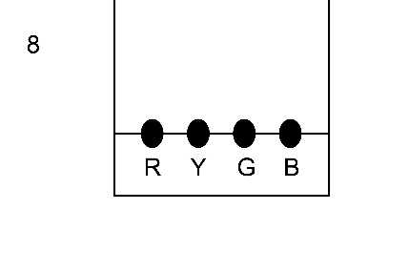Label each colour in pencil. | 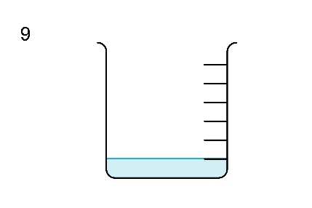Add 1 cm of water to the beaker.
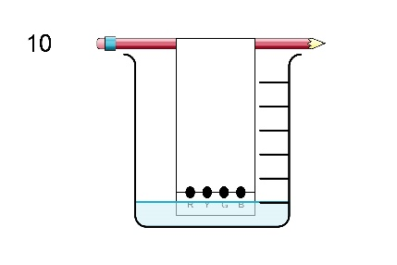Lower the chromatography paper into the water. The water should not touch the spots. | 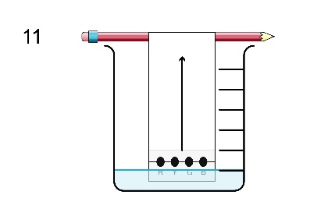Leave until the water is near the top. | 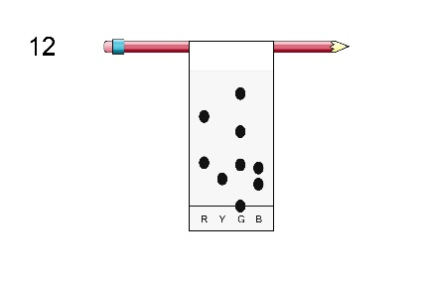Immediately mark the water line with pencil.
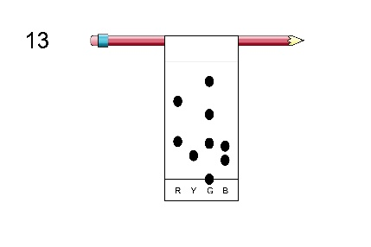Leave to dry. | Safety note: Sweets are for laboratory use only and should not be licked or eaten.

Conclusion questions
- List the sweet colours that contained one dye.

_________________________________________________________________________________

- List the sweet colours that contained a mixture of dyes.

__________________________________________________________________________________

- Identify two sweets that contained the same dye.

___________________ and ___________________ both contained _________________ dye.

- Suggest why some dyes separate out into different colours while others do not.

__________________________________________________________________________________

__________________________________________________________________________________
__________________________________________________________________________________

- Suggest why some colours move further up the paper than others.

__________________________________________________________________________________

__________________________________________________________________________________

__________________________________________________________________________________

- Give one way of improving the separation between the different spots.

__________________________________________________________________________________

__________________________________________________________________________________

__________________________________________________________________________________

- What common errors can be made during the procedure?

__________________________________________________________________________________

__________________________________________________________________________________

__________________________________________________________________________________

- Why is the start line drawn in pencil rather than pen?

__________________________________________________________________________________

__________________________________________________________________________________

__________________________________________________________________________________

