Some reactions of nitrogen dioxide – student sheet

Procedure
- Cover the worksheet with a clear plastic sheet.
- Place the base of the Petri dish directly over the circle below. Place the reaction vessel in the centre of the Petri dish.
- Put two drops of full-range indicator where shown.
- At another corner of the triangle, place two drops of ammonia solution. Place the lid on the Petri dish and wait for the indicator drop to change colour.
- Remove the lid from the Petri dish and, using a piece of tissue, mop up the drop of ammonia.
- At the two remaining corners of the triangle, add the two other test solutions.
- Add a few copper metal turnings to the reaction vessel, followed by three drops of nitric acid. Quickly replace the lid on the Petri dish.
- Record all your observations over the next 15 min.

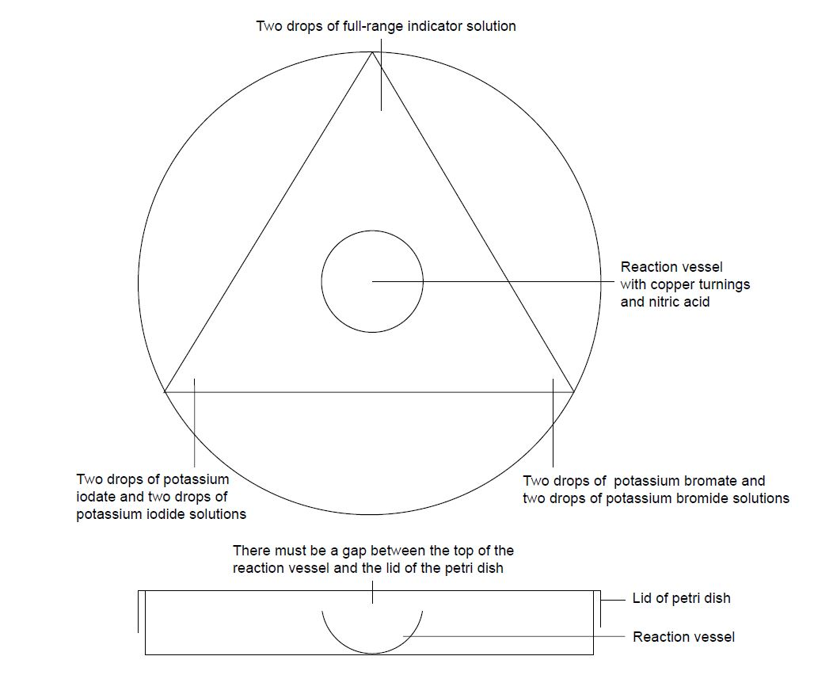

Questions
- What explanations can you give for your observations?

Health, safety and technical notes
- Read our standard health and safety guidance here https://rsc.li/3LVOUbN
- Students must wear suitable eye protection (Splash resistant goggles to BS EN166 3).
- Nitrogen dioxide is extremely toxic and corrosive if inhaled, with sometimes delayed effects. It is important to ensure that the amount of NO₂ generated does not result in significant leakage from the Petri dish (see CLEAPSS Hazcard HC068b). No more than 2 copper turnings should be used.
- Concentrated Nitric acid, HNO₃(aq), 5 mol dm^{–3}, is CORROSIVE and gives of toxic fumes (see CLEAPSS Hazcard HC067).
- Potassium iodate(V), KIO₃(aq),0.1 mol dm^{–3}, Potassium bromate(V), KBrO₃(aq), 0.1 mol dm^{–3} (see CLEAPSS Hazcard HC080), Potassium bromide, KBr(aq), 0.2 mol dm^{–3} and Potassium iodide, KI(aq), 0.2 mol dm^{–3} are low hazard (see CLEAPSS Hazcard HC047b).
- Ammonia solution, NH₃(aq), 3 mol dm^{–3} is corrosive and a respiratory IRRITANT (see CLEAPSS Hazcard HC006).

