Separating salt from sand
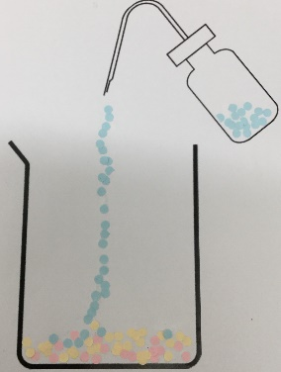
Education in Chemistry
January 2018
rsc.li/EiC118-preciouswater
Class experiment and particle pictures pair work, ages 11–14
Separating salt from rock salt is a common practical for younger secondary school pupils. Find details for the practical on Learn Chemistry: rsc.li/separating-salt-sand
Running it as a competition adds a nice challenge element. The winner has the cleanest salt sample.
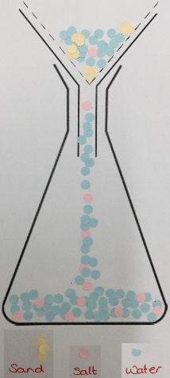
Even when pupils are very careful, ‘dirty’ samples with visible sand or silt particles are common. An interesting discussion for the pupils is ‘are all filter papers created equal?’. Many pupils won’t have considered how a physical filter works (chip pan basket, sieve and other analogies are helpful here). School filter papers are basic and may not filter out very fine particles. Particles the size of ‘silt’ particles may come through.
The particle model underpins much of chemistry, especially for 11–14 students. A solid foundation in the particle model helps pupils with simple concepts like state changes and separations, but also provides the basic building blocks for more advanced study in areas such as bonding.
Challenge students to model the separation of salt from rock salt in a series of images.
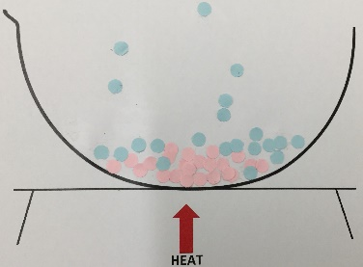
Share out templates of the experimental sequence. Two diagrams per pair works well with the expectation each diagram is constructed between the pair.
Particles can be drawn onto the templates provided. Or better, they can be collaged onto the template using hole-punched coloured paper or dot stickers as drawing the particles can cause issues with particle diameter consistency. I found the hole-punched paper best as the arrangement of particles can be discussed with pupils before they’re stuck in place.

