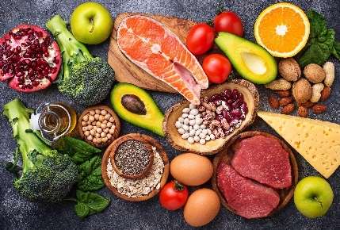
- Salmon, french beans, basil, eggs and some nuts are some examples of superfoods.

These types of food contain many important nutrients.
- What is a ‘nutrient’?
Source: Envato Elements

- Give two examples of important nutrients needed in our diet.

Many important nutrients are polymers made from many smaller molecules.
- Describe a polymer.

- Give the term to describe the small molecules that make a polymer.

The diagram shows a natural polymer being made from many glucose molecules.
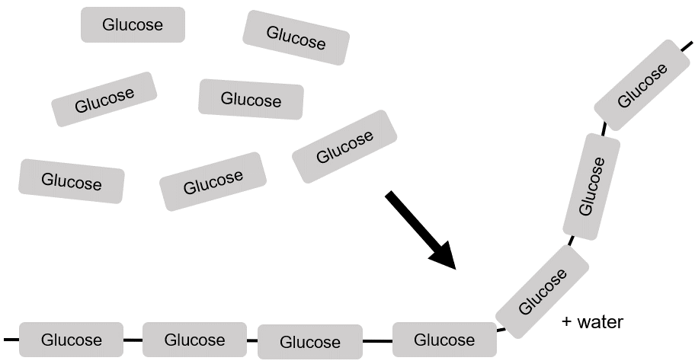

- State the name of the polymer being formed.

- What type of polymerisation takes place when glucose forms the polymer in part e)?
Why does it have this name?

Another important type of polymer is made from amino acids.
- Complete this diagram to show a polymerisation taking place.
Use the previous diagram to help you.
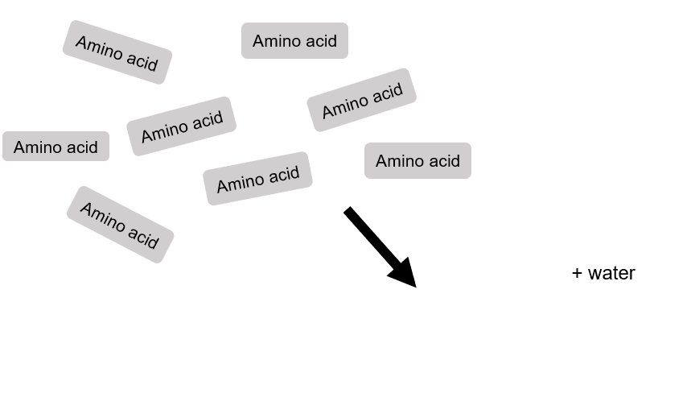
- What is the name of this type of polymer?

- Give one similarity between the polymer in part g) and the one in part e).

- This question is about chicken eggs.
The diagram shows the mass of different nutrients in 100 g of chicken eggs.

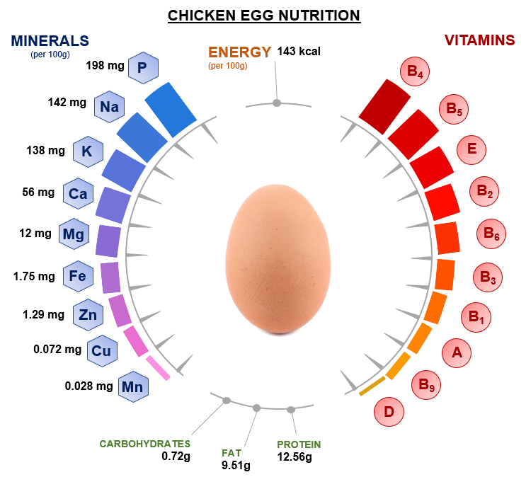
Use the diagram to answer the questions.
Source: International bunch / adapted from Shutterstock

- What is the mass of fat in 100 g of chicken eggs?

- What percentage of chicken eggs, by mass, is due to protein?

- Write the mass of iron in grams.

- Write the mass of vitamin A in grams.

- Write the mass of manganese in grams and in standard form.

- State the name of a nutrient in chicken eggs that is a polymer.

- Which of the nutrients in the diagram has the:

i) largest mass?

ii) smallest mass?

- Why is the total mass of all of the nutrients in the diagram not equal to 100 g?

