- Below are some statements about carboxylic acids.
However, there are some mistakes.
Mark each statement, correct or incorrect. For the incorrect statements give the correct answer.
- A carboxylic acid contains the -OH functional group.

- The names of carboxylic acids all end in –oic acid.

- The first part of the name tells you how many hydrogen atoms are present in the molecule.

- The letters –an– link the prefix to the –oic acid ending.

e)
Number of carbon atoms | Prefix
1 | Meth-
2 | Prop-
3 | Eth-
4 | But-

- The molecule below is called ethanoic acid.
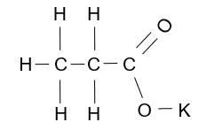

- George is asked by his teacher to draw out the structure of ethanoic acid.
He gives four possible structures, but only one is correct.
Which one is correct?
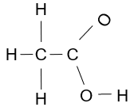
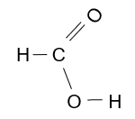
A
B

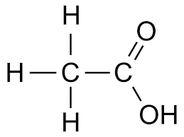
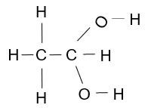
D
C

- Alan and Michelle carry out some experiments using ethanoic acid, and test for any gases formed.
The chemical formulae of the substances added are in the left-hand boxes.
Their observations are on the right-hand side.
Draw straight lines to link the substance with the correct gas test.

Formula of substance Observation
being added
Mg
A gas forms that turns limewater milky

Na₂CO₃
No gas forms

NaOH
A gas that forms a squeaky pop with a lighted splint

- This question is about the acidity of ethanoic acid solution.
Complete the spaces.
- Carboxylic acids dissolve in water to produce a acidic solution.

- When they dissolve they partially or slightly to produce . . ions.

- Universal indicator turns when added to a solution of ethanoic acid.

- The pH of a solution of ethanoic acid is normally about ..

- The equation to show ethanoic acid’s reaction in water is:
CH₃COOH ⇌ + .

